2020 Virtual Graduate
Research Symposium

Many thanks to our faculty judges, Drs. Irina Falls, Roger Ladd,
Nicole Stargell, Richard Kang, Velinda Woriax, and Sojin Jang!

RESEARCH PAPER COMPETITORS | PROJECT TITLE | LINK TO  PAPER | GRADUATE PROGRAM | FACULTY ADVISOR
Jenna Rankin  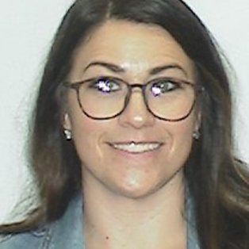 | Barriers to Pursuit: A Review of Research Involving First-Generation Graduate Social Work Students. |  | Clinical Mental Health Counseling | Susan Frauenholtz
Denise Salvetti  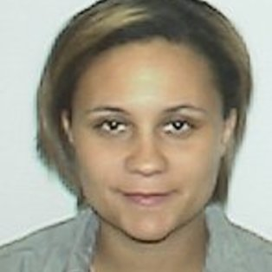 | A Look into Amount of Weeks Worked Last Year. |  | MPA | Joe West
Eric Verhine | “Beyond the Realms of What We Might Call Usual:” Fantasy as Spiritual Practice. |  | English Education | Roger Ladd
Kaylyn Locklear 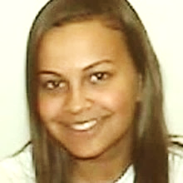 | Building a Sustainable Food System. |  | MBA | Ed Hunt
Keisha Moore | The Long-term Effects of Income Inequality. |  | MPA | Joe West

RESEARCH PAPER COMPETITORS | PROJECT TITLE | LINK TO  PAPER | GRADUATE PROGRAM | FACULTY ADVISOR
Beatrice  Ogbonna-Otu | How Effective Are Business Incubators in Helping Startup Businesses? A Study of The Thomas Entrepreneurship Hub. |  | MBA | Michael Mollohan
Sarah Shannon-Mohamed  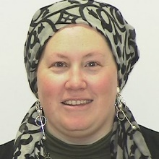 | Ensuring Accountability in Water Infrastructure Agreements. |  | MPA | Martin Mayer
Sheila O'Sullivan 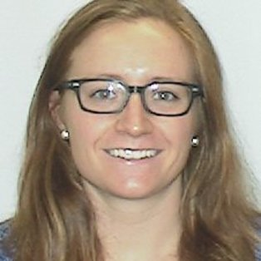 | Health-Related Content Knowledge & Heath-Related Behaviors Among College Students. |  | Exercise and Sports Administration | Leah Fiorentino
Laken Royall | Contributing Factors to the Amount of Television Watched Per Day. |  | MPA | Joe West
Laurel Tabaka | Neighborhood Conditions: How a Neighborhood Can Influence a Childs Health Status. |  | MPA | Emily Sharum
Meredith Boyd | Age at First Child's Birth: Influencing Factors from a Quantitative Perspective. |  | MPA | Joe West

RESEARCH PAPER COMPETITORS | PROJECT TITLE | LINK TO  PAPER | GRADUATE PROGRAM | FACULTY ADVISOR
Micah Simpson  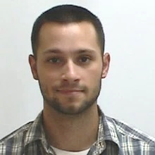 | The North Carolina Emergency Management Act: Disaster Management. |  | MPA | Sojin Jang
Selina Chalk | Discrimination: The Factors Impacting Income. |  | MPA | Joe West
Nicklaus Courmon | Bars and Bars: Hip Hop and its Role Combating Mass Incarceration. |  | Social Studies Education | David Walton
Rachel Sutton  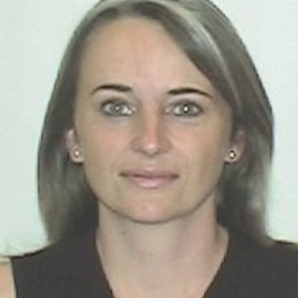 | Rural Opioid Misuse and Overdose Related Deaths. |  | MSW | Josphine Chaumba
Sherri Cash | Sustainable Hazard Resilience. |  | MPA | Sojin Jang

3 MINUTE THESIS COMPETITORS | PROJECT TITLE | LINK TO  3MT VIDEO | GRADUATE PROGRAM | FACULTY ADVISOR
Rispah Sang  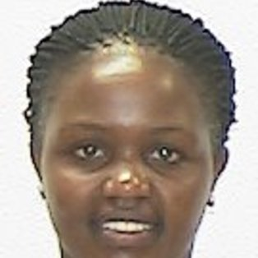 | The psychological and Psychosocial Impact of Female Genital Mutilation Among Immigrant/Refugee Women and Girls. |  | Clinical Mental Health Counseling | Nicole Stargell

POSTER COMPETITORS | PROJECT TITLE | LINK TO  POSTER | GRADUATE PROGRAM | FACULTY ADVISOR
Dennay Brewton  and Emily Nick | Creating and Sustaining Academic Workshops for Students with Disabilities. |  | Clinical Mental Health Counseling | Summer Woodside
Elizabeth Spanburgh  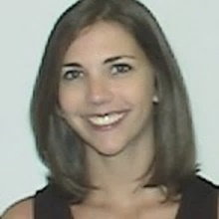 | Equine Assisted Psychotherapy. |  | Clinical Mental Health Counseling | Kelly Ficklin
Naila McConnell | The Role of Mental Health and Efficacy in Students in Higher Education. |  | Clinical Mental Health Counseling | Leslie Locklear
Rashanda Coachman  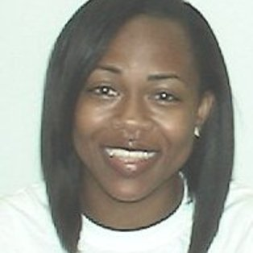 | Hair Discrimination: Empowering Diverse Cultures and Lifestyles. |  | Clinical Mental Health Counseling | Whitney Akers
Rashida Wise  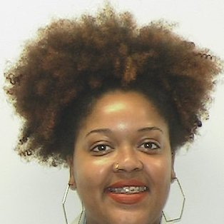 | The Effectiveness of Family Involvement in Recovery Outcomes for Substance Use Disorder Treatment. |  | Clinical Mental Health Counseling | Jeffrey Warren
Rebecca Ozment | Somatic Counseling: Connecting the Mind and the Body. |  | Clinical Mental Health Counseling | Whitney Akers

POSTER COMPETITORS | PROJECT TITLE | LINK TO  POSTER | GRADUATE PROGRAM | FACULTY ADVISOR
Sara Parisi  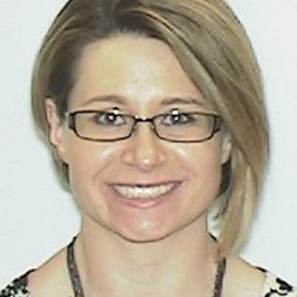 | Career Counseling Intervention Proposal for Robeson County Offender Population. |  | Clinical Mental Health Counseling | Nicole Stargell
Sydney Blake | Documenting ANTIFA – Sacco and Vanzetti: 100 Years Later. |  | English Education | Michele Fazio
Ean Ormsby | Effects of Campus Recreation on Recruitment and Retainment of College Students. |  | Exercise and Sports Administration | Marian Wooten
Alesia  Shaw-Pulley  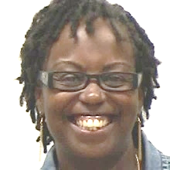 | "The Prevention" of Suicide Amongst Middle School Students and Interventions. |  | Professional School Counseling | Shenika Jones
Avvette Smith  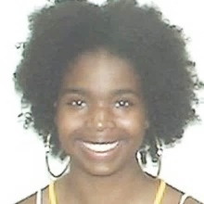 | Predicting School Counseling Student Success Through Non-cognitive Factors. |  | Professional School Counseling | Shenika Jones
Mary Butler | The Impact of Socioeconomic Status on Kindergarten Readiness. |  | Professional School Counseling | Jeffrey Warren
Patrick Cole | Exploring Non-Suicidal Self-Injury in the Field of School Counseling. |  | Professional School Counseling | Shenika Jones

POSTER COMPETITORS | PROJECT TITLE | LINK TO  POSTER | GRADUATE PROGRAM | FACULTY ADVISOR
Susana  Valderrama Banda | First-Generation Students Navigating Post-Secondary Education. |  | Professional School Counseling | Alfred Bryant
Emily Moore  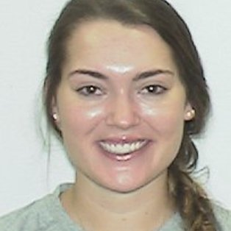 | The Effects of Media on Body-image Satisfaction Levels and Disordered Eating Patterns in Collegiate Student-athletes. |  | Kinesiology | Leah Fiorentino
Kathryn Fonseca  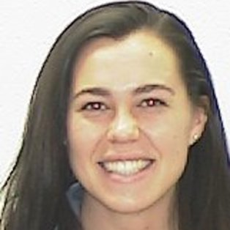 | Perceptions of College Students on the Sexualization of Female Athletes. |  | Kinesiology | Marian Wooten
Tyler Makosy  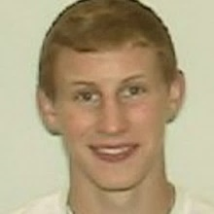 | Triage: An In-Depth Examination of Walk-In Counseling Appointments for UNC Pembroke CAPS. |  | Kinesiology | LynnDee Horne
Ana Maria Guillermo Florentino  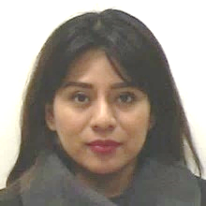 | Entrepreneurial Ecosystems. |  | MBA | Christine Bell
ShanTi'onna Summers  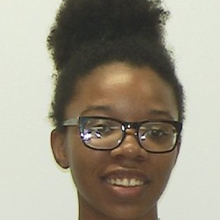 | How Much Does Your House Cost? |  | MBA | Bishwa Koirala

POSTER COMPETITORS | PROJECT TITLE | LINK TO  POSTER | GRADUATE PROGRAM | FACULTY ADVISOR
Adam Kirkley | Education Outcomes & Paternal Social Status. |  | MPA | Joe West
Benjamin Coleman  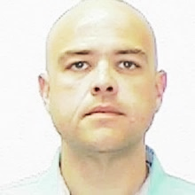 | Thanks Mom! Working Mothers and Their Children’s Educational Attainment. |  | MPA | Joe West
Lisa Valverde  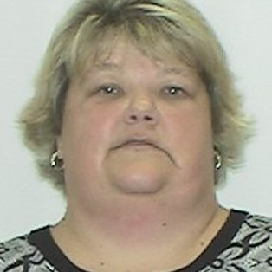 | Next Generation NCLEX Toolkit Implementation. |  | Nursing | Amy Medina
Ashley Lytle | Elementary Teachers’ Attitudes and Beliefs About Science Teaching. |  | Science Education | Irina Falls
Mariam Qambar | North Carolina Greenhouse Study of Vegetative Growth on Southern Highbush Blueberries Grown in Biochar and Compost Amended Soils. |  | Science Education | Bryan Sales
Timothy Hinton  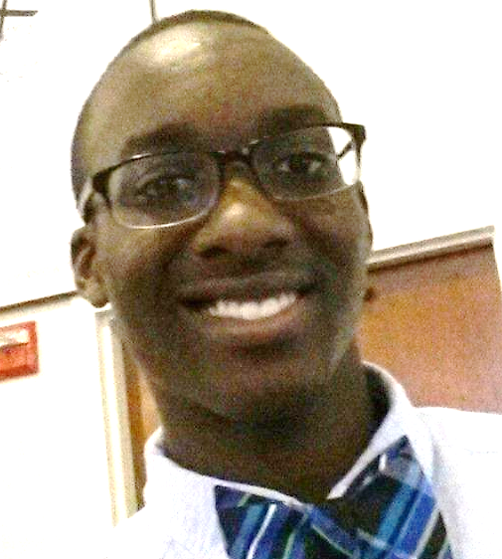 | The Use of Herbarium to Study Pollen and Pollinator Visitation. |  | Science Education | Rita Hagevik

POSTER COMPETITORS | PROJECT TITLE | LINK TO  POSTER | GRADUATE PROGRAM | FACULTY ADVISOR
Tanner Nygaard | Pushing Envelopes: The Story of Rosina Sacco and Woody Guthrie. |  | Social Studies Education | Michele Fazio
Alexis Ellis | The Atlantic Coast Pipeline from the Perspective of American Indian Tribal Governments. |  | Social Work | Tamara Savage

Congratulations to all participants!

The Graduate School appreciates your hard work,
perseverance, and scholarly acumen!

