**How to Invite a Vendor to Register**

* Log into BraveCart
* Click the 6th icon (Vendors) on the left side pane
* Click Add Vendor

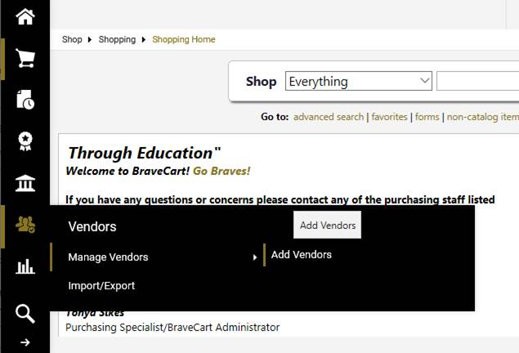

* Enter the Name of the company, first and last name of the company rep, their email address, confirm email
* Click (Invite Vendor to Register)

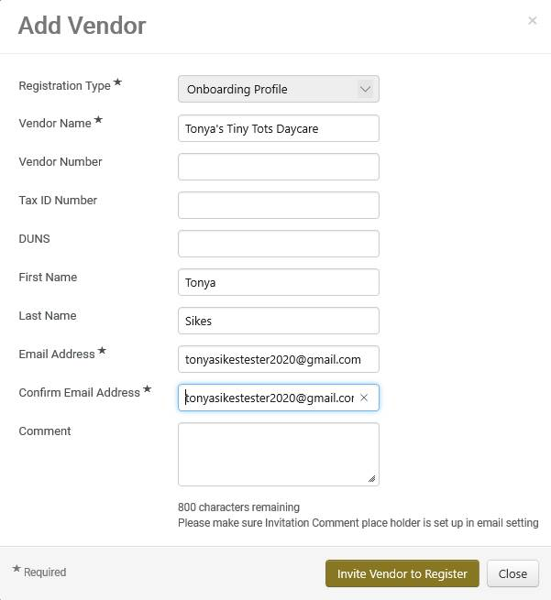

If “Duplicate Vendor(s) Found” pop-up, please review the list and click “Invite Existing Vendor” next to the vendor that is most like the vendor you want to invite. You will be able to edit the contact information. Enter the first and last name of the company rep you want the registration to be completed by and their email address.

**Please keep in mind that whomever the invite is sent to, that is the individual that is required to complete the registration. It cannot be forwarded to anyone else in the company to complete.  
  
They will receive an email and link to complete the registration. Vendor Management will receive notification when the registration is completed and ready to be approved. An email will be sent to the department informing them of the approved vendor and the Banner/BraveCart ID #.  
  
Please let send an email to vendormanagement@uncp or call Beatrice Williams at x 4657 if you have any questions or concerns regarding how to request a vendor.

**Individuals Requests:**

The vendor registration form along with a W9 must be completed. Please send the form to Beatrice Williams in the Purchasing Office. NOTE: For security purposes, information containing social security numbers should not be forward via email.