Ordering Transcripts Through Parchment
When and why is it important to request a transcript for college purposes?
- Answer: Completing college applications for undergraduate, graduate admission, and transcript credit review.

Step 1:
Use a computer to visit https://www.parchment.com/u/registration/individual and create an account.
Step 2:
Click start by adding a school or organization you attend.
- Example:
Step 3:
Add your school or organization by searching the school and clicking the add button.
- Example:

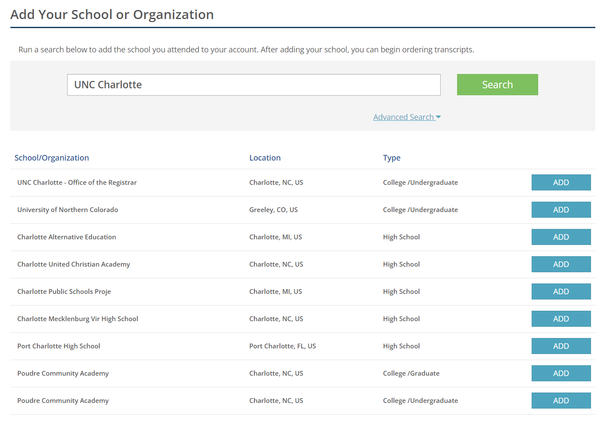
Step 4:
Enter your enrollment information and click continue.
- Example:
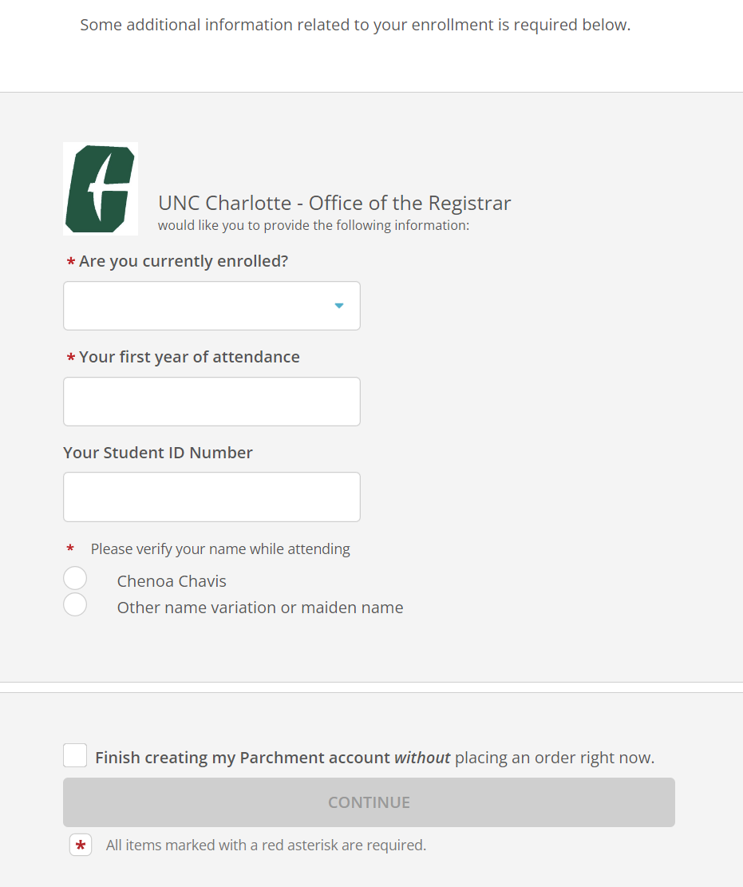

Step 5:

Click order and search and select the school you’d like to send your transcript to.

- Example:

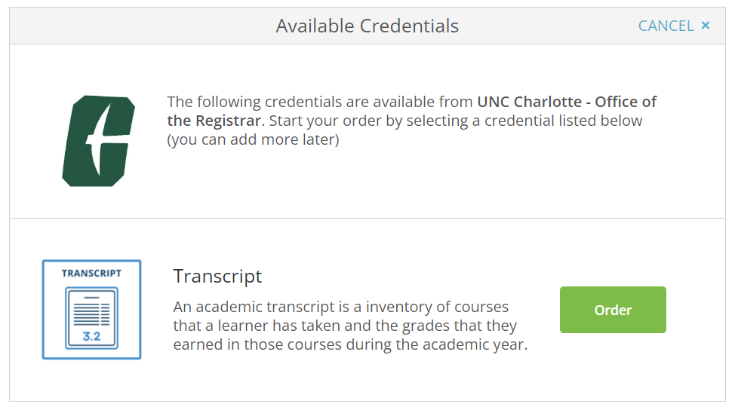

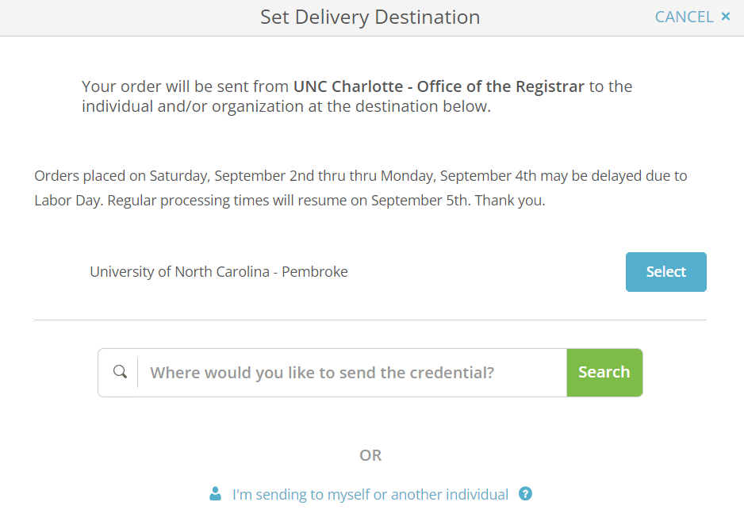
Step 6:
Select the purpose for sending transcript, add any additional documentation needed, electronically sign, and click the I consent box, and then click continue.
- Example:
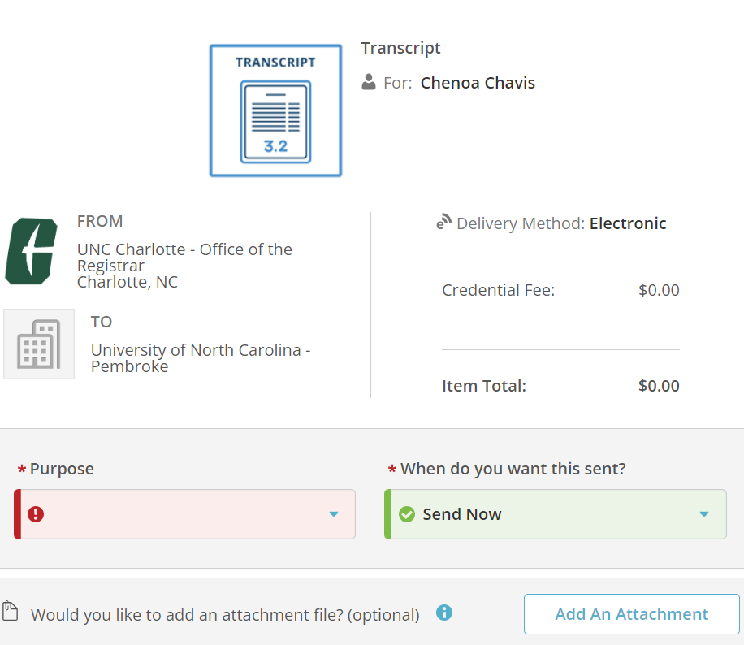
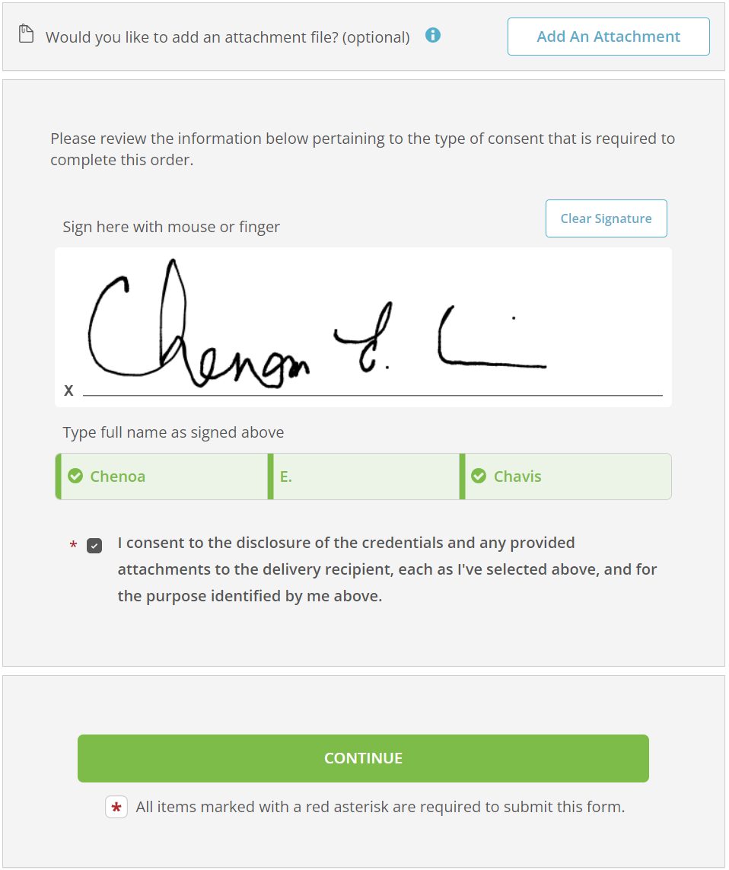
Step 7:
Review your order summary and click complete order.
- Example:
