Minutes
Subcommittee on Academic Support Services
3:30 PM, April 10, 2018
UC 233

Present
Robert Arndt, Chair (ARTS)
Michael Baker (Graduate Student Rep)
Nicolette Campos (Accessibility Resource Center)
Nancy Crouch (DoIT)
Alice Kay Locklear (at-large)
Derek Oxendine (CSS)
Marissa Scott (EDUC)
Dennis Swanson (Library Services)
Mark Thompson, Secretary (LETT)

Absent
Brandy Brown (Writing Center)
Dinna Edgell (Center for Student Success)
Rita Hagevik (NSM)
Pam Morgan (at-large)
Joe West (SBS)
SGA Senator

Guests
Chunmei Yao (Institutional Research)
David Ward (Provost)
Elizabeth Normandy (Planning and Accreditation)

- Meeting convened: 3:32 PM
- Minutes unanimously approved
- Agenda approved
- Reports
  - Accessibility Resource Center
    - Report (appended below)
    - ARC been working with various committees to improve accessibility into various buildings and classrooms.
    - ARC is working on an Onboarding plan to train new faculty and staff on accessibility issues.
  - Center for Student Success
    - Report (appended below)

  - Division of Information Technology
    - Report (appended below)
    - DoIT continues to upgrade classrooms and wireless networks across campus.
    - The clock continues to count down on the retirement of Blackboard. Deadline for accessing course sites and documents is June 1, but DoIT stresses the importance of faculty saving and converting class materials well before that deadline.
    - Canvas classes have been created for upcoming sessions.
    - DoIT added a level of security to email and is simplifying the quarantine process.
    - DoIT will soon be ordering new computers for the refresh program.
  - Mary Livermore Library
    - A new systems librarian has accepted an offer to join the library.
    - Work begins on Monday, April 16, for the new café.
    - The library will be trying to reduce the Reference foot print in the building.
  - Writing Center
    - Report (appended below)
    - No representative at the meeting
- Old Business
- New Business
    - Survey change rationale
      - Dr. Liz Normandy explained the origin of the SASS-directed surveys and how they grew out of the Faculty Senate’s response to reported and perceived in the Writing Center and Library. Surveys were implemented to determine what issues students and faculty thought needed to be addressed, and to collect data at a time that data was not being collected. It was then applied to other units providing academic services.
      - The heads of academic services units explained their need for actionable or useable data, and they concurred that past and current surveys have not produced that, and therefore they have implemented their own surveys. Liz Normandy indicated that the surveys are not used for accreditation purposes.
      - Committee members and guests discussed whether the reason and need for SASS surveys still exists, and whether it should continue to administer surveys.
      - Joe West moved that the Subcommittee on Academic Support Services submit the following motion to the Faculty Affairs Committee for its consideration: 1) Since the current surveys do not produce useful, actionable data, terminate the surveys and request that academic service units, if they conduct their own surveys, share the results of those services with Faculty Affairs; or, 2) continue to require the Subcommittee on Academic Support Services to conduct surveys but revise those instruments according to the changes proposed by Joe West.
    - Spring 2018 Survey Results
- Announcements
  - Next meeting: September 11, 2018
- Meeting adjourned: 4:28 PM

Respectfully submitted by Mark Thompson, Secretary

Appendix — Reports

Accessibility Resource Center
Academic Support Services Subcommittee
April 10, 2018

March statistics from Titanium database:
- Active in database: approximately 600. May not have finished the process, or may have finished the process but may not have implemented approved accommodations.
- 105 (91, 135, 87, 66) student have currently implemented accommodations for the semester
- 19 (9, 8, 1, 6) Intake appointments
- 18 (4, 9, 1, 8) accommodations appointments
- Proctored 59 (73, 80, 42,41) exams for 35 (39, 43, 30, 20) SWD’s
- 78 (16, 26, 31, 42) consultations with professors regarding 33 students
- Coordinated 60 hours (46, 106.5, 187, 135) of interpreting services (American Sign Language)
- 3,389 (240, 378, 278) pages converted to alternate format

From our hash mark sheet (numbers are not in Titanium, because they did not require a case note)
101 (143, 207, 192, 258) phone calls
109 (81, 94, 133, 77) Note taker visits
326 (308, 356, 365, 256) Walk-ins

ADA Coordinator
A/ Chancellor’s ADA Advisory Committee and subcommittees:
Instruction: format, materials, auxiliary materials
Facilities: building access, accessible paths of travel, access barriers
Programs: campus events, departmental events
Policies: barriers to access
Web-site and other electronic platforms

B/ Software assessments: requesting and reviewing Voluntary Product Accessibility Templates (VPAT’s)
C/ Current access barrier removal:
Multiple automatic doors
Path of travel (grinding service)
Library physical reconfiguration and electronic resources
Dial building exterior stairs
Pool elevator card reader
Other Activities
- Nicolette and Debbie presented two sessions within the Center for Student Success (CSS) Advisor Training series. The presentation was entitled, Advising Students with Disabilities.

- Nicolette and Vanessa were to present at the North Carolina Association on Higher Education and Disability (NC AHEAD) Spring Conference in Winston Salem, but the conference was cancelled and the building closed due to snow 15 minutes prior to the presentation. The presentation was entitled, Campus and Community Collaboration.

- Nicolette presented at the drive-in conference for the North Carolina School Counselors Association (NCSCA), Sandhills Region. The presentation was entitled, Transition Planning: Differences Between K-12 and Higher Education.

- Nicolette and Vanessa participated on a training panel for UNCP Orientation Leaders.
- Beginning in April Nicolette will conduct a training session within the New Employee Onboarding program. Nicolette will also conduct a session within the New Faculty program in August.

Committees:
- Academic Support Services Subcommittee
- BravesBook subcommittees
- CARE/EHS team
- Chancellor’s ADA Advisory Committee
- Commencement
- Coordinated Community Response Team (CCRT)
- Documentation Review Committee (DRC)
- Military Advisory Group (MAG)
- New Student Orientation
- SMART
- Special Olympics
- Sports Empowerment
- Tuition Surcharge
- University Center Advisory Board
- VSA

Center for Student Success
April 10, 2018

Tutoring Program

525 tutoring appointments were scheduled during the month of March of which 111 appointments were canceled and 74 students were no shows. Total tutored appointments = 340

HAWK Alert

As of 3/31/2018 there were 783? referrals compared to 704 Referrals for March 2017.

Study Hall Sessions

For the month of March, we had 126 students utilize our study hall session accumulating 1,096 hours for the month.

Number of Athletes served: 83 for 867.35 hours
Number of SOAPs served: 43 for 228.33 hours

Suspension Appeals

The Center for Student Success has received 45 suspension appeals for Summer 2018 and Fall 2018. After the second committee meeting, 25 cases has been completed and closed.

Type of Appeal
Academic | 7
Financial Aid | 9
Combo (ACAD/FA) | 29
TOTAL | 45

Term
Summer 2018 | 20
Fall 2018 | 25
TOTAL | 45

College Opportunity Program

COP faculty members have been meeting in individual conferences with COP students about writing assignments, advising issues, and overall academic progress. Robin Snead has conducted conferences with 73 students over the past few weeks. Amy Williams has held 45 conferences (32 for Writing, 13 for Advising), and Deana Johnson has met with 95 students (73 for Writing, 22 for Advising). We will each have one more round of conferences with our students before the end of the semester.

Spring 2018 Conferences (to this point in the semester) = 213
Spring 2017 Conferences (to this point in the semester) = 117

Deana Johnson and Amy Williams completed a service-learning project with the Center for Community and Civic Engagement on February 28. A total of 54 COP students participated. Our students did a great job of planning for the event and working with the CCE, and COP students contributed approximately 216 volunteer hours. Each elementary student who attended had the opportunity to create a poem based on Dr. Martin Luther King’s “I Have a Dream” speech, and our COP students served as mentors. Teachers from the partner school, R. B. Dean Elementary in Maxton, praised our efforts and stated that they were very impressed by our students and the execution of the event.

For this project, we are working to publish a booklet of all of the elementary students’ original works. We will provide a booklet to each student and teacher who participated as a special outreach during a visit to the school (date TBA). We will send the manuscript to the printer this week. Additional details will be provided in a subsequent report.
Total COP Volunteers Spring 2018 = 54 Total
Total COP Volunteers Spring 2017 = 70 Total
Total COP Volunteer Hours Spring 2018 = 216 (approximate total)
Total COP Volunteer Hours Spring 2017 = 120 (approximate total)

TRiO

Tutoring Sessions (March 18)

Career Counseling 1/19
Academic Advising 45/87
Personal Counseling 35/33
Financial Aid Verification 4/5
FAFSA completion 5/4
ISP completion 3/0
Tutoring Assistance 5/5
Study Skills Flash drive disbursed 3/0
Number of Tutors 11/15
Number of Mentors 7/6 (1 mentor is also a tutor)
Number of Tutees 15/5
Subjects CRJ 4000, CSC 2150, MAT 2150, ACC 2270, ENG 1060, BIO 3710, MAT 1090, MAT 1080, MAT 1070, MAT 2100, Praxis Math, BIO 1060, BIO 1000, CHM 2510, CHM 1300, PHS 1100, CHM 1310, ENG 1050, SPN 1320, SWK 3600, CHM 2500, ACC 2270, HST 1020, CSC 2600, CSC 1300, PSY 2060

5 new students accepted into SSS

APR was successfully submitted March 21, 2018

Division of Information Technology Report
Academic Support Services Subcommittee
April 10, 2018

Project Portfolio Updates

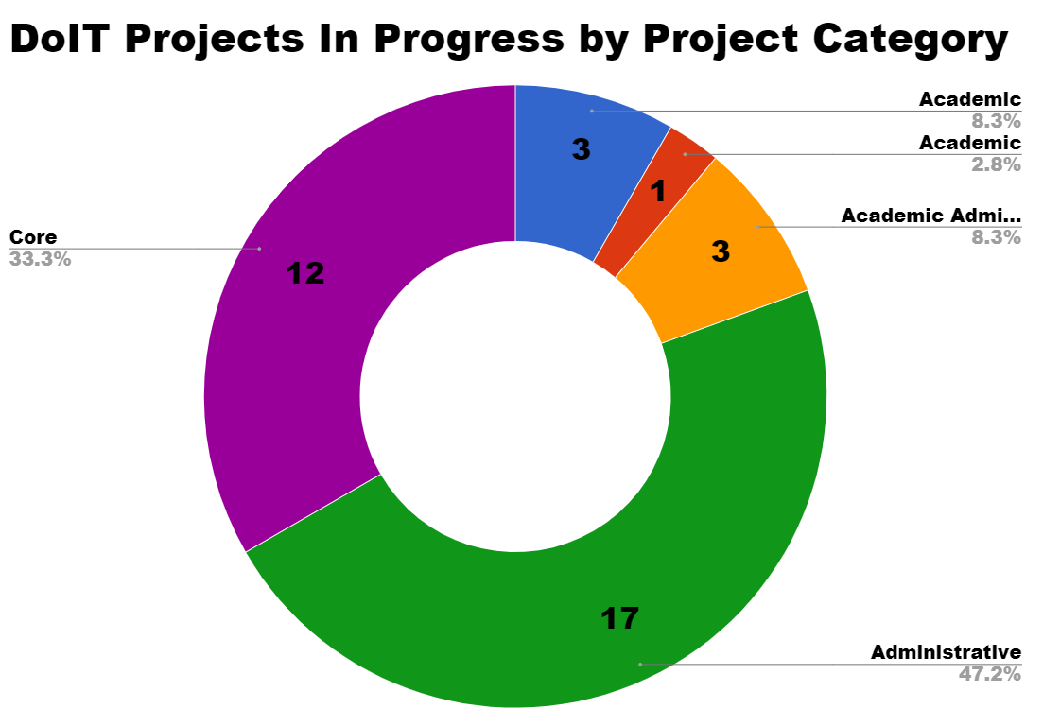

Projects and Operational Topics of Academic Interest
- CCI 2018 Project Update
  - ITSS Staff are in the process of reviewing justification for special use technology requests. Computer order underway.
  - All non state departments with computers that are out of warranty have been notified that their technology needs to be refreshed.
- WiFi Upgrades: All academic buildings will be upgraded by Fall 2018. Additionally upgrades will be made in Lumbee Hall, North, Belk and Pine residence halls.
- Instructional Spaces Infrastructure (ISI) Refresh Project Update
  - 17 classrooms will be upgraded prior to the beginning of the Fall 2018 semester. Prior to Spring Break, DoIT met with each of the departments selected for summer deployments to share our design standard and gather information on how they utilize each space. Locations are listed below:
    - BA 103B, BA 218
    - Education 202
    - Dial 221, Dial 237
    - Jones 1106
    - Locklear 122
    - Moore Choir Room 0010
    - Oxendine 1254, Oxendine 2202, Oxendine 3246, Oxendine 3248
    - Sampson 101, Sampson 134, Sampson 204
  - Equipment for the ISI refreshes are in progress. All equipment should be ordered by Friday, April 6, 2018.
- LMS Migration to Canvas
  - Please refer to the DoIT webpage (Canvas) for a listing of up and coming training opportunities. Additional staffing to support instruction design secured and workshops will be scheduled by Distance Ed.
  - Blackboard will be unavailable after June 1, 2018. Faculty must export content before May 16. ALL UNCP courses will be in Canvas beginning with Maymester 2018.
  - For a summary of training offerings and attendance to date, see https://sites.google.com/uncp.edu/uncpcanvastraining2018/home?authuser=0

Additional Projects Currently in Progress
- Active Directory Student Cleanup
  - The first round of announcement emails went out earlier this week. We have announced to the campus that we are disabling inactive student accounts. To improve our overall IT security posture, DoIT will disable student accounts that have been inactive more than a year effective April 30, 2018. All UNCP student account holders were notified of this change via email. Disabling inactive accounts mitigates the risk that these accounts will be used to send spam emails or perform other malicious activities, such as attempted access to your data and other personal information.

Incident Categorization Report for March 2018
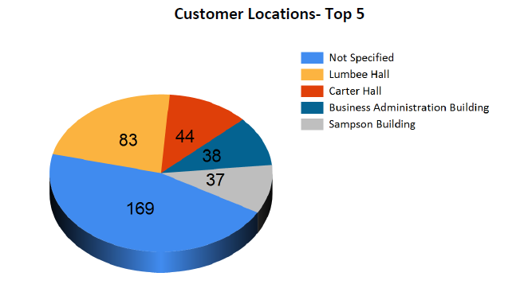
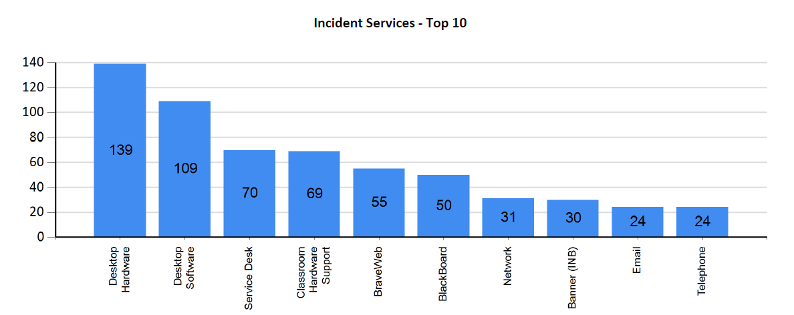
Resolution of Incidents (First Call / Escalated) March 2018
Incidents Resolved at First Call | Incidents Escalated to Other Teams
180 (74.47%) | 224 (31.77%)

Number of Incidents Resolved in March 2018 (700)
Calls Presented to the Help Desk March 2018 (1,296)
Interactive Video Facility
The Interactive Video Facility provides services to the campus community in a variety of service categories. Please see the chart below depicting the number of hours of service provided during this reporting period in each category.
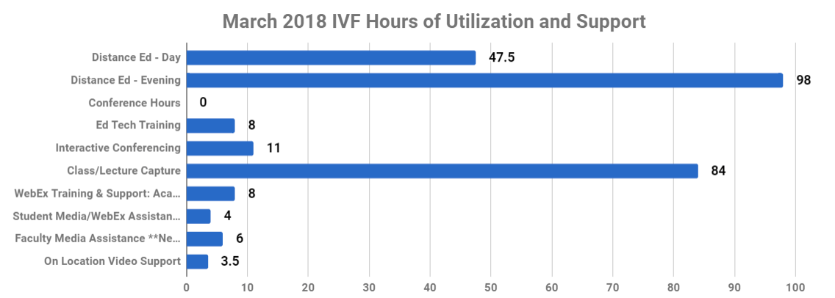
Canvas Support Tickets to Instructure by Type - March 2018
Email | Live Chat | Online Submission | Phone | Total
1 | 5 | 11 | 41 | 58
*DoIT will continue to work with Instructure (the Canvas vendor) to gather appropriate data on their support services and our campus's experience.
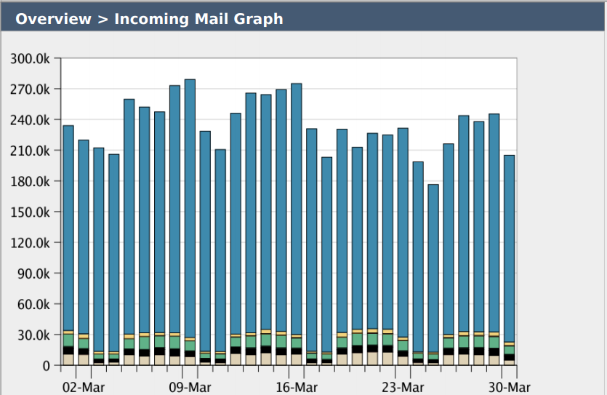
Email Security Metrics:
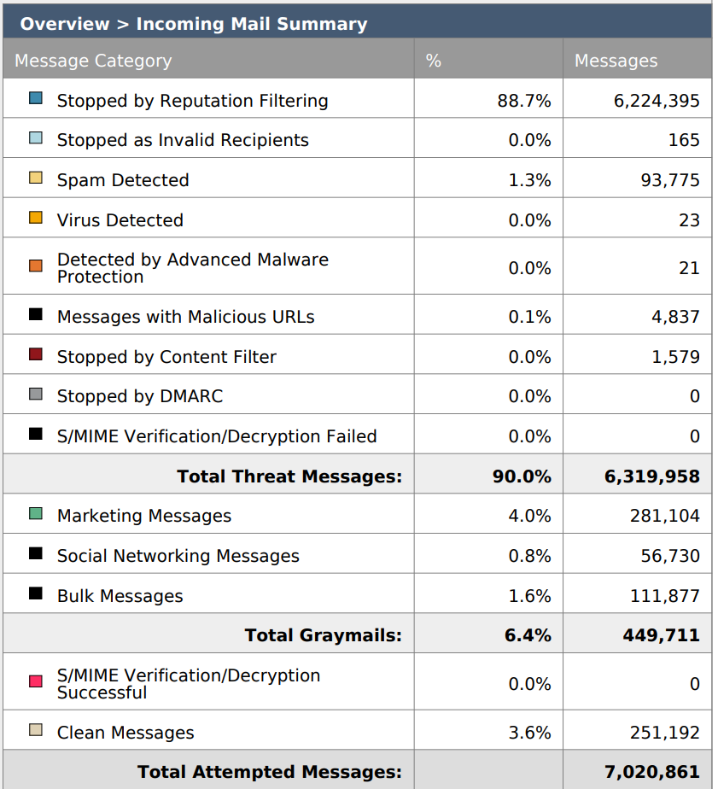

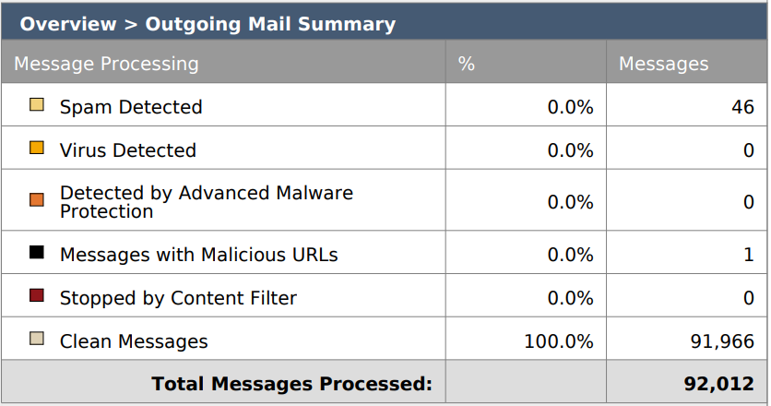
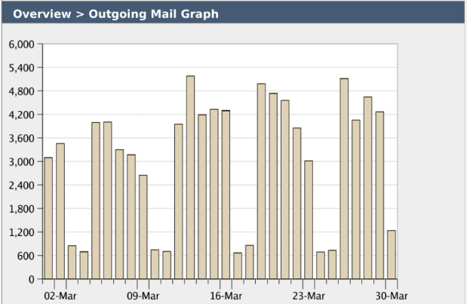

Website Security Metrics:
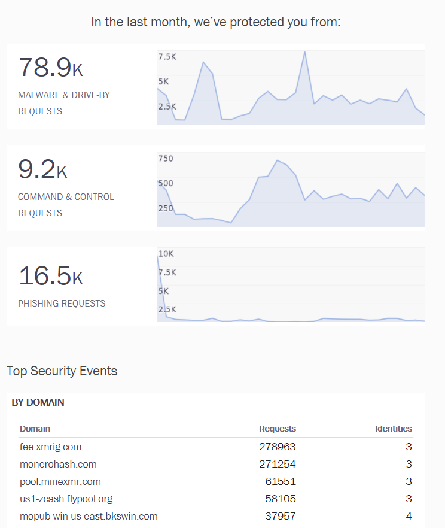

University Writing Center Report
Academic Support Services Subcommittee
Submitted by Dr. Brandy Lyn Brown, Director of the University Writing Center

April 10, 2018

Activities and Projects – March

- Internal Assessment project meetings and check-ins
- Classroom visits

Usage Information: March 1- April 9 (Spring 2018)

    - 312 total consultations | 2017 379 total consultations
    - 167 individual writers | 2017: 131 writers
    - 64 online consultations | 2017: 46 online consultations
    - 53% of unique clients visited one time |
2017: 64% of unique clients visited one time
    - 47% of unique clients visited more than one time |
2017: 36% of unique clients visited more than one time.
    - 73 new clients registered | 103 new clients registered
    - Ratio of Genders (new category): 119 Female; 60 Male;
    - Total number so far: 673 | 2017: 835

Student Satisfaction Survey (66 responses)

Responses:
I really left the Writing Center feeling better about writing than I have prior to me attending the center.

I wished I had gone in the beginning for brainstorming.
Excellent help every time I go in for revisions.

The consultant was very helpful and I will be returning to the writing center.
Spring 2018 Staff
Brandy Lyn G. Brown, Director

Graduate Student Assistant Directors:
- Brittani Allen (Education)

Undergraduate Tutors:
- Erin Duprey (English)
- Yuri Moore (English Education)
- Citori Swink (Secondary Education)
- Jordan Williams (English)
- Angela Baker (English)
- Tonia Hunt (English)
- Heather Boggess (Psychology)

