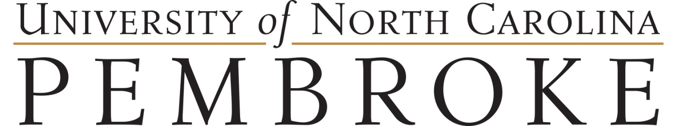

Bank Letter Request Form
If you will set up a bank account with a U.S. banking institution you will need to provide a letter noting your mailing and physical address. Complete this form and provide it to The Office of Global Engagement (OGE) so that the letter can be generated. Please PRINT your information below. This information will be used to generate your letter and must be accurate. You can collect this letter from OGE 2 business days after submission.

LAST Name: _____________________________________First Name: _______________________________

Date you started at UNCP: _______________________________

Name of the bank where you will set up an account ________________________________________________

Current U.S. Physical Living Address

__________________________________________________________________________________________
__________________________________________________________________________________________
City State Zip

Current U.S. Mailing address

__________________________________________________________________________________________
__________________________________________________________________________________________
City State Zip

_______________________________________________ __________________________________________
Signature Date

