The University of North Carolina at Pembroke
Academic Information Technology Committee (AITC)
Agenda - Monday, January 14, 2019 at 3:30 p.m.
Chavis University Center 208

Members of the AITC:
Aaron Vandermeer (Chair), Senator
Conner Sandefur, Senator
Larry Arnold (ARTS, 2020)
Lisa Mitchell (EDUC, 2020)
Walter Lewallen (LETT, 2019)
Jesse Rouse (NSM, 2019)
Mohammad Rahman (SBS, 2020)
Nancy Crouch, CIO
Joy Fuqua, Director of Online Learning
Terry Locklear, Instructional Designer
Debbie Bullard, Representative of the Accessibility Resource Center
Dennis Swanson, Representative of the Library
Tremain Ingram, SGA Senator

Order of Business
A. Roll Call
B. Approval of Minutes (Appendix A)
C. Adoption of Agenda
D. Reports
- AITC Chair—Aaron Vandermeer
- Executive Director of University Communications and Marketing—Jodi Phelps
- AVC for Technology, Resources and Chief Information Officer—Nancy Crouch
- Director of Online Learning—Joy Fuqua
- Library Report—Dr. Dennis Swanson (Appendix B)
E. Unfinished Business
- Course Evaluations/Scantrons (Nancy Crouch)
- Standard Template for Online Programs (Joy Fuqua and Terry Locklear)
- Getting Feedback on Classroom Upgrades (Nancy Crouch)
F. New Business
- LTI Requests (Appendix C)
  - CourseEval
  - Capsim
  - WebEx
- Faculty Training for Online Teaching (Dr. Scott Hicks)
- Placing Instructions Online for Instructional Technology (Jesse Rouse)
G. For the Good of the Order
H. DoIT Technology Report for AITC: (Appendix D)
I. Announcements
J. Adjournment
Appendix A—Minutes Draft of November 12, 2018
The University of North Carolina at Pembroke
Academic Information Technology Committee (AITC)
Minutes - Monday, November 12, 2018 at 3:30 p.m.
Chavis University Center 208

Members of the AITC Present:
Aaron Vandermeer (Chair), Senator
Conner Sandefur, Senator
Larry Arnold (ARTS, 2020)
Lisa Mitchell (EDUC, 2020)
Walter Lewallen (LETT, 2019)
Jesse Rouse (NSM, 2019)
Mohammad Rahman (SBS, 2020)
Nancy Crouch, CIO
Joy Fuqua, Director of Online Learning
Terry Locklear, Instructional Designer
Debbie Bullard, Representative of the Accessibility Resource Center
Dennis Swanson, Representative of the Library
Tremain Ingram, SGA Senator

Members Absent:
None
A. Roll Call
B. Approval of Minutes (Appendix A in Agenda)
The minutes were approved as disseminated.
C. Adoption of Agenda
D. Reports
- AITC Chair—Aaron Vandermeer
- Presented DoIT activities to senate
- Task stream, Indiana University knowledge base has best documentation
- Electronic portfolios, FERS, try to use to use Canvas for a portfolio tool
  - Canvas or other option (Office365, Digital Measures, etc as options)
  - Look at portfolio options at January meeting
- Canvas limit is 1GB per course

- AVC for Technology, Resources and Chief Information Officer—Nancy Crouch
- Introduction to Wes Frazier, Tabitha O. Locklear, and Ray Buehne as leads of LMS
- Quarterly portfolio link sent to committee and available online
  - Able to project out 18 months on projects
  - Anticipated projects are growing
- Funding and security tied to Computing report

- Director of Online Learning—Joy Fuqua
- Quality Matters
  - What levels of support for faculty?

E. Unfinished Business
- Quality Matters Information and discussion (Appendix B in Agenda)
- Terry Locklear: Not sure where UNC System is with subscription (duration)
- Possible to have external review through QM
- Working with individual departments to schedule workshops
- Aaron – possible that Faculty Senate might suggest that new online faculty first receive training
- Perhaps create broader training or even differently levels of certification for campus online faculty
- Standardized course content and structure might simplify materials for students

- Course Evaluations/Scantrons (Appendix C in Agenda)
- Nancy Crouch: scantrons are reaching end of life
  - Scantron machines can be replaced if needed, but is it the best option?
- Many departments are already requesting online evals, but not this supported in handbook
- Canon copiers may offer an option to move away from scantron
  - Possible test cases - Psychology and Biology use scantron
- Digital course responses in 22-25% range
  - If moving SEIs online, we should have a way for students to opt-out instead of opt-in
  - Student representative to take the idea to the SGA and bring forward
  - Digital would allow faculty to compare consistency, not just in the department but across broader contexts (WE courses, Freshmen, etc), would allow for easier archiving and access, would reduce administrative assistant time
F. New Business
- LMS Third Party Integration Procedure (Appendix D in Agenda)
- Proposal to approve passed 12-0-0
- Aaron will verify that AITC LMS decisions do not need to be voted on by the senate

- LTI Request - WEPA (Appendix E in Agenda)
- Proposal to approve passed 12-0-0
- Launching Beta features in Canvas
- Example, quizzes.next and beta gradebook
- Should these be turned on?
- Should we create a Rubric to guide DoIT to select which need to come to the committee?
- Use of test environment for those interested in trying features before turning them on in active classes
- Instructure will turn things on as they like
- Will consider how to proceed

- Classroom Instructor Machines
- Lenovo Tiny for classrooms
- DoIT will send out specs for the machines

- Updating online program templates for consistent navigation
- Will transition the discussion to next meeting in January
G. For the Good of the Order
Library
- New library enterprise system under consideration
- Presentation will be made by a streaming video service
- Stack Map for locating materials in library is moving forward
H. Announcements
Tremain will remain on the committee for Spring as SGA representative
I. Adjournment

The meeting adjourned at 4:54

Minutes submitted by Jesse Rouse.

Return to Agenda

Appendix B—Library Report
Submitted by Dennis Swanson

We have signed the contract and are moving forward on implementing a new Integrated Library System (Alma from Ex Libris), along with this will come Primo, which will supplement and enhance the Summon universal search structure we already have in place. We will also be getting Leganto, which is the tool that will integrate the library system into Canvas. Most of the implementation will be invisible to everyone. By about April I plan to begin having orientation and instruction for faculty. Our plan right now is that the system will go live on July 1.

We are also working to implement Stacks Map. This is a program that will tag each library record so that you will be able to see a graphic map telling you which shelf in the library any particular book or item is located.

Return to Agenda

Appendix C—LTI Requests

- CourseEval, submitted by Wes Frazier, January 2019
See also CoursEval-VPAT.pdf as distributed with Agenda 19.01.14 AITC Agenda (rev1)
Role
CourseEval provides an online digital equivalent to offline paper based end of semester course evaluations. It is already employed and in use by Online Education. We are seeking to directly integrate it into Canvas.

Nature of Vendor
CampusLabs Inc. Is a relatively young organization which has been operating in this space for ten years. A subsidiary of Edcentric, Inc. and a portfolio company of Leeds Equity Partners, LLC. Their products and services are entirely along student feedback and service analytics. They currently provide services to over 1,400 campuses nationwide including institutions smaller and larger than our own.

Benefits to Campus
CourseEval is already a purchased tool in use by this University and is heavily used by Online Education to facilitate evaluations online. This integration should streamline the experience for students while also reducing the amount of work Online Education must perform to facilitate its operation. Freeing resources for other projects.

User Experience
It operates much like other external tool links in the navigation area of a course. It can be moved or hidden by the instructor. Student use of the product is much like an online survey in Qualtrics / Microsoft Forms / Google Forms. This integration will simply facilitate students accessing the survey directly within Canvas in a more convenient way.

Cost/Funding
No additional funding needed.

Existing Functionality
Its features are wholly unique compared to all other in use LTIs at this time.

Legal Concerns
CoursEval will have no additional data collected from students than the current system already possesses. Student anonymity and privacy will be protected by the current agreements already employed in its current use.

Security Concerns
Capsim is in the Canvas App database and is not a recognized Canvas partner. There are no security concerns at this time.

Accessibility Concerns
The integration of CoursEval itself has no accessibility concerns specific to it. It merely acts as “glue” between Canvas and CoursEval. CampusLabs itself has provided a VPAT report on the entire CoursEval product which is included in the supplemental documents folder. ARC was given a chance to review this document and had no specific reservations about CoursEval’s VPAT report; they however have requested to test CoursEval ahead of time with current accessibility software and tools. According to Online Education we have technical limitations preventing us from setting up a fake course or users in our current CoursEval environment which prevents us from doing this. CampusLabs Inc. is quite positive their product is compliant with screen readers and other assistive tools as stated in their VPAT report.
Technical Concerns
None at this time.

Recommendations
The integration itself has no specific accessibility issues and integrating the product into Canvas is likely to make the software easier to get to, for all students. Assuming the issues with our inability to test using our active instance of CoursEval are of sufficiently small concern, IT recommends proceeding with the integration.
__________________________________

b) Capsim
Wes Frazier, June 2018; Revised: November 2018
See also Capsim VPAT General 2016…pdf as distributed with Agenda 19.01.14 AITC Agenda (rev1)

Role
Capsim's Capstone product is used within business courses to conduct simulations, so students can try out the actual business theories from class in detailed simulations, cooperatively or individually under an instructor's guidance.

Nature of Vendor
Capstone has been in the business simulation business since the mid 80s, though their modern offerings targeting academic course work have been running since 2001.

Benefits to Campus
Capsim's products including Capstone are narrowly geared towards business simulations and would not be applicable to many fields of study outside of school of business. As of today only one instructor is seeking to make use of this software.

User Experience
As it stands today Capsim's integration with Canvas is very loose. It largely uses our LMS as an integrated single signon portal, and for the instructor to present Capsim beside other course content. Capsim would appear as an item in the course navigation, but not the global navigation bar. No assessments or grading takes place today, though Capsim has indicated they are working towards these goals in the future.
Cost/Funding
No additional funding needed.

Existing Functionality
It's features are wholly unique compared to all other in use LTIs at this time.

Legal Concerns
No FERPA protected data is collected, however students email addresses are collected from Canvas, in part to facilitate the single sign on and in part because Capsim facilitates some email notifications to students using its product. Capsim could not provide any data security policies outside of their web privacy agreement here: http://capsim.com/terms/#/policy

Security Concerns
Capsim is not in the Canvas App database and is not a recognized Canvas partner. They also could not provide an LTI Conformance Certificate. This is unusual and we have no trusted way of verifying their LTI is in compliance with standards or usual security precautions at this time.

Accessibility Concerns
Capsim has provided a VPAT report. Their current products accessibility issues are too numerous to list here, but the full VPAT report is included in the supplemental documents folder alongside an annotated VPAT report by ARC. The VPAT report has not been updated since 2016. Capsim believes they can address ARC’s concerns in the short term but cannot produce a written document to that effect.

Technical Concerns
None at this time.

Recommendations
The lack of even a LTI conformance certificate and no security documents besides their company's web privacy agreement for student contact information is troubling. Combined with the accessibility report makes it difficult to recommend this LTI for inclusion at this time.
__________________________________
c) WebEx
Tabitha O. Locklear, January 2019
Role
Making learning intuitive. Cisco Webex brings the capability to build courses that can be linked directly to WebEx teams using the education connector. Instructors and students will have the ability to access recorded lectures, assignments and more from within Canvas.

Nature of Vendor
Cisco Webex, formerly WebEx Communications Inc., is a company that provides on-demand collaboration, online meeting, web conferencing and video conferencing applications. All WebEx products are part of the Cisco Systems collaboration portfolio. WebEx has been around since 1996 later purchased by Cisco in 2007. The University is currently familiar with Cisco Webex and many of its features, although it has never been integrated with our LMS.

Benefits to Campus
Students and Faculty will benefit from being able to access Webex from within Canvas. Students will be able to collaborate via desktop, video device, tablet, or smartphone from anywhere, on campus or off. Faculty can use Cisco Webex meetings natively within Canvas to schedule class meetings, hold virtual office hours, create project groups, share content, record lectures, and more.

User Experience
Webex fully integrates with Canvas. The user experience should be very similar to what the user has already experienced with Webex.

Cost/Funding
Webex Education Connector comes for free for Webex customers

Existing Functionality
Webex Education Connector works much like Cisco Webex Teams. Users will use the same features but within Canvas.

Legal Concerns
None

Security Concerns
None. Webex meetings, events, training, and remote support products are protected by a highly reliable and secure network.

Accessibility Concerns
ARC and DoIT are working with Cisco to identify and remove access barriers.

Technical Concerns
LTI integration seems seamless, but there are concerns with faculty training.

Recommendations
DoIT recommends proceeding with the integration. DoIT would recommend extensive testing after implementing by faculty due to the user experience and inform the help desk of any issues with the functionality of WebEx in Canvas.

Return to Agenda

Appendix D— DoIT Technology Report for AITC (December 10, 2018)

Division of Information Technology Report
Academic IT Committee
December 10, 2018
Project Portfolio Updates
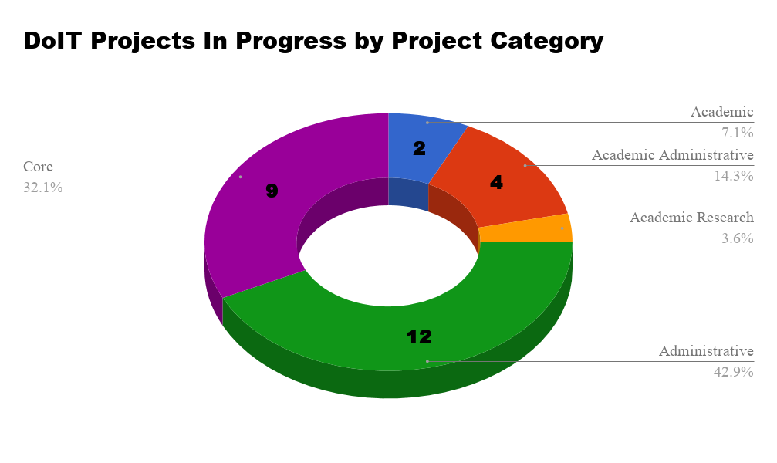
Projects and Efforts of Academic Interest
- Instructional Spaces Infrastructure 2019 - UNCP must provide faculty, staff, and students with high-quality technology for instruction, learning, research, work productivity, and creative endeavors. This project focuses on the goals of creating a sustainable, predictable, and dependable model for identifying, procuring, and managing instructional space infrastructure at UNCP. 23 classrooms were updated last academic year, FY 17 - 18. The instructional infrastructure in the remaining 200 plus rooms remains out of warranty and dated. To establish a refresh cycle to keep the infrastructure up to date continues to be established. Funding for this project will be a combined pool of state and fee-based funding. Instructional Spaces infrastructure technology is funded through Education & Technology fees and appropriated state funds provided by the University. We plan to update over 30 spaces in this round, accomplishing the updgrades over Christmas break, Spring break, and summer 2019. Anticipated go live is scheduled for August 2019.
- Password Reset Utility – This project implementation will create a self-service application, that will allow campus users to reset and/or recover their password. The application should take into consideration accounts that have been locked due to failed login attempts and/or expired passwords. It should also provide robust feedback on account status. i.e. Disabled account. We would also like to include additional recovery options. (Mobile Device, Email, etc.). Kickoff for the project, is scheduled for this month, with an anticipated go live is scheduled for Summer 2019.
- Windows 7 and Office 2010 End of Life – Microsoft will cease providing all support for the Windows 7 operating system on January 14, 2020 and Office 2010 on October 13, 2020. This means Windows 7 and Office 2010 will no longer receive security updates from Microsoft and will be extremely vulnerable to malware and outside attacks. Many of our campus computers have already been migrated to Windows 10, including all standard lab and classroom machines and many office production desktops/laptops. PCs purchased in the in the last two years arrived already imaged with the Windows 10 operating system. Additionally, any PC that was reimaged recently was migrated to Windows 10, unless there was a compatibility issue with the device, a required business application or attached equipment. Any PC reimaged in the future will receive Windows 10, unless there is a compatibility issue. However, many machines on campus are still in need of transitioning to Windows 10 before January 2020. DoIT’s ITSS will be spearheading the endeavor to migrate all remaining Windows 7 machines by October 31, 2019. In the event that any machine cannot be migrated due to the machine’s inability to run Windows 10, DoIT will work with the individual department to identify affected machines for replacement. If a particular application or device will not run on Windows 10, we need the assistance of each department in helping them upgrade the necessary software or equipment so it can be used with the newer operating system. Any computer that is running Windows 7 on January 14, 2020 will be disconnected from the campus network, both wired and wireless, and will have no further network access until the upgrade is completed or the computer is replaced.

Resolution of Incidents November 2018
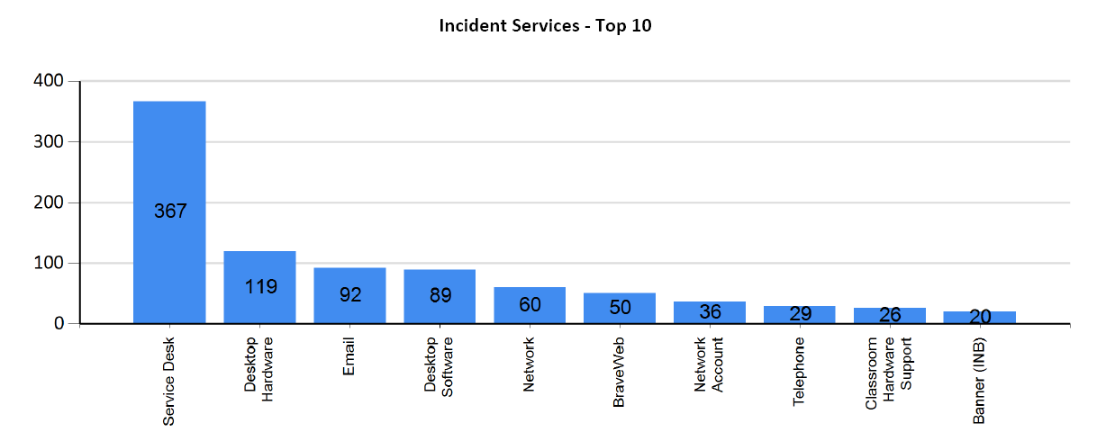
Number of Incidents Resolved in November 2018: 656
Calls Presented to the Help Desk November 2018: 1,006
Interactive Video Facility
The Interactive Video Facility provides services to the campus community in a variety of service categories. Please see the chart below depicting the number of hours of service provided during this reporting period in each category.
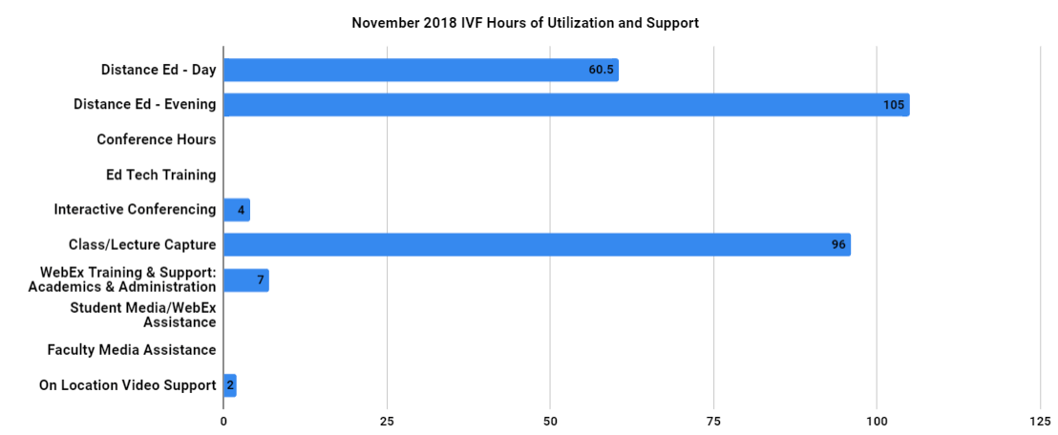
Canvas Support Tickets to Instructure by Type – October 2018
Email | Live Chat | Online Submission | Phone | Total
0 | 26 | 10 | 54 | 80

*DoIT will continue to work with Instructure (the Canvas vendor) to gather appropriate data on their support services and our campus's experience.
IT Security Summary Report
Executive Email Summary – November 1st – 30th 2018
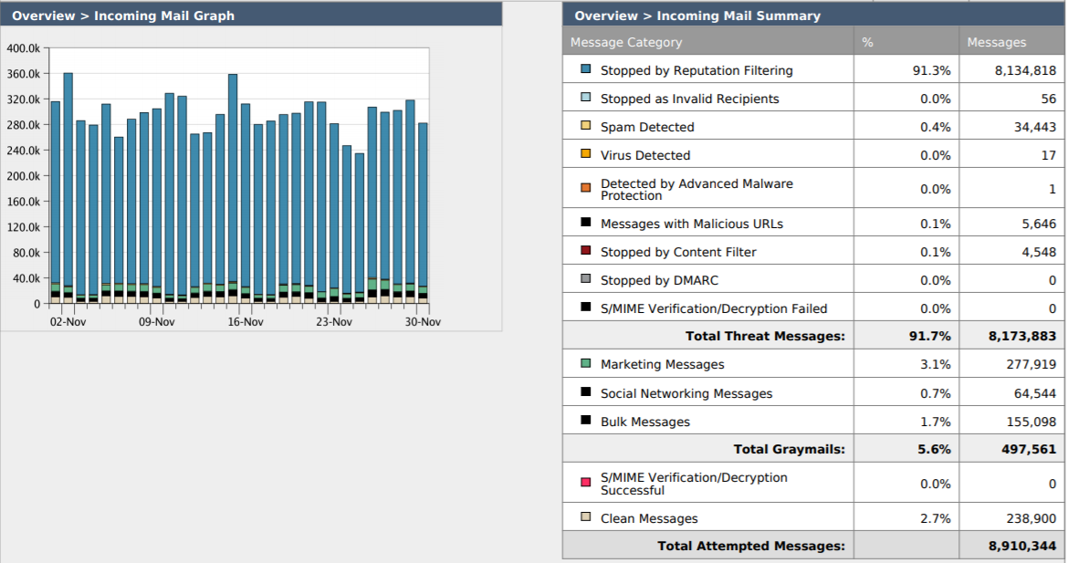
For November, there was an increase in messages being blocked by reputation filtering. The exact cause of this increase is unclear. Reputation filtering represents most blocked emails. Notable, as well, are the number of messages stopped due to containing malicious URLs. Malicious URLs in emails constitute a major security risk should these emails reach their intended recipients, as simply clicking on a malicious URL can cause malware to be installed and / or executed.
Vulnerabilities – For the month of November 2018
The first chart in blue shows the number of computers with vulnerable applications with a CVE (Common Vulnerabilities and Exposures), per day and the number of critical, high, and medium severity vulnerabilities within these applications per day. The second chart in red shows the number of vulnerable applications that have been executed, moved, or copied, and the number of vulnerable university owned computers. DoIT intends to purchase and implement a patch management solution in 2019. This tool will help us proactively address these vulnerabilities on university owned computers.
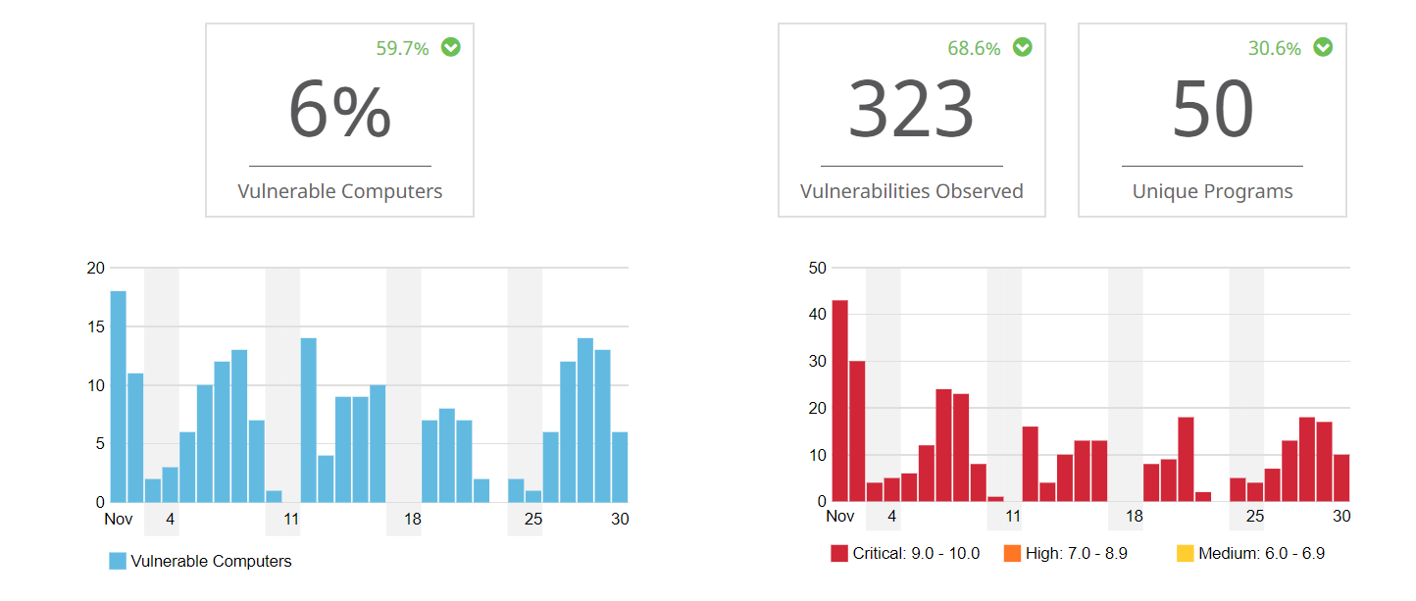

AMP File and IP’s Scanned – November 1st – 30th 2018
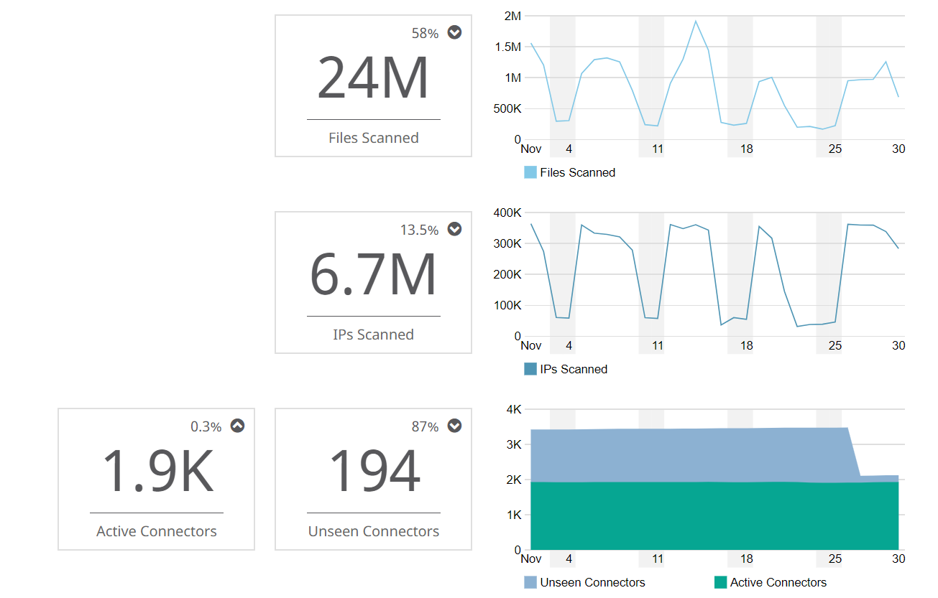

Virtual Sandbox Submissions November 2018
Using the security tools we already own, the IT Security Team was able to setup an automated file submission process in a protected environment in the cloud. This capability allows us to free up valuable time that would normally be spent manually uploading these files in order to determine their threat score.
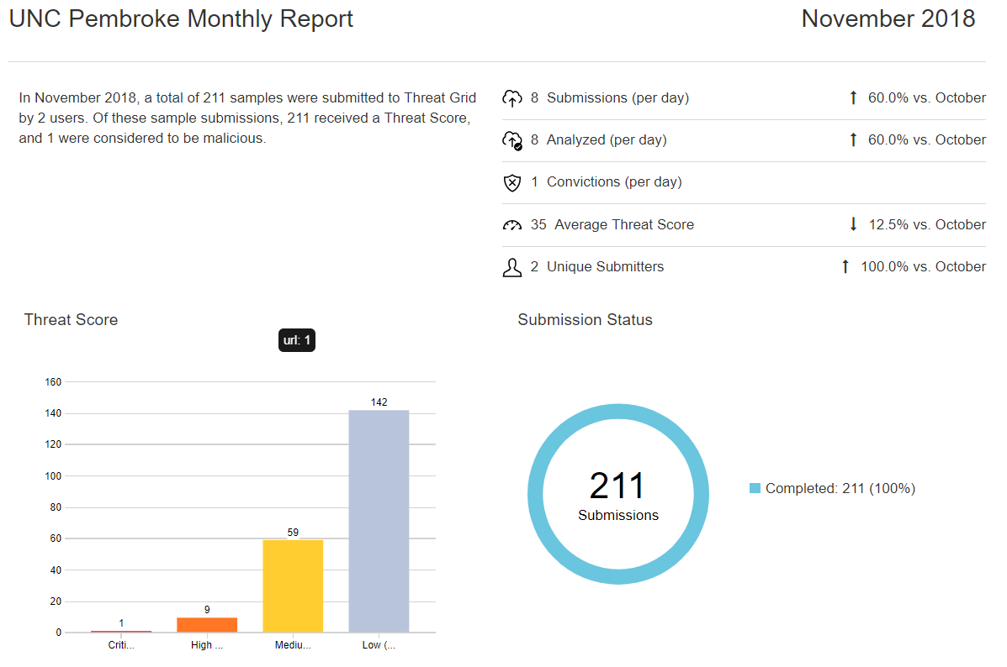
Number of New Compromises Reported in AMP / Compromises Resolved – November 2018
Notable for November 2018 are the efforts to not only keep up with current compromises but catching up on compromises resolved during the hectic period after Hurrican Florence and having that reflected in AMP. It should also be noted that ITSS is taking over daily responsibility for mitigation of compromised endpoints. A RACI has been developed outlining responsibilities of each team in DoIT for AMP. This should result in more rapid mitigation of compromised endpoints, as well as more responsive policy adjustment in response to threat intelligence.
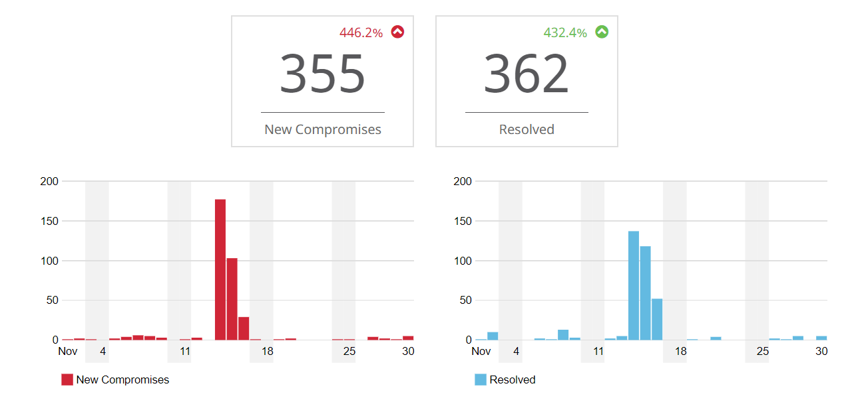
Security Activity as Noted in Umbrella / OpenDNS – November 2018
Showing the number of blocked requests in Umbrella / Open DNS in a tabular, instead of graphical, format may be more illustrative of the value of Umbrella / OpenDNS in keeping our data and networks secure. Blocking UNCP-owned computers from making outbound requests to known malicious IP addresses prevents the download and / or full execution of malware by preventing those computers from responding to these sites and receiving further instructions or completing a request for malware-containing content.
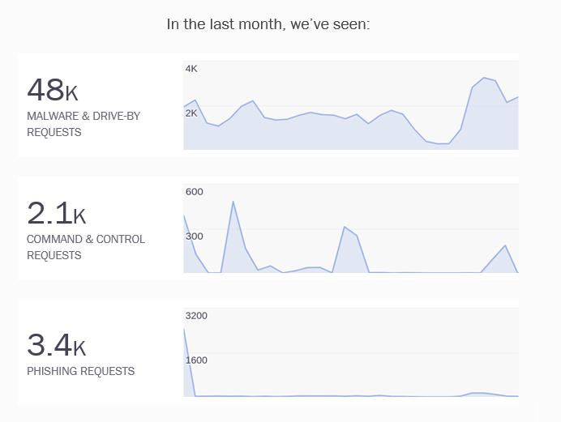

DUO Activity - November 2018
There were 1000+ DUO authentication attempts in the last 30 days with an 80.3% success rate. Unsuccessful attempts can be due to user cancellation, wrong code or failure to click to authorize a DUO Push. The use of two-factor authentication is increasing due to the need to access resources that require VPN when outside our network. Two-Factor authentication is required for such access.

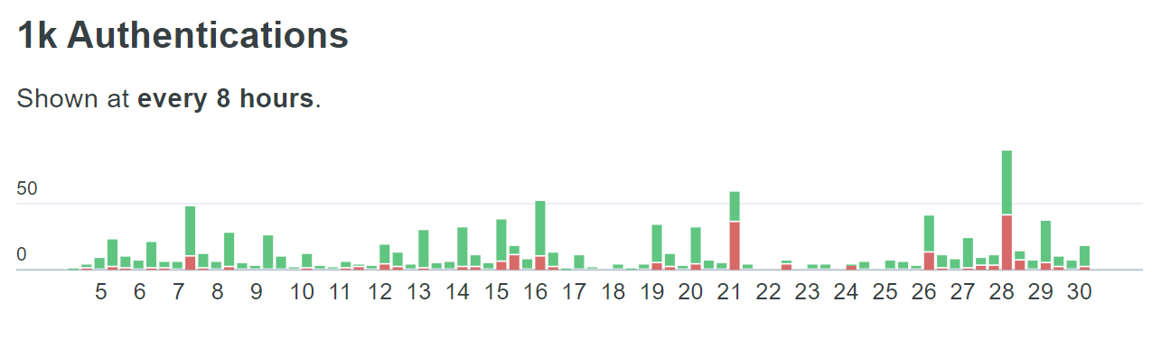
Authentication Attempts on a Daily Basis (Green – Successful / Red – Unsuccessful)

