Faculty & Institutional Affairs Committee (FIAC)
Tuesday, February 19, 2019 at 3:30pm
University Center 213

Meeting Notes

Committee Members:
Heather Kimberly Dial (Senator)
Windy Miller (Senator)
Nathan Phillippi (Senator)
Melissa Schaub (Senator)
Robin Snead (Senator)
Sally Vallabha (Senator)
Larry Arnold (Chair; Faculty Evaluation & Review Subcommittee)
Autumn Lauzon (Chair; Faculty Development & Welfare Subcommittee)
Walter Lewallen (Chair; Health, Safety and Environment Subcommittee)
Scott Billingsley (AVC for Academic Affairs)
Bryan Robinson (VC for Advancement)
Stewart Thomas (VC for Finance & Administration)
Ottis Murray (Chair; Faculty & Institutional Affairs Committee)

Order of Business
- Call to Order : 3:41
- Approval of Minutes from January 15, 2019: Approved
- Approval of Agenda: Approved
- Report from the Chair
- Library: mistakes have been made. Things have been worked on to make sure that they do not happen again. There is an organization chart associated with it.
- There is a threat assessment form that is available thru Ottis.
- Commencement: Recipients of the board being honored by having a seat on the dais
- Request to keep email for retired professors.
- Health science search underway and will be taking place later this week.
- Library workers now have faculty status.
- Student evaluations and Faculty portfolio will be online

- Reports from Administrators
  - Vice Chancellor for Finance & Administration
- Absent/no report

  - Vice Chancellor for Advancement
- Completed all the town halls to collect info on campaign priorities. Spend the next months to write up the changes that the mission of the school of colleges and fundraising priorities. Work with deans of the college to work out goals for each of the schools and colleges.
- Will wrap up the staff hiring by this summer.
- March 21st is the 24 hour campaign. Primarily digital instead of meeting in the UC. Sending out notices to deans to determine how the department will want to handle the distribution of funds. Do what you feel that you can do (give).

  - Associate Vice Chancellor for Academic Affairs
- Enrollment update
- Electronic faculty and student evaluations
  - AITC has two ad hoc groups working on each of these
- CHS Dean candidates visiting campus over the next few weeks
- Library
  - Open House April 7 from 2:00-4:00
  - Special Collections in not closing
- Construction/Renovation projects
  - Old infirmary – AMO and Graduate School – complete August 2019
  - West Hall – Abatement should begin next month
  - School of Business
    - Groundbreaking in April
    - Real construction begins this summer
- Courtyard Apartments
  - Project about to kickoff
  - Should have additional beds by August 2019
- Weinstein Health Sciences Building – Noise/vibration – complete in May 2019
- Dial Upfit – technology and furniture in classrooms and hallways

- Reports from Subcommittees
  - Faculty Development & Welfare
- Half the committee did not show up. Worked on office hour suggestion and not much was remembered about the brave kickoff, the history portion will be kept because it is important. It deals with the school mission or vision but no actionable items. These is a committee for planning it in the future.
- Talked about the parking issue in the future for faculty and staff vs. students. Use is being looked into. Email Travis Bryant to see what the UNCPD has for information.
- Compliance training will be changed and reduced and be made more relevant. You can print out your certificates from previous training.

  - Faculty Evaluation & Review
- Moving forward for the electronic portfolio and the IT committee will be making the decision on the software.
- There are two separate committees for the student evaluation and the faculty evaluation.
- Request through FIAC for the schedule of the student evaluation of teachers to be looked at to make it every other years. Requires no new revisions

  - Health, Safety & Environment
- Active shooter link on the homepage was not working. But it is fixed now. Michael Bullard got it fixed within two hours.
- Still no door locks for certain rooms on campus.
- 911 locations on campus. See the Excel document. This is being addressed.
- No emergency service is 20 minutes away. Student health services cannot do anything for faculty. Will discuss this in the committee next month. Mcduffy Cummings is also looking into this.
- Call 911, then campus police. Have someone to meet the emergency services in the parking lot to help direct to the situation? Change signs in the classroom to reflect this.

- Unfinished Business
  - Faculty Office Hours Policy
- Approved by vote for all yes, no nay. Sent to senate with new changes.
[Extended time for 10 minutes 4:57 pm]
  - Disciplinary Statements/Protocol
- Proposal accepted as written all in favor, no nays’ no abstain

  - Campus Safety
i.
ii.

iii.

iv. LiveSafe Mobile App ) hyperlink

  - Interpersonal Violence Statement

- New Business
- none
- For the Good of the Order
- none
- Announcements
- none
- Adjournment At 5:00 pm
The next meeting will be held at 3:30 pm, March 19, 2019.

Attachments
- Faculty Office Policy

From the Faculty Handbook (2018-2019) – OLD
In addition to teaching, each member of the faculty must maintain a minimum of five office hours a week in order to be available for academic advisement and to meet students for consultation. It is strongly recommended that the advisor be in the office at least one hour each day. The office hour schedule is to be posted on the faculty member's office door so that students may make arrangements for conferences. Each Department Chair is to have a complete class and office hour schedule for each faculty member of the department. Faculty members must be in their offices and available to students during advisement week, registration (except when assigned to registration duties elsewhere), and the drop-add period.
NEW
In addition to teaching, each member of the faculty must maintain a minimum of five office hours a week in order to be available for academic advisement and to meet students for consultation. Office hours may involve a combination of face-to-face office hours (three hours minimum) and designated virtual office hours facilitated through synchronous technologies. Faculty teaching a combination of face-to-face, hybrid, and/or online classes should have a minimum of three face-to-face office hours per week. Faculty teaching exclusively online may hold virtual-only office hours with the approval of the Department Chair. It is strongly recommended that the advisor be in the office at least one hour each day. The office hour schedule is to be included on all course syllabi and posted on the faculty member's office door so that students may make arrangements for conferences. Each Department Chair is to have a complete class and office hour schedule for each faculty member of the department and is responsible for ensuring that the office hours are published online. Regardless of teaching assignment, fFaculty members must be in their offices and available to students during advisement week, registration (except when assigned to registration duties elsewhere), and the drop-add period.
READABLE
In addition to teaching, each member of the faculty must maintain a minimum of five office hours a week in order to be available for academic advisement and to meet students for consultation. Office hours may involve a combination of face-to-face office hours (three hours minimum) and designated virtual office hours facilitated through synchronous technologies. Faculty teaching exclusively online may hold virtual-only office hours with the approval of the Department Chair. The office hour schedule is to be included on all course syllabi and posted on the faculty member’s office door so that students may make arrangements for conferences. Each Department Chair is to have a complete class and office hour schedule for each faculty member of the department and is responsible for ensuring that the office hours are published online. Regardless of teaching assignment, faculty members must be available to students during advisement week, registration, and the drop-add period.

B. Disciplinary Statements/Protocol
From p. 72, Faculty Handbook [additions in green, original in black]
As can be seen, The Code prohibits the mechanical use of “checklists” in faculty evaluation. Thus, Disciplinary Statements should not take a checklist form nor should they state a candidate must complete a specific number of activities in a particular area of evaluation in order “to be eligible” for tenure and/or promotion. Further, while evaluators are strongly advised to take the department’s Disciplinary Statements into account before rendering an evaluation, the above section of The Code also states evaluators should draw on their own experience. As a result, faculty should not assume these statements are binding on evaluators.
Used properly, Disciplinary Statements offer useful insights into specific expectations within a discipline and/or department. The statements are not a vehicle for creating substantially new or more stringent requirements for faculty nor can they be used to create new faculty evaluation procedures that go beyond the general requirements laid out in the Faculty Handbook in Section II, Chapter 2, Faculty Evaluation Policy and Chapter 3, Faculty Tenure and Promotion Policy. Rather, Disciplinary Statements are intended to ensure a common understanding of the ways university expectations for faculty apply across heterogeneous disciplines and departments. Departments that prefer to substantially modify criteria or procedures are strongly encouraged to develop a Departmental Evaluation Plan described in the subsection entitled, “Optional Departmental Evaluation Plan.”
Combined academic departments may develop an overall set of Disciplinary Statements that incorporate expectations for each departmental discipline or may choose to develop a separate set of statements for each discipline. Departments offering more than one degree program may choose to develop subsets of program-specific statements if department members believe such subsets are warranted.
All Disciplinary Statements must be approved by the Dean and the Provost prior to implementation. Disciplinary Statements should be reviewed by academic departments not less than once every five years to ensure they remain an accurate representation of the department’s expectations.
The Provost and Vice Chancellor for Academic Affairs will notify Department Chairs in August of the academic year in which departmental review of the Disciplinary Statements should take place. The departmental review of the Disciplinary Statements may result in approval of the statements already in use, or in changes that departmental faculty may formulate. The Disciplinary Statements, including revisions, should be approved by a majority of the General Faculty members in the department and signed by the Department Chair. If a majority of departmental faculty does not approve the revisions the current Disciplinary Statements will remain in effect. The Department Chair records the department vote count in the appropriate section of the Disciplinary Statements before submitting them to the Dean and the Provost and Vice Chancellor for Academic Affairs.
While changes may be made more often than every five years if exigent circumstances warrant, statements should be reasonably consistent across time so that evaluations are not affected by temporary, arbitrary, or radical changes. Departments may initiate the review of Disciplinary Statements by notifying the Provost and Chancellor for Academic Affairs no later than the first day of the academic year during which revisions are to be considered. All revisions must be completed by March 1 so that faculty undergoing evaluation in the next academic year will have ample time to prepare.
All revisions must be approved by the Dean and the Provost and Vice Chancellor for Academic Affairs prior to implementation. Under normal circumstances, revisions approved during an academic year will become effective at the start of the following academic year. The Office for Academic Affairs maintains an online listing of all approved Disciplinary Statements and their effective dates for examination by all faculty and evaluators. Older sets will be archived online.
Under normal circumstances, when faculty members undergo review (e.g., tenure, promotion, and annual) the evaluation is guided by the Disciplinary Statements in effect in their department at the time of the evaluation. However, if a department revises its Disciplinary Statements a faculty member may elect to be evaluated under the previous set of Disciplinary Statements without penalty for a period of up to two academic years after the effective date of the new Disciplinary Statements. In such cases, the faculty member should notify his or her Department Chair in writing within 30 calendar days of the effective date of the new Disciplinary Statements. This letter must indicate whether a one or two-year grace period has been elected. If a tenure and/or promotion review occurs during the grace period, a copy of the faculty member’s letter to the Department Chair should be included in the portfolio. In no case will a faculty member be permitted to be evaluated for any purpose under a portion of an older set of Disciplinary Statements and a portion of a newer set of Disciplinary Statements.

- Campus Safety

  - 911 Building Addresses
AUXILIARY SERVICES BUILDING | 270 | FACULTY |  | ROW
BELK RESIDENCE HALL | 81 | FACULTY |  | ROW |  | Green | Residence Halls
BRAVE HEALTH CENTER | 113 | HAWK |  | DR |  | Yellow | Athletic Fields
BUSINESS ADMINISTRATION BUILDING | 185 | FACULTY |  | ROW |  | Orange | Name to be determined
CARTER HALL | 200 B | ODUM | N | ST
CATON FIELDHOUSE | 316 | UNIVERSITY |  | RD
CHANCELLORS RESIDENCE | 1223 | OLD MAIN |  | RD
CHAVIS UNIVERSITY CENTER | 209 | ODUM | N | ST
COX FIELD (BASEBALL) | 296 | BRAVES |  | DR
CYPRESS RESIDENCE HALL | 62 | BRAVES |  | DR
D.F. LOWRY BUILDING | 136 | FACULTY |  | ROW
DESCRIPTION | NUMBER | STREET |  | TYPE
DIAL HUMANITIES BUILDING | 379 | BRAVES |  | DR
DOGWOOD BUILDING | 27 | DOGWOOD |  | LN
EDUCATION CENTER | 141 | FACULTY |  | ROW
FOOTBALL PRACTICE FIELD | 157 | CHEVELLE |  | DR
GIVENS PERFORMING ARTS CENTER | 359 | PROSPECT |  | RD
HICKORY HALL | 37 | FACULTY |  | ROW
INTERNATIONAL PROGRAMS | 34 | DOGWOOD |  | LN
INTRAMURAL FIELD | 1099 | PROSPECT |  | RD
JACOBS HALL | 42 | PSU |  | CT
JONES HEALTH AND PHYSICAL EDUCATION | 176 | UNIVERSITY |  | DR
LINDSEY HALL | 200 A | ODUM | N | ST
LIVERMORE LIBRARY | 40 | FACULTY |  | ROW
LOCKLEAR HALL | 47 | ALUMNI |  | LN
LRA EMC SOCCER FIELD | 18 | FACILITIES |  | DR
LRA FIELD (SOFTBALL) | 270 | BRAVES |  | DR
LUMBEE GUARANTY BANK FIELD | 16 | CURT LOCKLEAR |  | DR
LUMBEE HALL | 416 | BRAVES |  | DR
MAGNOLIA HOUSE | 64 | DOGWOOD |  | LN
MOORE HALL | 19 | PSU |  | CT
NORTH RESIDENCE HALL | 105 | FACULTY |  | ROW
OAK RESIDENCE HALL | 287 | FACULTY |  | ROW
OLD MAIN BUILDING | 1369 | OLD MAIN |  | RD
OLD STUDENT HEALTH SERVICES | 49 | FACULTY |  | ROW
OXENDINE SCIENCE BUILDING | 1403 | OLD MAIN |  | RD
PINCHBECK MAINTENANCE BUILDING | 128 A | FACILITIES |  | DR
PINCHBECK MAINTENANCE BUILDING | 128 B | FACILITIES |  | DR
PINCHBECK MAINTENANCE BUILDING | 128 C | FACILITIES |  | DR
PINCHBECK MAINTENANCE BUILDING | 128 D | FACILITIES |  | DR
PINCHBECK MAINTENANCE BUILDING | 128 E | FACILITIES |  | DR
PINE COTTAGE | 205 | ERNEST LOWRY |  | RD
PINE RESIDENCE HALL | 239 | FACULTY |  | ROW
PRACTICE FIELD | 344 | BRAVES |  | DR
ROTC BUILDING | 1131 | PROSPECT |  | RD
SAMPSON BUILDING | 301 | BRAVES |  | DR
TENNIS COURTS | 180 | UNIVERSITY |  | DR
UNIVERSITY CENTER ANNEX | 239 | ODUM | N | ST
UNIVERSITY COURTYARD APARTMENTS | 519 A | UNIVERSITY |  | RD
UNIVERSITY COURTYARD APARTMENTS | 519 B | UNIVERSITY |  | RD
UNIVERSITY COURTYARD APARTMENTS | 519 C | UNIVERSITY |  | RD
UNIVERSITY COURTYARD APARTMENTS | 519 D | UNIVERSITY |  | RD
UNIVERSITY COURTYARD APARTMENTS | 519 E | UNIVERSITY |  | RD
UNIVERSITY COURTYARD APARTMENTS | 567 A | UNIVERSITY |  | RD
UNIVERSITY COURTYARD APARTMENTS | 567 B | UNIVERSITY |  | RD
UNIVERSITY COURTYARD APARTMENTS | 567 C | UNIVERSITY |  | RD
UNIVERSITY COURTYARD APARTMENTS | 567 D | UNIVERSITY |  | RD
UNIVERSITY VILLAGE APARTMENTS | 717 A | PROSPECT |  | RD
UNIVERSITY VILLAGE APARTMENTS | 717 B | PROSPECT |  | RD
UNIVERSITY VILLAGE APARTMENTS | 717 C | PROSPECT |  | RD
UNIVERSITY VILLAGE APARTMENTS | 717 D | PROSPECT |  | RD
UNIVERSITY VILLAGE APARTMENTS | 717 E | PROSPECT |  | RD
UNIVERSITY VILLAGE APARTMENTS | 717 F | PROSPECT |  | RD
WEINSTEIN HEALTH SCIENCES BUILDING | 204 | BRAVES |  | DR
WELLONS HALL | 160 | FACULTY |  | ROW
WEST HALL | 129 | FACULTY |  | ROW
WEST OFFICE BUILDING | 57 | UNIVERSITY |  | RD

- Senate Questions
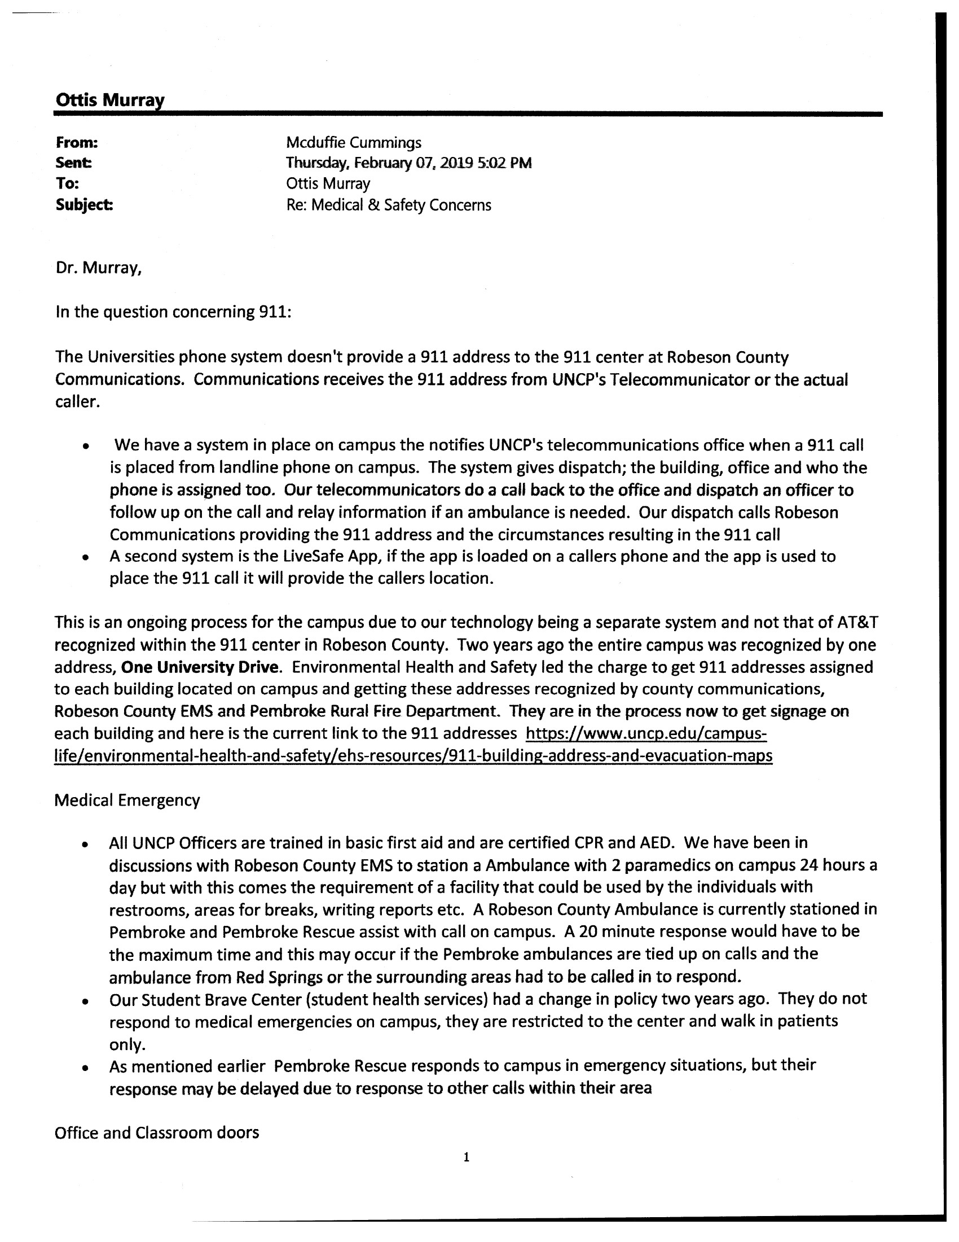
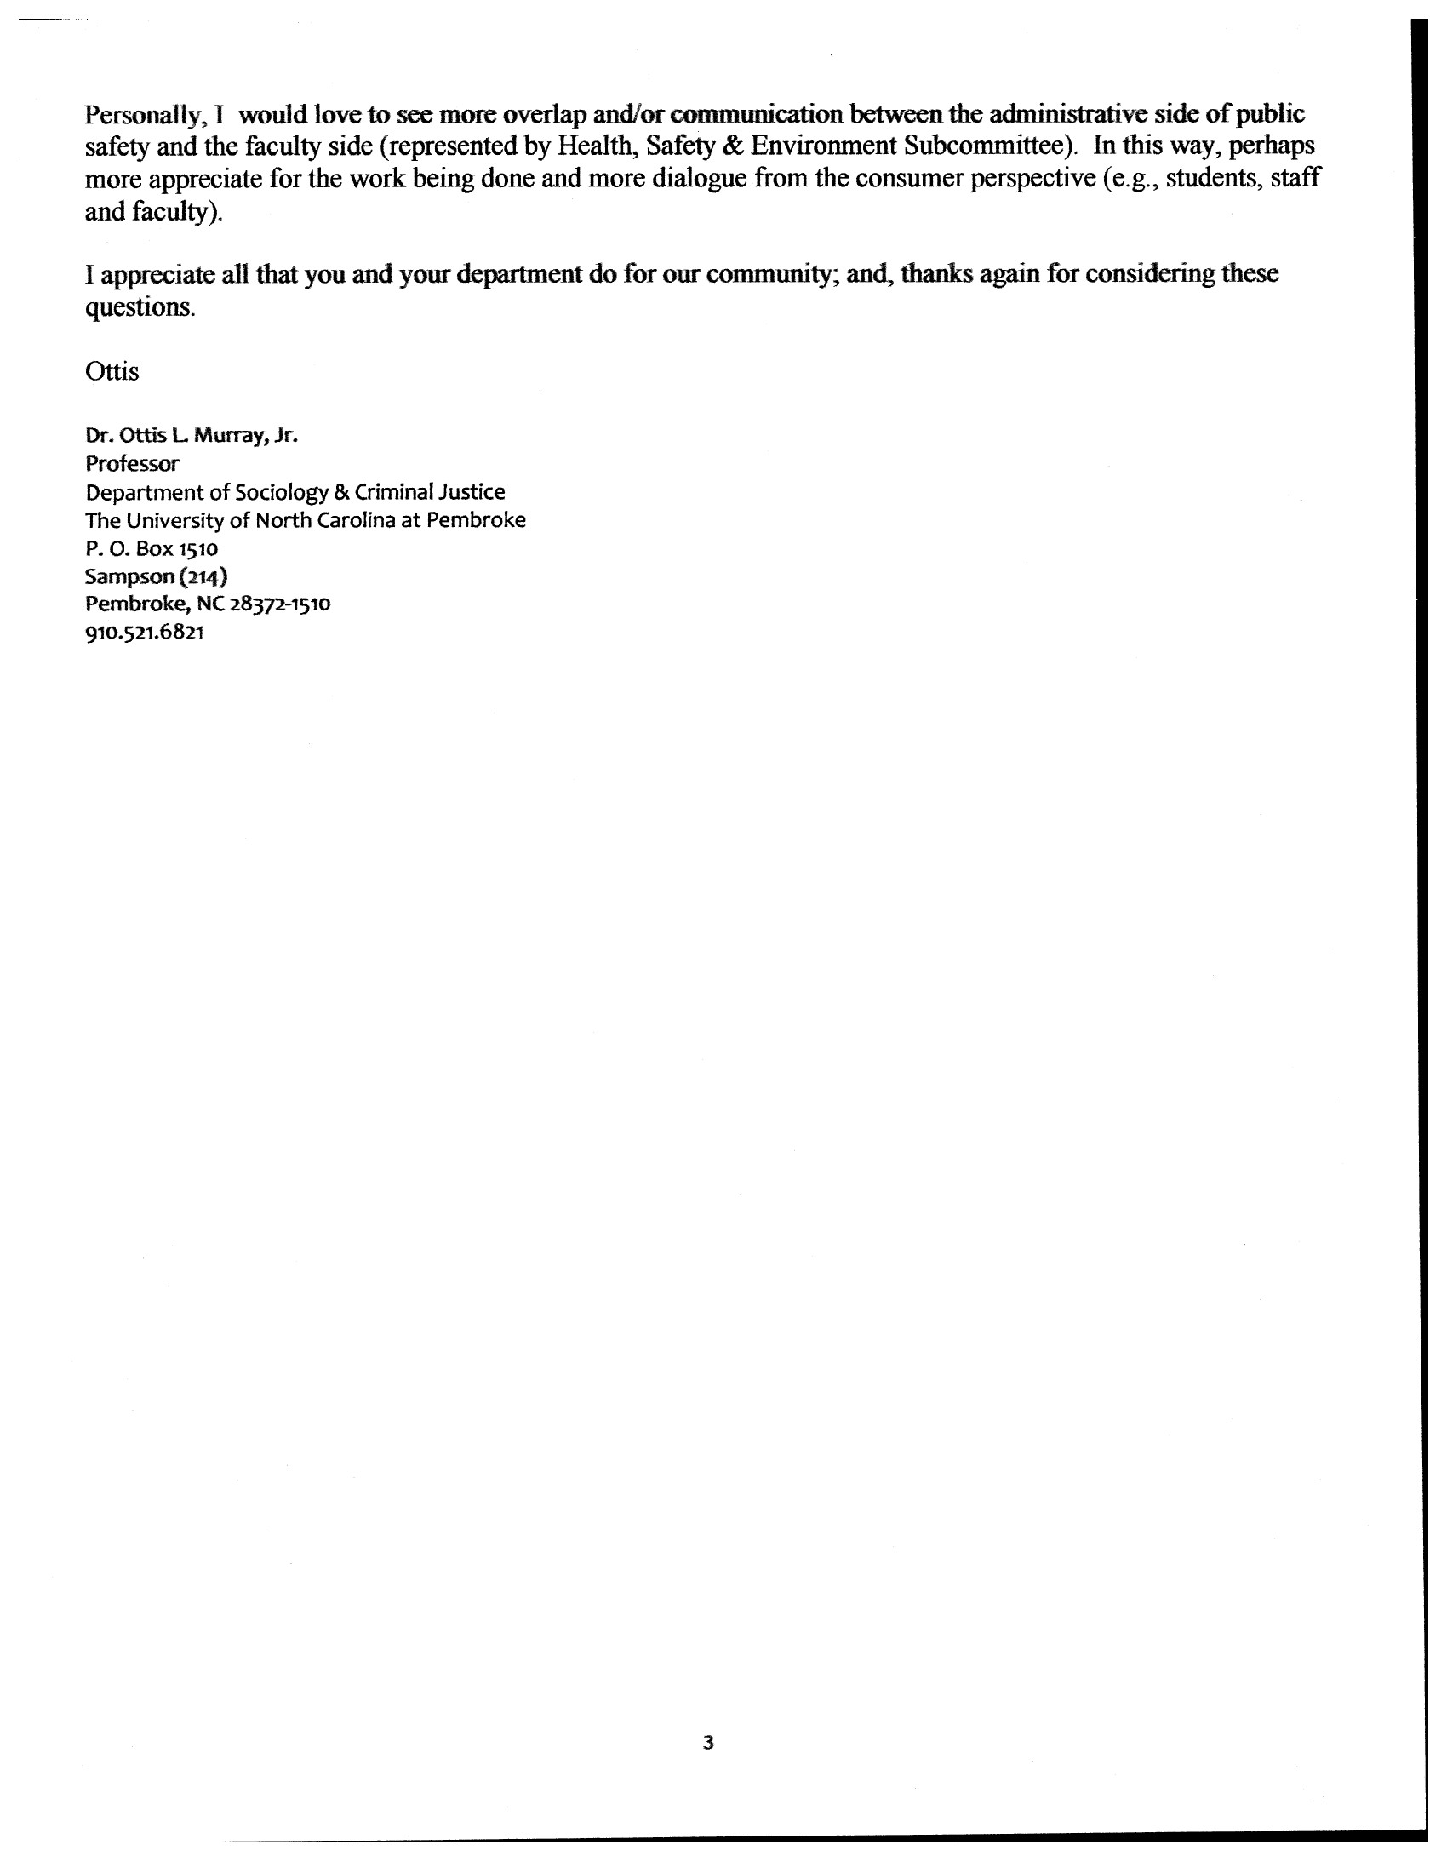

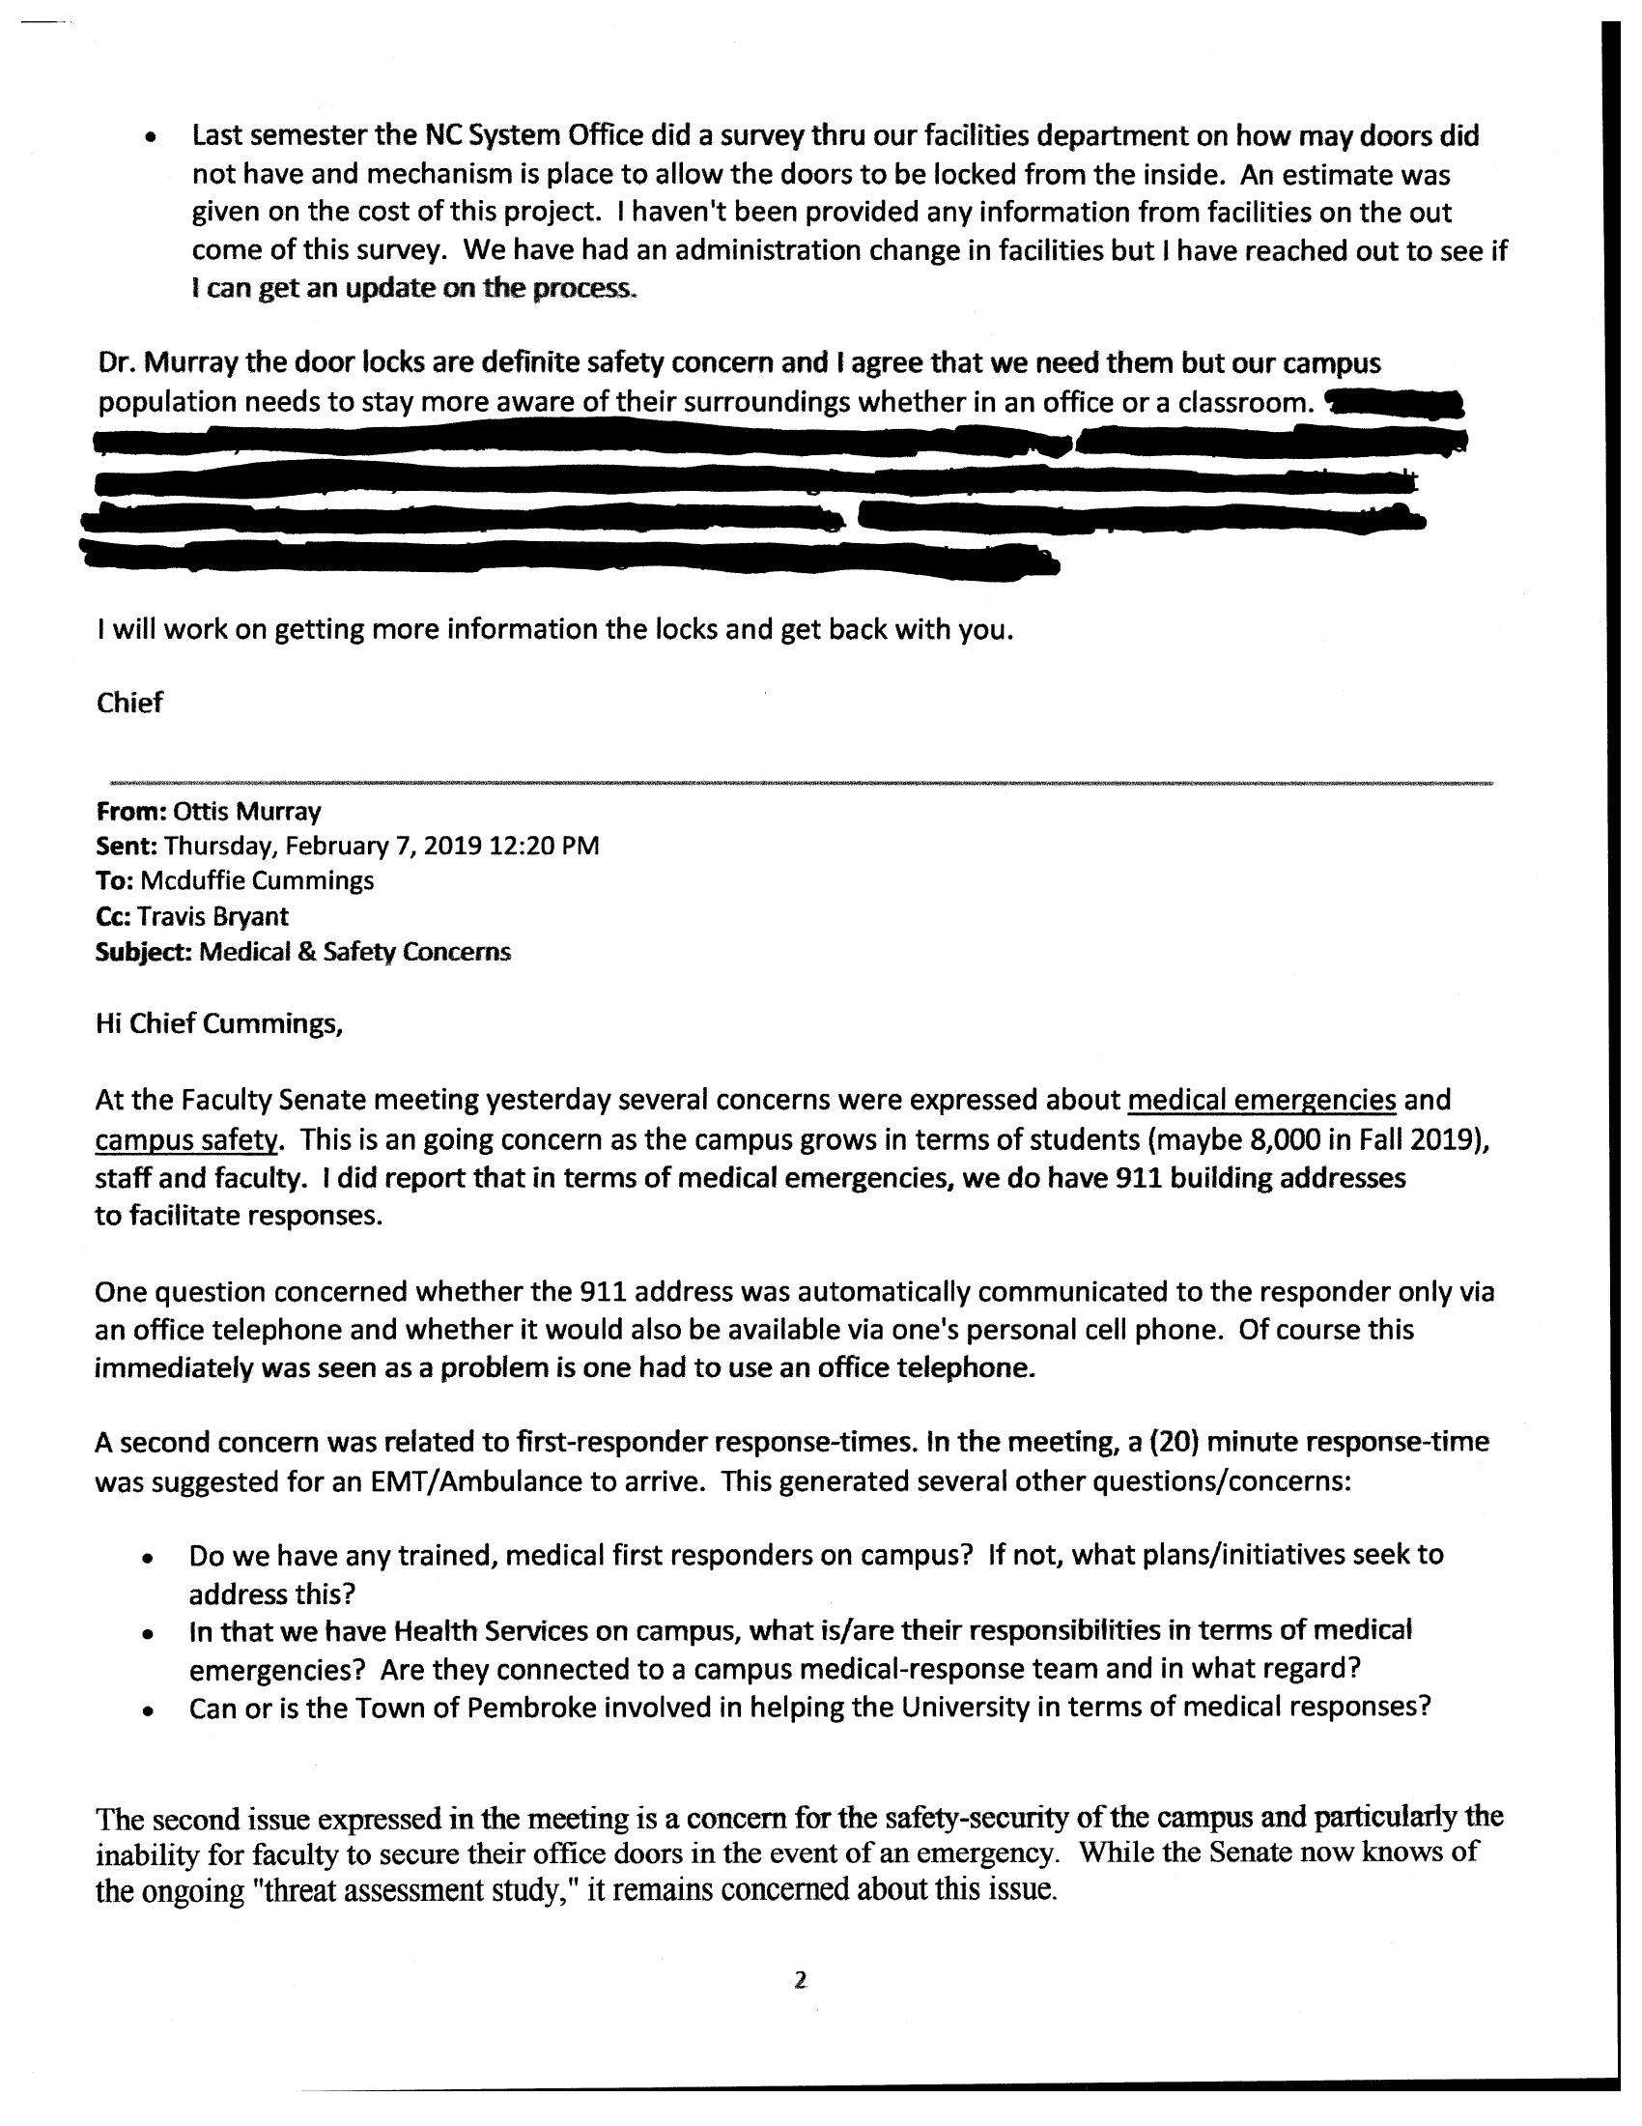

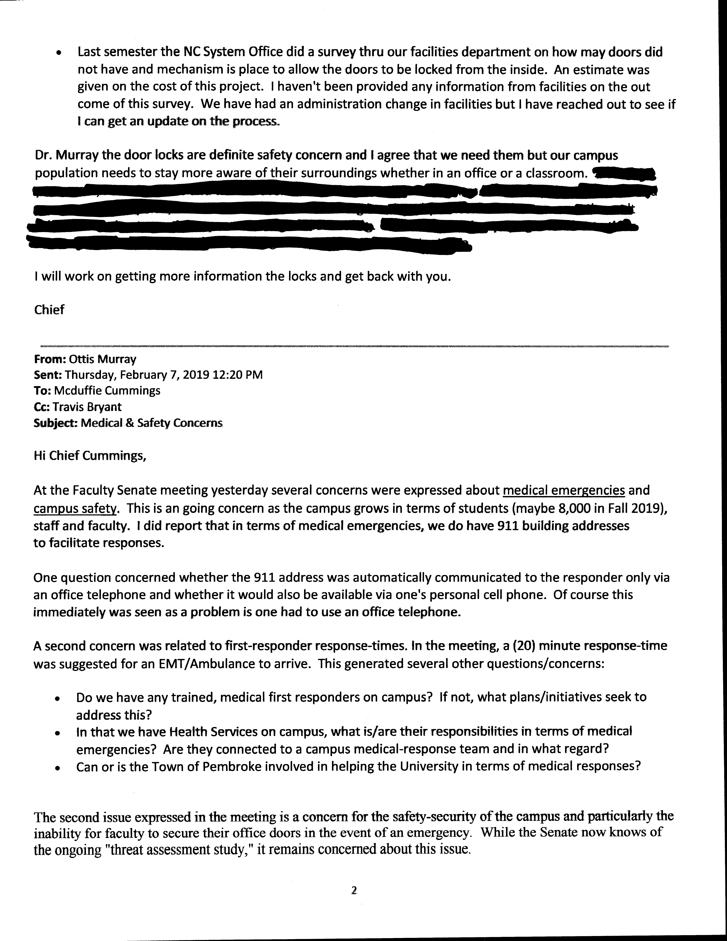

- UNC-Main Page Department Quick Links
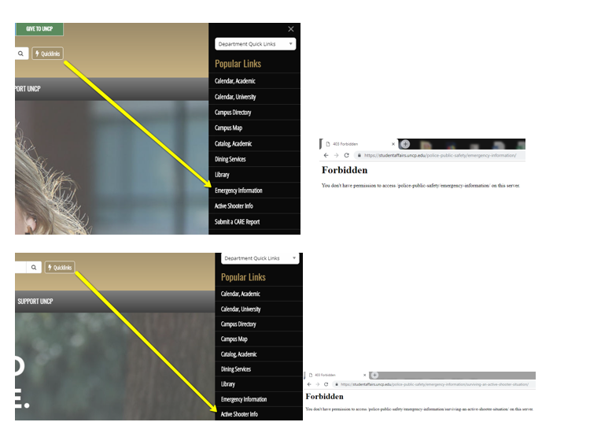
Emergency Information
Active Shooter Information

Note: Walt (HSES) investigated and reported this; the Active Shooter Information link is now working.

iv. LifeSafe app

(https://www.uncp.edu/campus-life/environmental-health-and-safety/livesafe-mobile-app)

- Interpersonal Violence Statement
As of 2.16.19, no response.

From: Ottis Murray
Sent: Sunday, February 10, 2019 3:17 PM
To: Melissa Buice <Melissa.Buice@uncp.edu>; Erin H. Nored <Erin.Nored@uncp.edu>
Subject: FW: October Senate Meeting Adding Interpersonal Violence Statement in the Class Syllabus (Resources Appendix J)

Hi Melissa and Erin,

You presented a proposal to include an Interpersonal Violence Statement in class syllabi at the October Faculty Senate Meeting. This was referred to the Faculty & Institutional Affairs Committee (FIAC).

Unfortunately, I am just getting around to including this as an item on the agenda for our upcoming meeting on Tue, Feb 19th at 3:30. In that so much time has passed, I wanted to check with you to see if this was still something you are recommending or perhaps you have developed other strategies. In either case, please let me know if wish to be on the agenda for the meeting.

Thanks,

Ottis

Dr. Ottis Murray
Professor
The University of North Carolina at Pembroke
Department of Sociology & Criminal Justice
Sampson 214
Pembroke, NC 28372
910.521.6821
ottis.murray@uncp.edu

