UNC Pembroke

EAB Student Success Collaborative

Advisor/Professor Home Page Training

Center for Student Success

Advisor Home

“Availability”

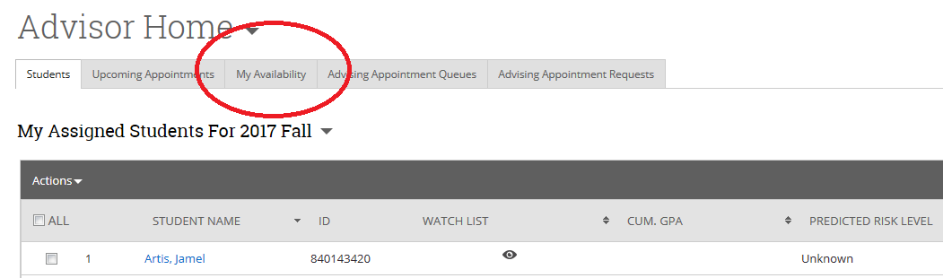

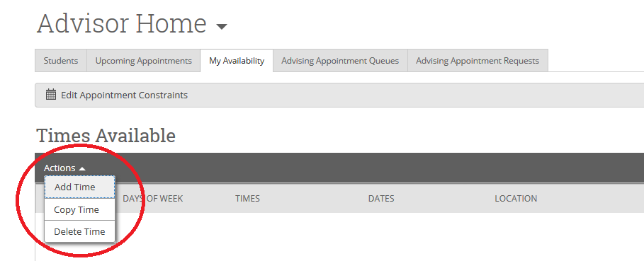

Availability
1. Select Available Days
2. Select Hourly Availability
3. Select Duration
4. Select ‘Drop-In’, ‘Appointments’ or ‘Campaigns’
5. Select ‘Care Unit’
6. Select ‘Location’
7. Select ‘All’ applicable services
8. Provide specific instructions for student
9. Select max students per appointment
10. ‘Save’
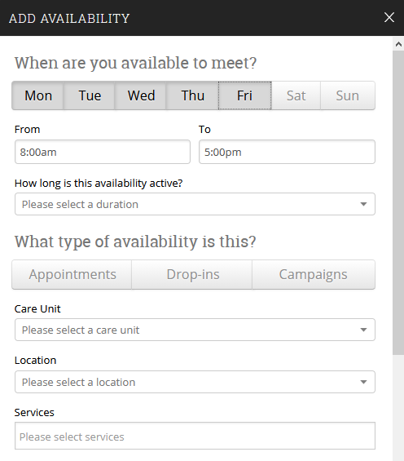
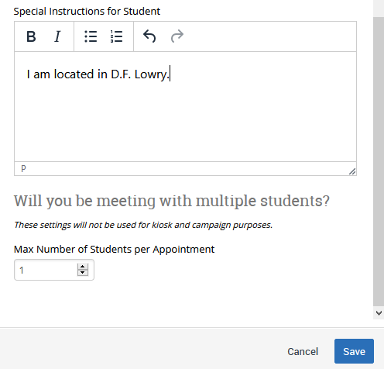

*NOTE*: Once you have created an ‘availability’ (i.e. ‘Drop-In’), you can select ‘Copy Time’ under the ‘Actions’ drop-down to mirror your selections for an alternate appointment type.

“Appointments and Appointment Campaigns”

1. ‘Select the students you want to message’

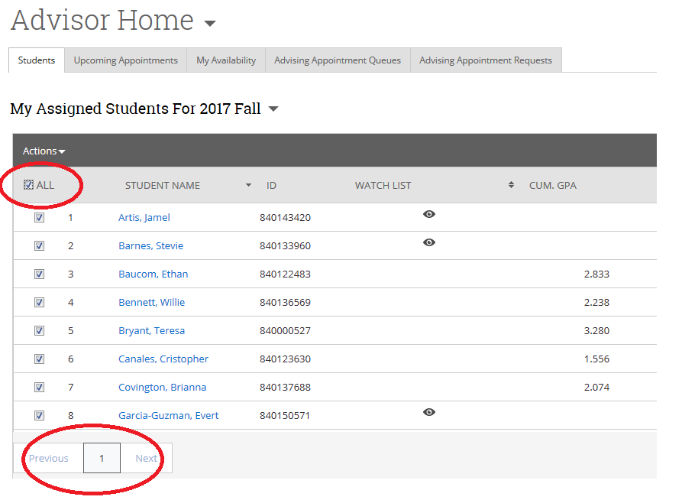

2. Select message preference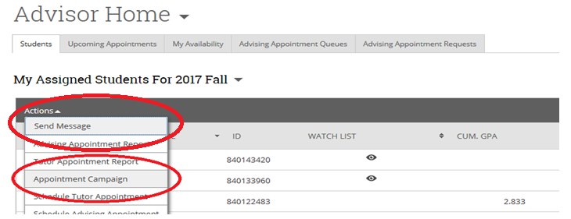

A. ‘Send a Message’
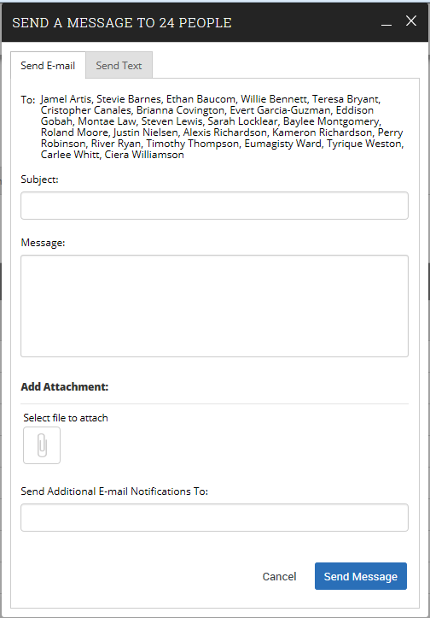

B. ‘Create Appointment Campaign’
1. Create your Availability for Campaigns:
Availability
1. Select Available Days
2. Select Hourly Availability
3. Select Duration
4. Select ‘Campaigns’
5. Select ‘Care Unit’
6. Select ‘Location’
7. Select ‘All’ applicable services
8. Provide specific instructions for student
9. Select max students per appointment
10. ‘Save’

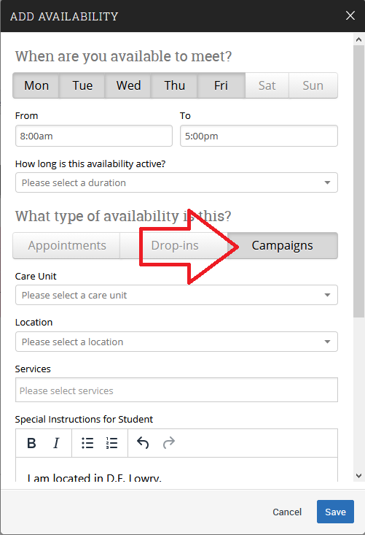
2. Create Campaign
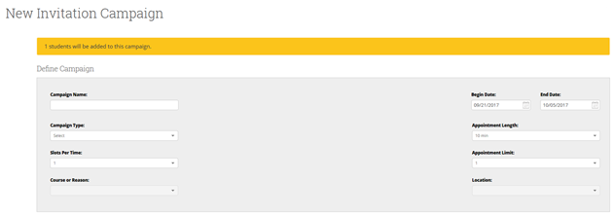
1. Name your ‘Campaign’
2. Select ‘Campaign Type’, ‘Slots Per Time’, ‘Course or Reason’, ‘Begin/End Date’, ‘Appointment Length/Limit’
...Review your Students
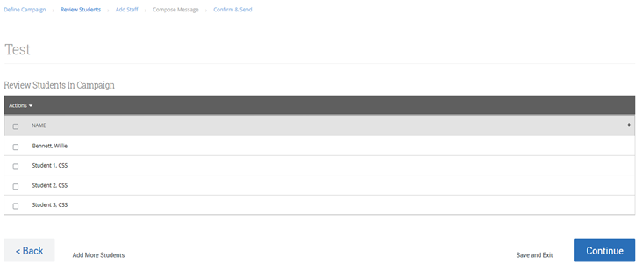

...Select your Advisors (Select yourself and others if they will be assisting you with your students)
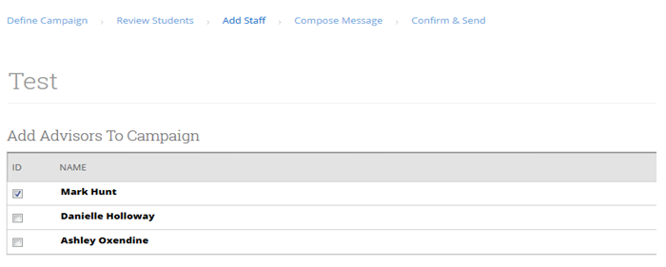
...Compose your Message or Keep the Preloaded Message
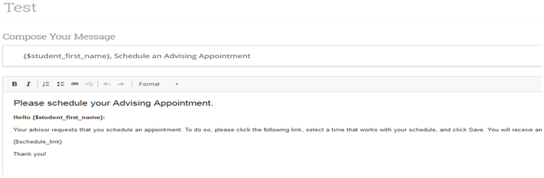

...Confirm and Send
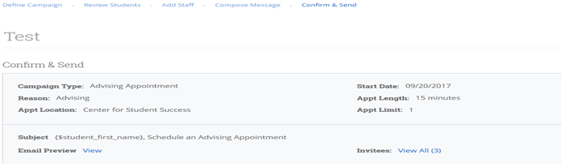
...Confirmation

“Advisor Reports”
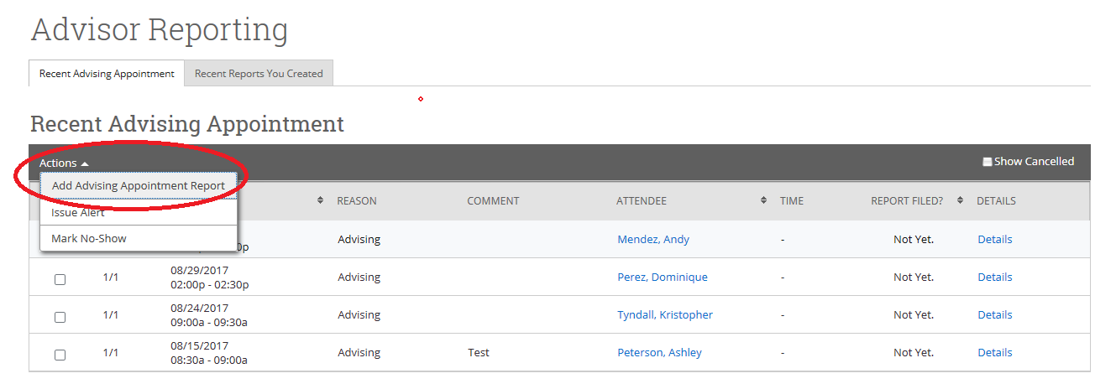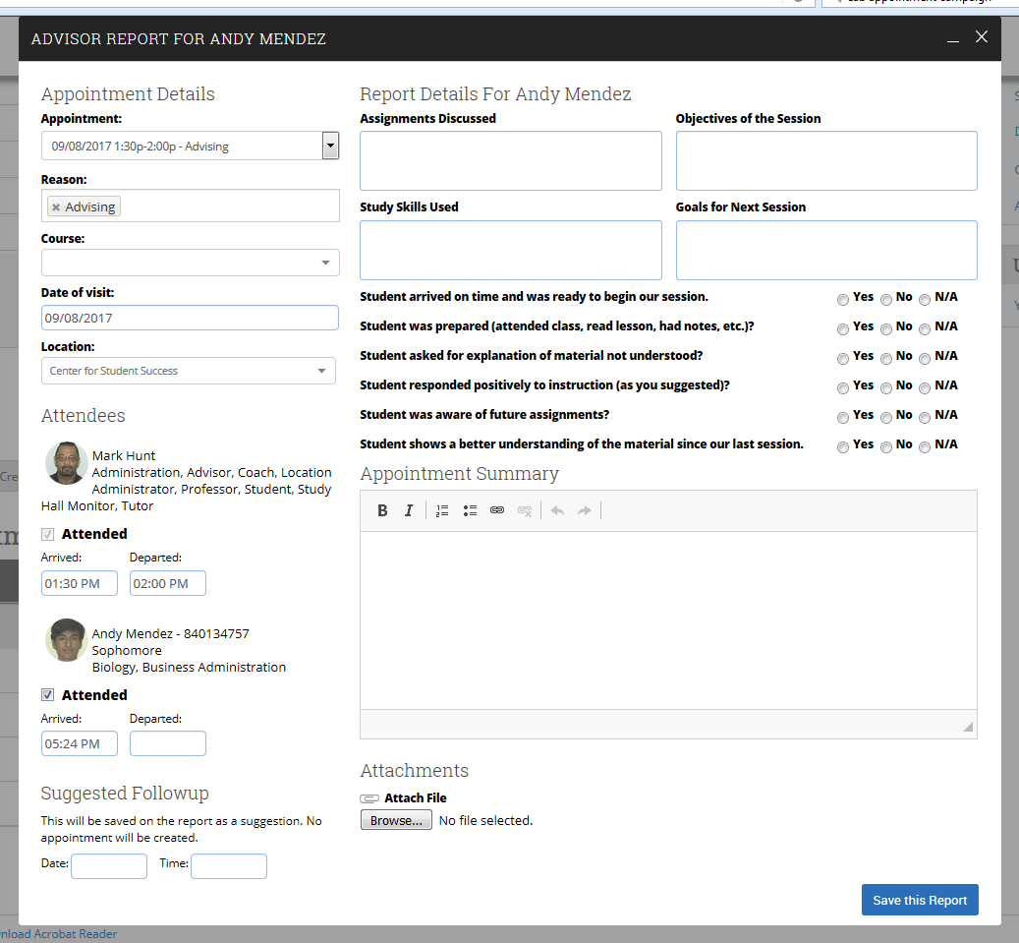

“Messaging”

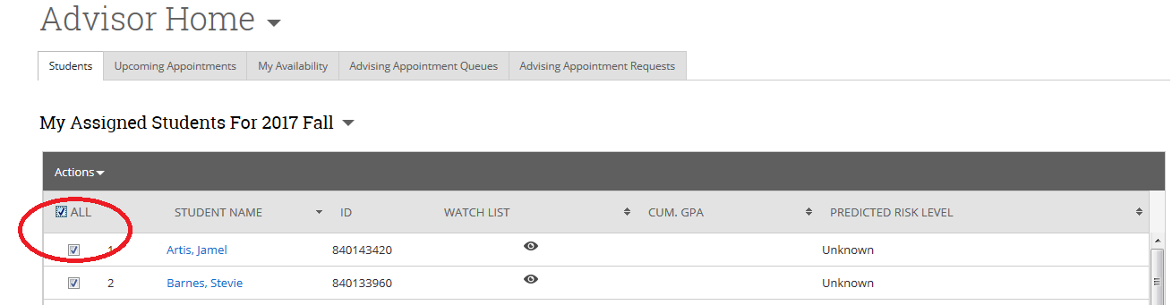

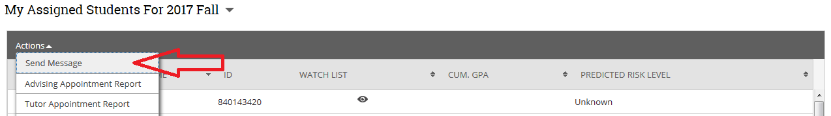

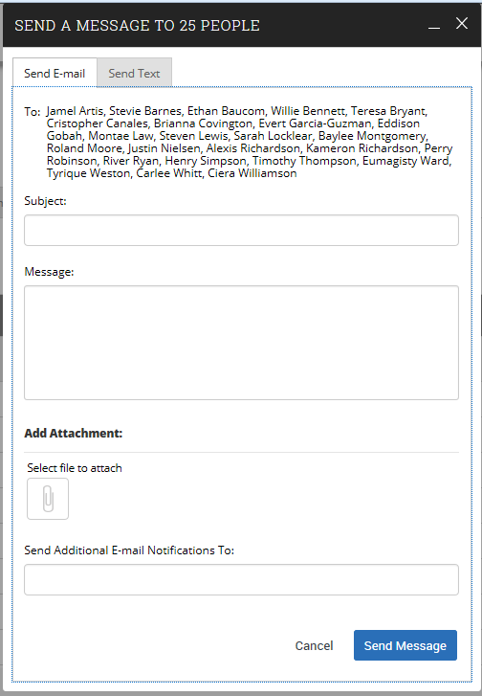

Professor Home
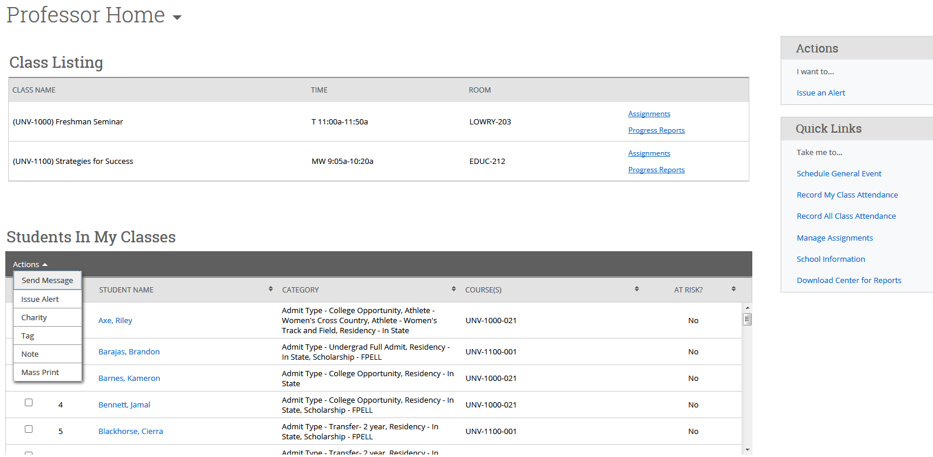
Send Message
Select students...
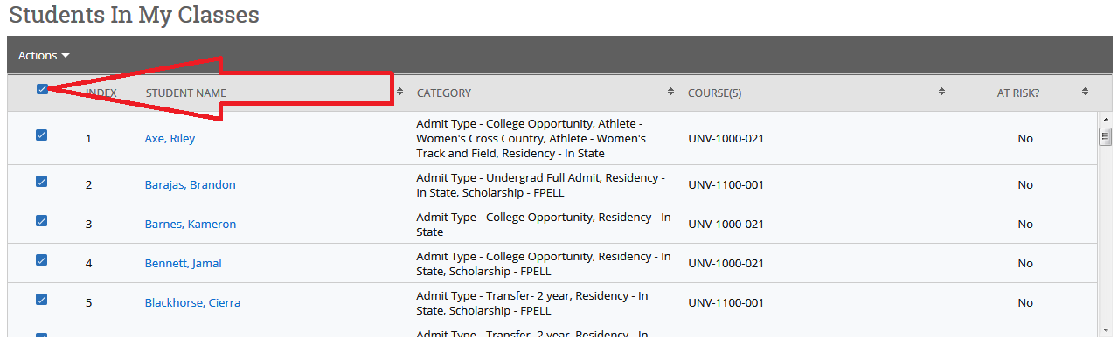

Send Message cont....
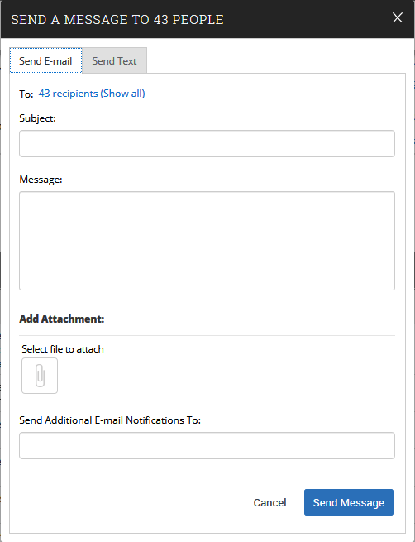

Issue Alert
1. Class Roster –
Step A: From your Professor Home page, check box next to student’s name under “Students In My Classes” and select “Issue Alert”

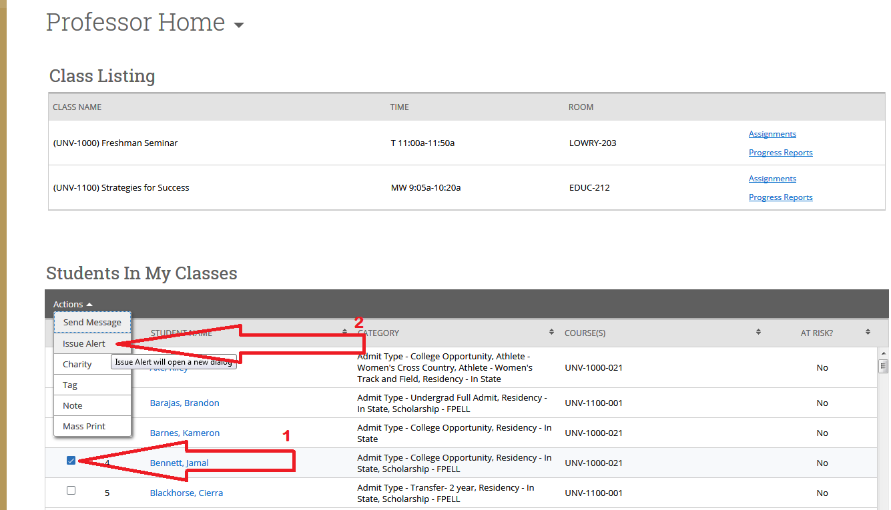

2. Professor Home Page –
Step A: At the right of your Professor home page, select “Issue an Alert” and select student by typing the name or Banner ID...

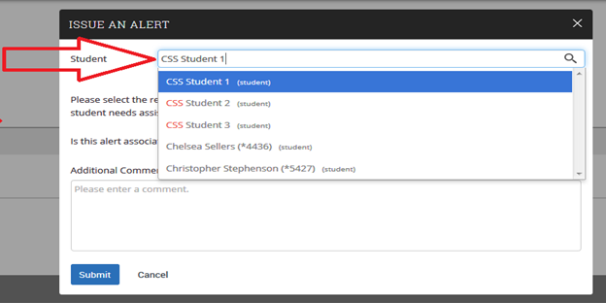

Step B: Alert Reason – Select the alert reason...both H.A.W.K. Alerts and KUDOS reasons are imbedded within this dropdown

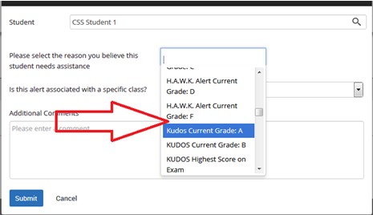

Step C: Associated with a Class? – Select course from students registered classes
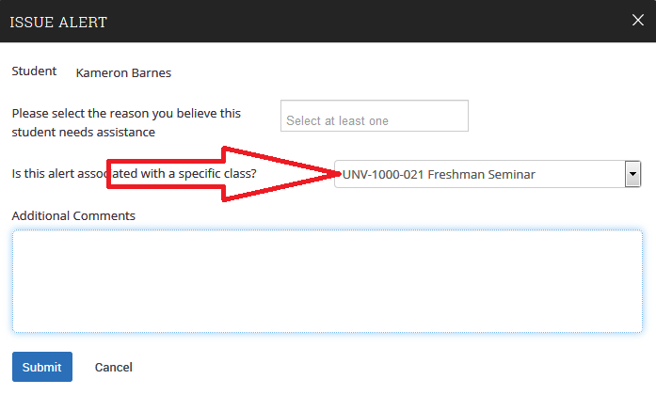

Step D: Additional Comments / Submit – Explain reason for referral and recommendations, if any and click “Submit” 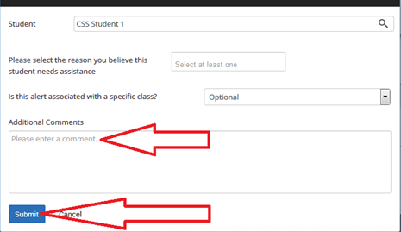

Follow-Up
To determine our progress with your referral...
1. Select the “History” tab at the top left of your student’s profile page
2. Select applicable case under “View Case”

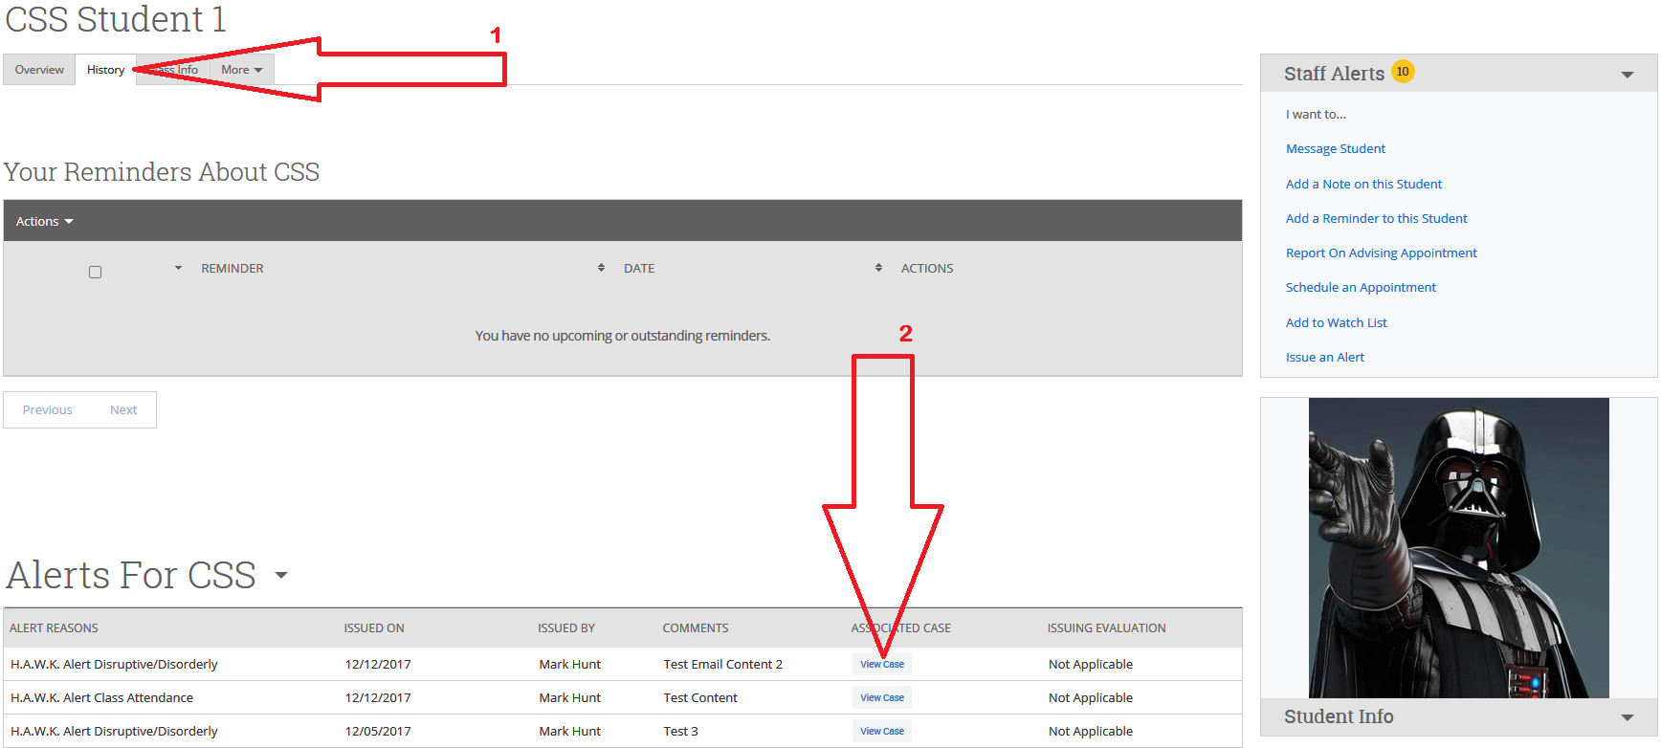

Follow-Up Continued...

From this screen you can see who the case is assigned to, when it was opened (by our H.A.W.K. Alert Specialist) and what their comments are, if any.
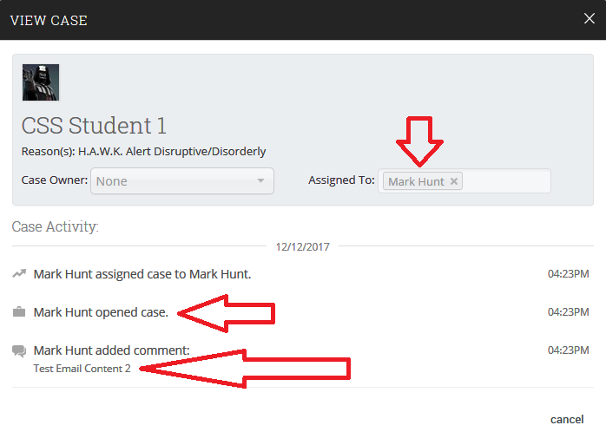

Progress Reports
Issued by various users to Professors to determine the academic progress of specific student populations.

Email notice is sent to Faculty, is accessible thorough email and includes:
- “Yes/No” field for “Is student at risk of failing your course?”
- “Yes” response requires alert reasons
- Alert reasons trigger ‘Cases’ (very similar to a H.A.W.K. Alert)
- Case management begins by:
  - Notifying assignees who initiate contact with student
  - Work with student to address ‘Case’ concerns
  - Track resoultions within EAB (under ‘Cases’ tab 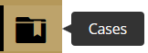)
Once case is closed notice is automatically sent to ‘Case’ issuer

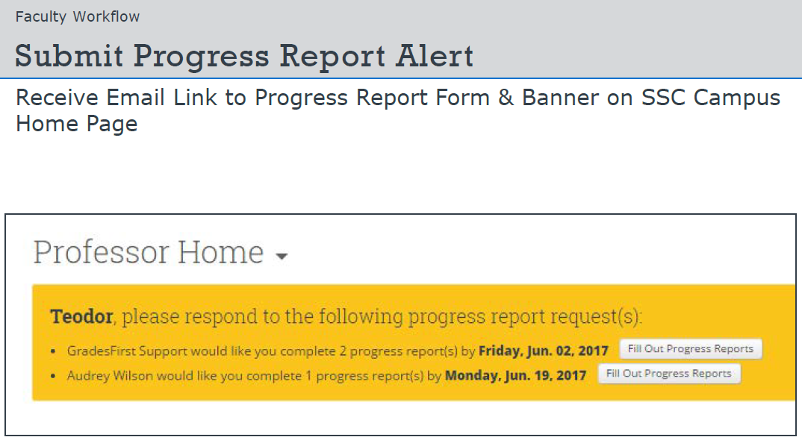

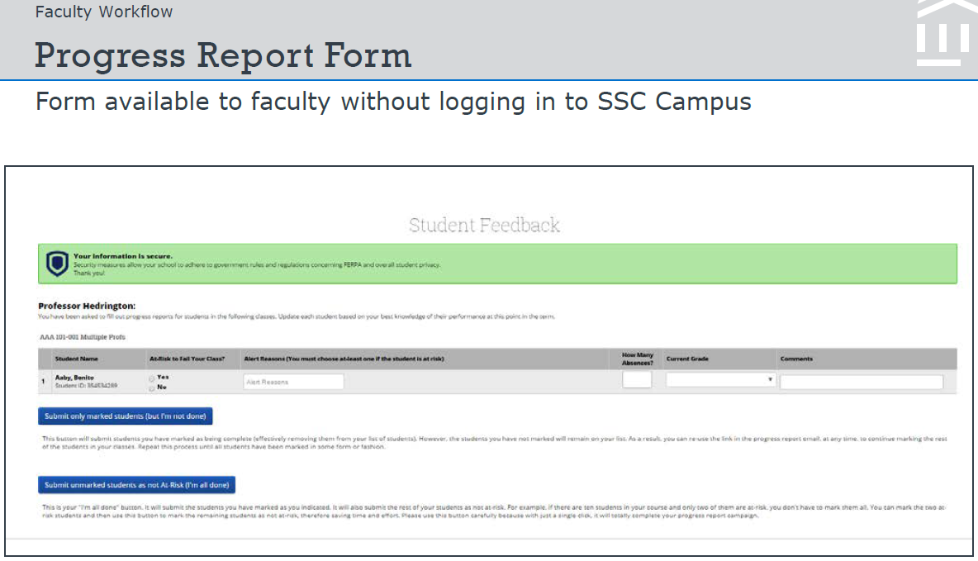

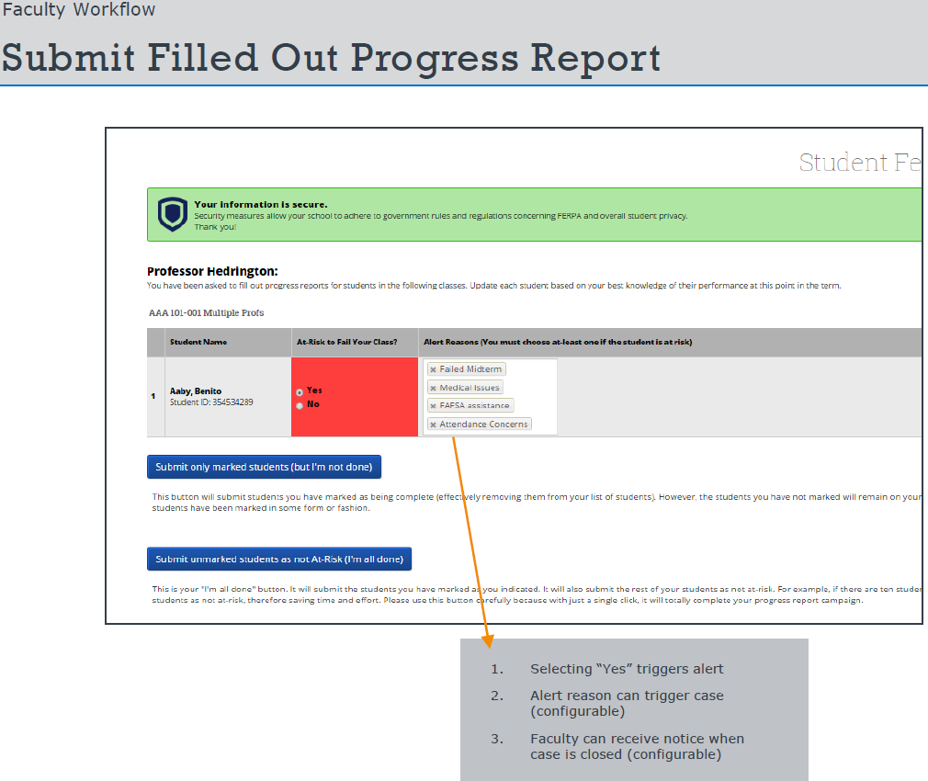
Record My Class Attendance
Select “Record My Class Attendance”

Select: Course> Date> Attendance> Save

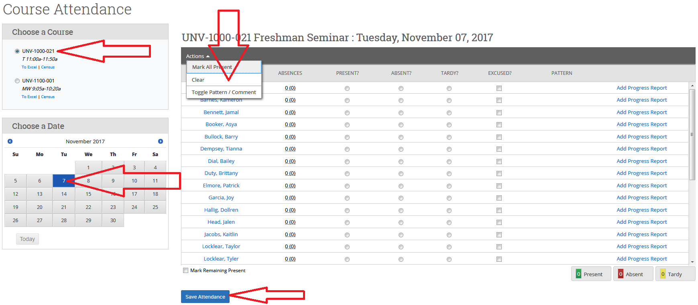
(You can record comments, toggle attendance patterns and view totals for the day. Attendance can also be taken retroactively and can be exported to an excel file.)

“Student Profile”

Tabs (Advisor Home Screen):

Overview (30 Sec. Gut Check)

Success Progress

History

Class Info

Major Explorer

More: Calendar, Study Hall, Appointments, Conversations

