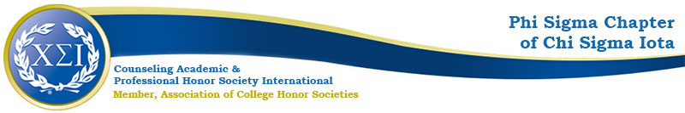

Phi Sigma Chapter Agenda
October 19, 2020
4:30pm

https://uncp.webex.com/meet/Nicole.Stargell

Present: Dr. Stargell
VP, DP, Treasurer
1 Student

- Welcome!
- Fall Projects
  - Black Lives Matter Workgroup (Advocacy/Counselor Community Engagement)
  - CPCE Study Groups
  - Wilmington Meetup 10/12 was a success!
  - PDAs: The Professional Counselor
    - October PDA 1: From Graduation to Full Licensure in the Private Practice Setting: Practical Considerations from an Alumnus
      - Speaker-Vanessa Doran, LCMHC, Past Phi Sigma VP
      - Date/Time/Location- 10/20/20 4-5pm
      - Advertising- Stargell
    - November PDA 2: Counseling Individuals Who Identify as Transgender: Ethical, Legal, and Practical Considerations
      - Speaker- Sheilagh Harrington, MSW, LCSWA
      - Date/Time/Location-11/10/20 4-5pm
      - Advertising-TAW Organizers & Stargell
  - Ugly Sweater Holiday Social
    - Dec 4th 4-5pm
    - VP, NS
- Spring Projects
  - Spring Meetings:
    - February—coffee break/business meeting
    - March
    - April
    - 4:30pm
  - Fundraiser
    - Online 50/50 Raffle
    - Treasurer will look into online services
  - 5th Annual Advocacy Summit
    - Typically combined with the annual NCCA Conference
  - Induction
    - April 2021
    - Online
    - Speaker: Stargell will reach out
  - Spring PDAs:
    - February—RS will reach out to a potential speaker
    - March— Annual Drive-In Conference
      - 03/25/2021
      - Online
      - Keynote: Stargell will reach out
- New business
  - CSI International Voting: https://www.csi-net.org/page/Elections_2020
    - 3 out of 4 Protivnak
    - 4 put of 4 Colburn
  - $100 credit
    - Table cloth—4 votes
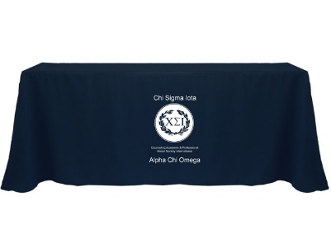
    - Cords/t-shirts for sale
  - Richard & Rebecca Graduating –they will discuss officer transitions, if any

Next meeting: February 2021

