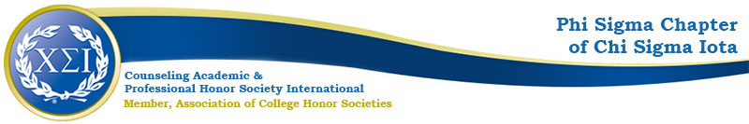

Phi Sigma Chapter Minutes
September 21, 2020
4:30pm

https://uncp.webex.com/meet/Nicole.Stargell

Present:
Vice President
Deputy President
Treasurer
3 Students
CFA

- Welcome!
- Fall Projects
  - Black Lives Matter Workgroup (Advocacy/Counselor Community Engagement)
    - Contact Nicole.Stargell@uncp.edu if you would like to join
    - Attending OSID Roundtables
    - Complete the Campus Climate Survey
  - CPCE Study Groups
    - Rocking and Rolling
    - Consider Extending through Winter Break
    - Consider a Weekend Option
  - PDAs
    - Theme: The Professional Counselor
    - October PDA 1:
      - Speaker-Vanessa Doran, LCMHC, Past Phi Sigma VP
      - Date/Time/Location-Webex
      - Advertising- Stargell
    - November PDA 2: Counseling Individuals Who Identify as Transgender: Ethical, Legal, and Practical Considerations
      - Speaker- Stargell will extend invitation
      - Date/Time/Location-11/10/20 4-5pm
      - Advertising-TAW Organizers
    - Provide a $100 stipend to 2020-2021 One-Hour PDA Presenters (excluding drive-in)
      - VP Motions
      - Aye’s Have It
  - New Business
    - October
      - Wilmington Meetup
        - Virtual
        - 10/12 at 6:30pm
      - NC School Counselor Association Conference 11/4-6
        - Virtual Graduate Student Poster Session
        - Application Deadline 10/05: https://forms.gle/sB7AdVECTzcvZPEv8
      - NCCA Conference: Week of February 22-27, 2021
        - Fully Online
        - Student Poster Presentations Opportunity: https://nccounselingassociation.org/2021-conference-call-for-proposals/
        - Deadline October 16
    - December
      - Ugly Sweater Holiday Social Dec 4 or 11
        - Counseling Department
        - Faculty & Students & Staff
        - All Students, not just members
        - Planning Committee:
          - VP
          - Email nicole.stargell@uncp.edu to help
- Spring Projects
  - Welcome Back Coffee Break
  - Fundraiser
    - Treasurer
    - Online Auction, Silent Auction, Raffle
  - 5th Annual Advocacy Summit
    - Typically combined with the annual NCCA Conference
  - Induction
    - April 2021
    - Online
  - Spring Meetings:
    - February
    - March
    - April
  - Spring PDAs:
    - February—RS Looking Will Reach out to a potential speaker
    - March— Annual Drive-In Conference
      - 03/25/2021
      - Online

Next meeting: 10/19/20

Action Items:
- Dr. Stargell will reach out to 2 PDA Speakers
- Dr. Stargell will ask faculty about Holiday Social Date
- RS will reach out to Potential Spring PDA speaker

