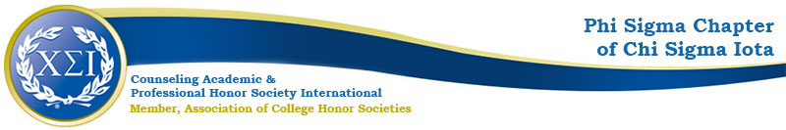

Phi Sigma Chapter Meeting Agenda
October 4, 2022
4:30pm
https://uncp.webex.com/meet/nicole.stargell

Welcome!
President: Eliza Burgess
Vice President: Whitney Scott
Secretary/Treasurer: Darcentia Turner
co-CFA: Dr. Ashley Smith
co-CFA: Dr. Nicole Stargell

Present:
Stargell
Smith
Secretary/Treasurer
Vice President
3 Students

Fall Projects
- PDA Workshops
  - Field Placement- Drs. Friedrich & Simon-10/25 @ 4:30
  - Testing and Licensure- Dr. Stargell- 11/15 @4:30
  - Spring PDA #3-Poster Presentations (Peer to Peer) January/February
    - Stargell will email 6130 students with template and video clip in preparation for NCSCA
  - GHW Counseling Workshop, Wednesday
    - Stargell will consult with faculty
- Fundraisers
  - T-shirts
  - Unisex, Inclusive Sizing
  - Design Contest—winner gets free t-shirt
  - Students will organize the contest, design choice, and sales
  - JotForm
- Advocacy Project
  - Trans Awareness Week 11/13-11/20
    - Clothing Exchange
      - Approved by Dean, SOE
      - Clothing Rack in Counseling Cove
      - Gather Donations and Advertise
    - Student-Led Forum for Inclusivity Monday 11/14 (OSID & Virtual)
    - Wellness Day Tuesday 11/15
    - Safe Zone Wednesday 11/16
    - I-rest Thursday 11/17 (OSID & Virtual)
    - Speaker Sponsor 11/18
    - Day of Remembrance Sunday 11/20 Virtual
Spring Projects
- Induction—on campus or online?
- GHW Workshop
  - Online
  - Keynote Suggestions: Friedrich & Duffy
- Spring Meetings: February, March, April

Next Meeting: November 8 @4:30

