UNC Pembroke

EAB Student Success Collaborative

Advisor/Professor Home Page Training

Center for Student Success

Staff Home

“Availability”

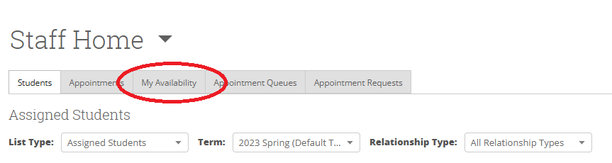

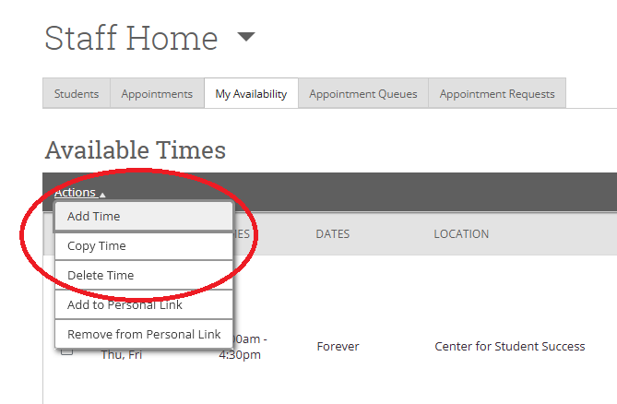

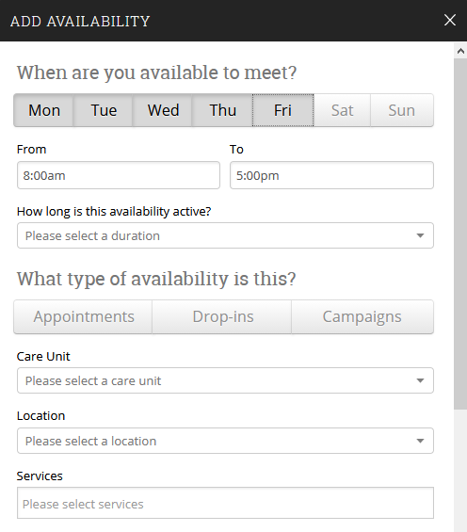

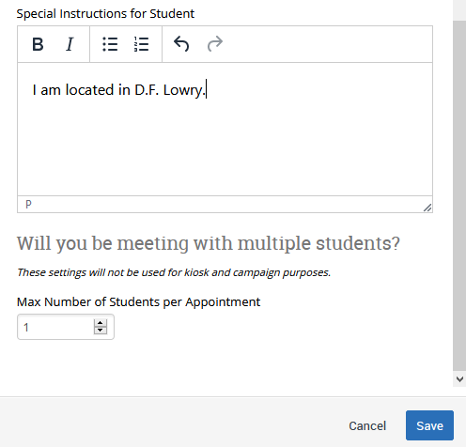
Availability
1. Select Available Days
2. Select Hourly Availability
3. Select Duration
4. Select ‘Drop-In’, ‘Appointments’ or ‘Campaigns’
5. Select ‘Care Unit’
6. Select ‘Location’
7. Select ‘All’ applicable services
8. Provide specific instructions for student
9. Select max students per appointment
10. ‘Save’

*NOTE*: Once you have created an ‘availability’ (i.e. ‘Drop-In’), you can select ‘Copy Time’ under the ‘Actions’ drop-down to mirror your selections for an alternate appointment type.

“Appointments and Appointment Campaigns”

1. Select the students

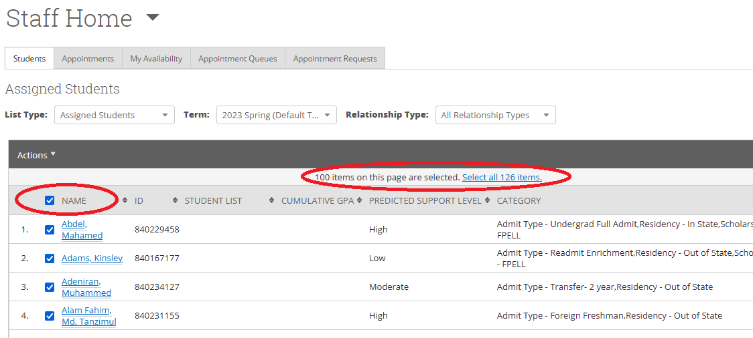

2. Select options
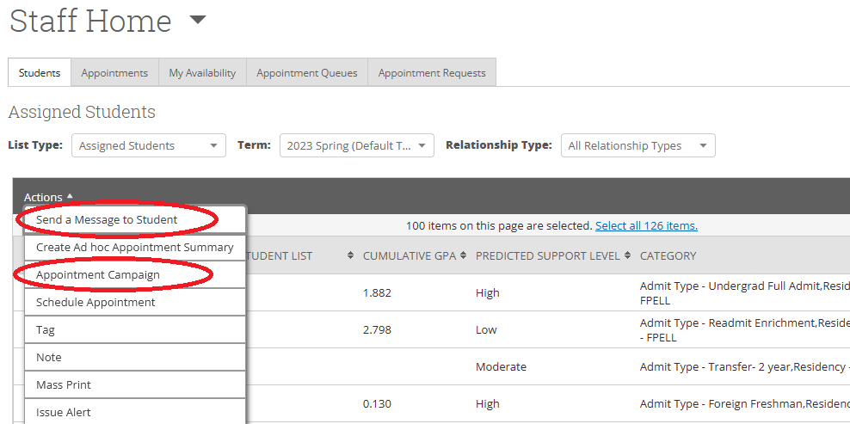

A. ‘Send a Message’
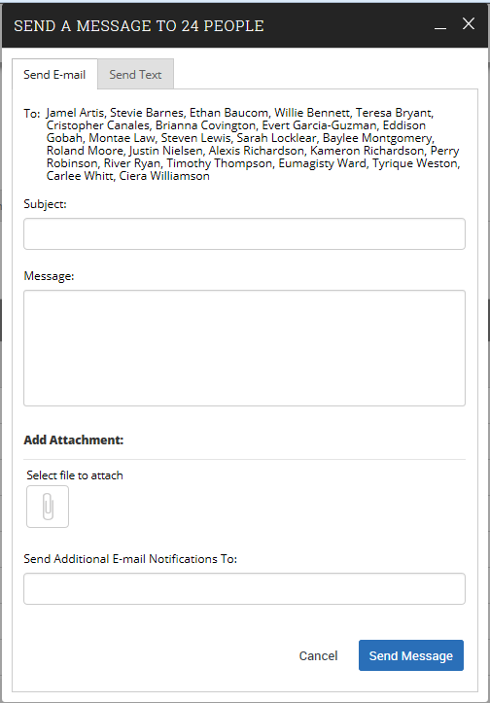

B. ‘Create Appointment Campaign’
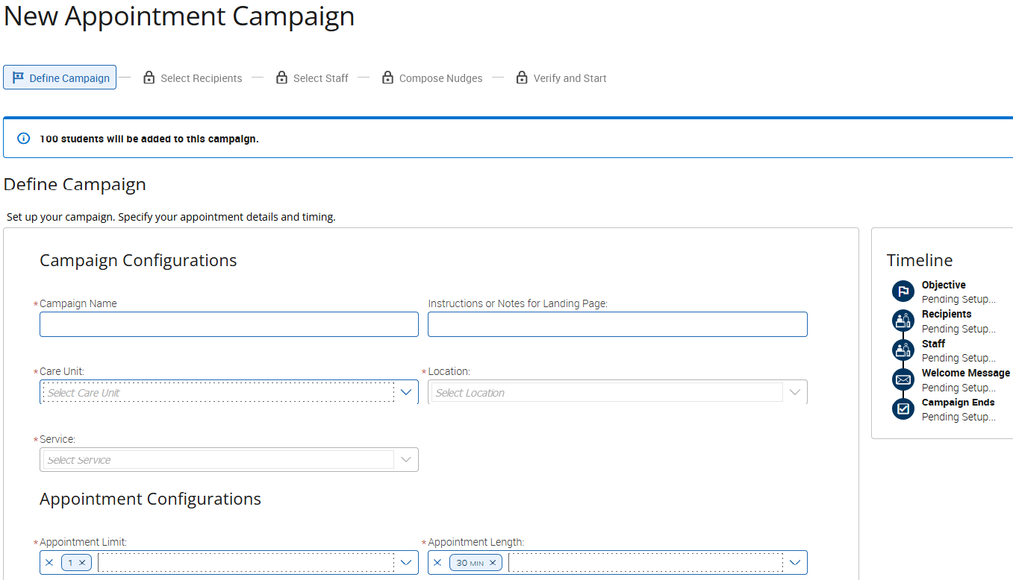
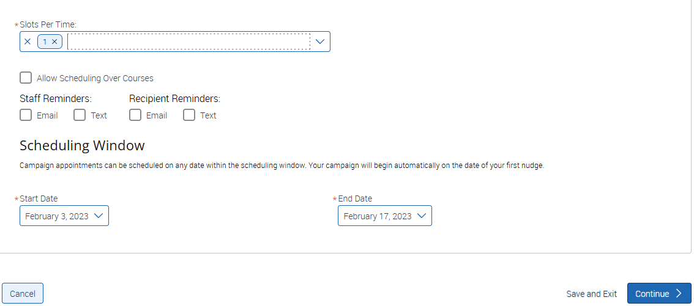
Campaign Configurations
1. Create ‘Campaign Name’ 2. Select ‘Care Unit’ 3. Select ‘Location’ 4. Select ‘Service’
Appointment Configurations
1. Select ‘Appointment Limit (appointments per campaign) 2. Select ‘Appointment Length’ 3. Select ‘Slots Per Time’ (how many students per appointment) 3. Select Reminders 4.

Schedule Window
1. Select ‘Start Date’ & ‘End Date’…select ‘Save and Exit’ or Continue’

Add Recipients to Campaign
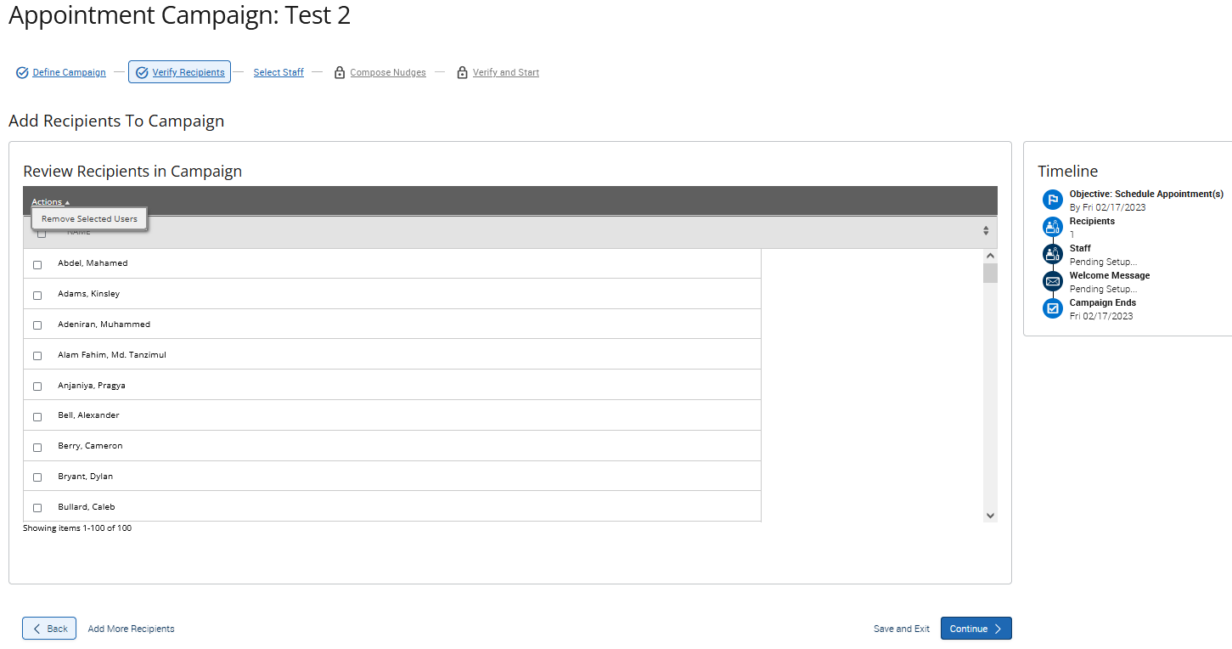
NOTE: From this screen you can ‘Remove Selected Users’ (you can also verify your progress with your campaign under ‘Timeline’), you can go ‘Back’ and add more recipients, ‘Save and Exit’ or ‘Continue’

Select Staff for Campaign
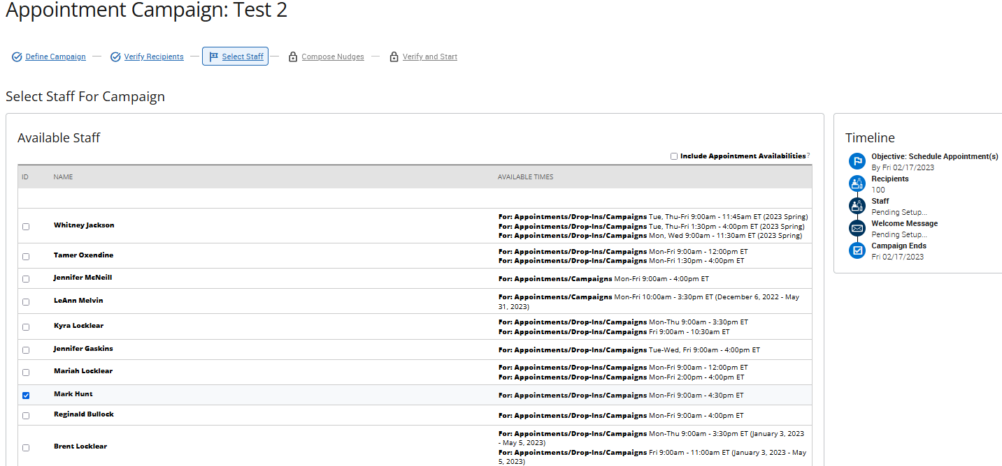
…include yourself and any others who may be assisting you.

...Compose Nudges: Click ‘+ Add Welcome Message’
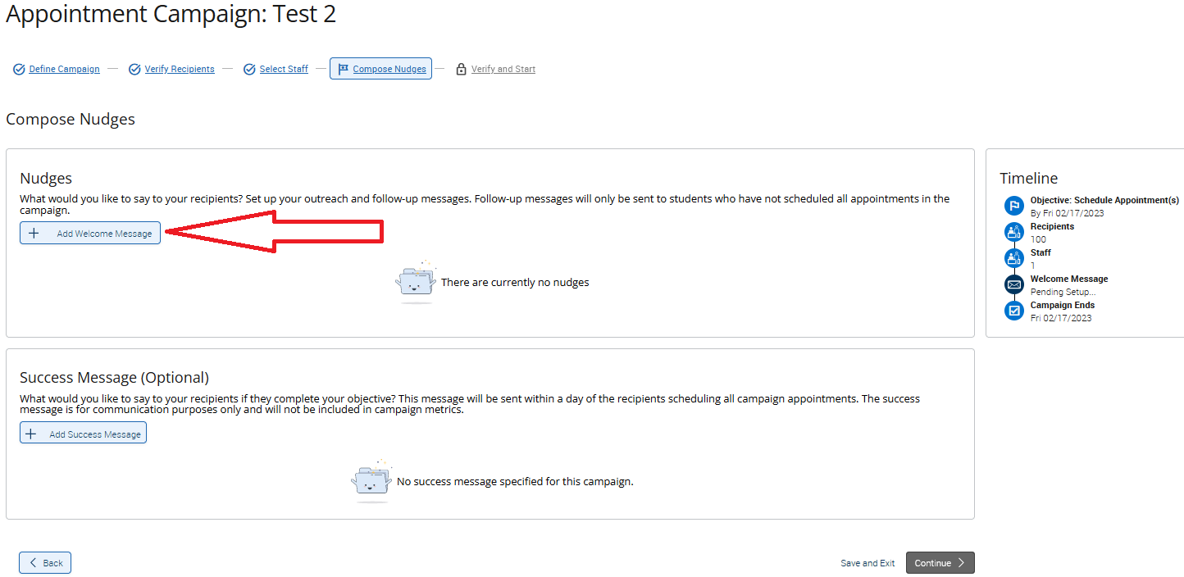

…Compose Message
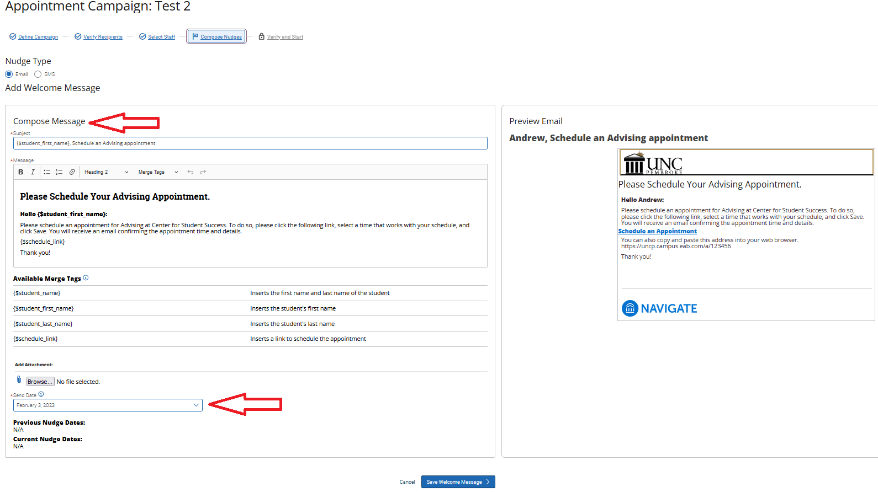
…Build your message as you prefer (this would be a great place to insert your office location), making sure to keep the ‘($schedule_link) tag in place…NOTE: You can ‘Preview Email’ on the right of your screen. Select your ‘Send Date’, then click ‘Save Welcome Message’
NOTE: If your Nudges is correct (Success Message is optional), click ‘Continue on the next page.

...Confirm and Send
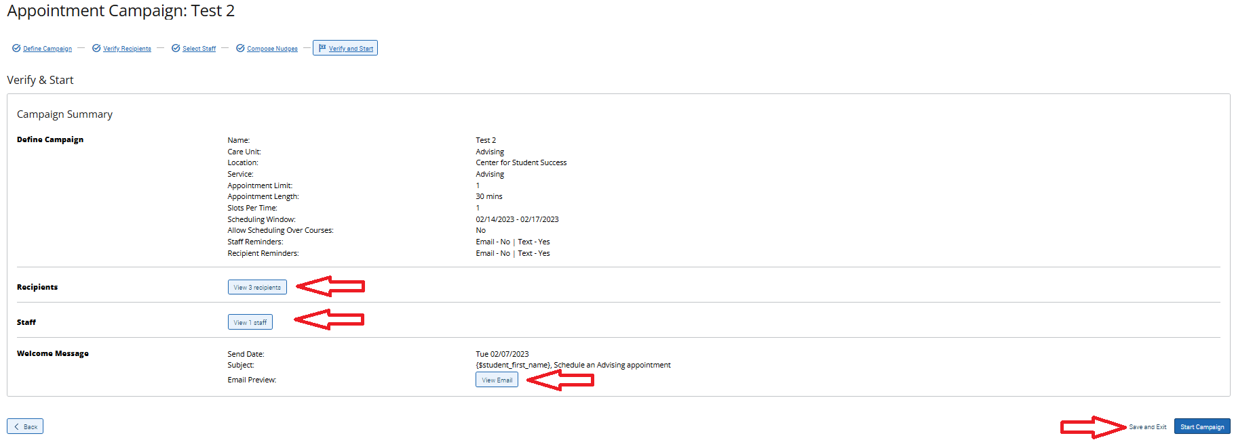
…from this screen you can confirm your recipients, staff, message, Save and Exit or ‘Start Campaign’.

...Confirmation
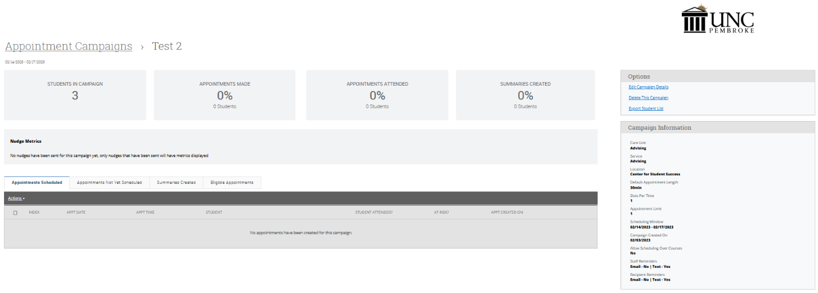
…Congratulations, you have successfully created your campaign. From this screen you can view the progress of your appointments made, attended, view how many students have not scheduled (and send a reminder) and see how many appointment summaries you have created.

“Advisor Reports”
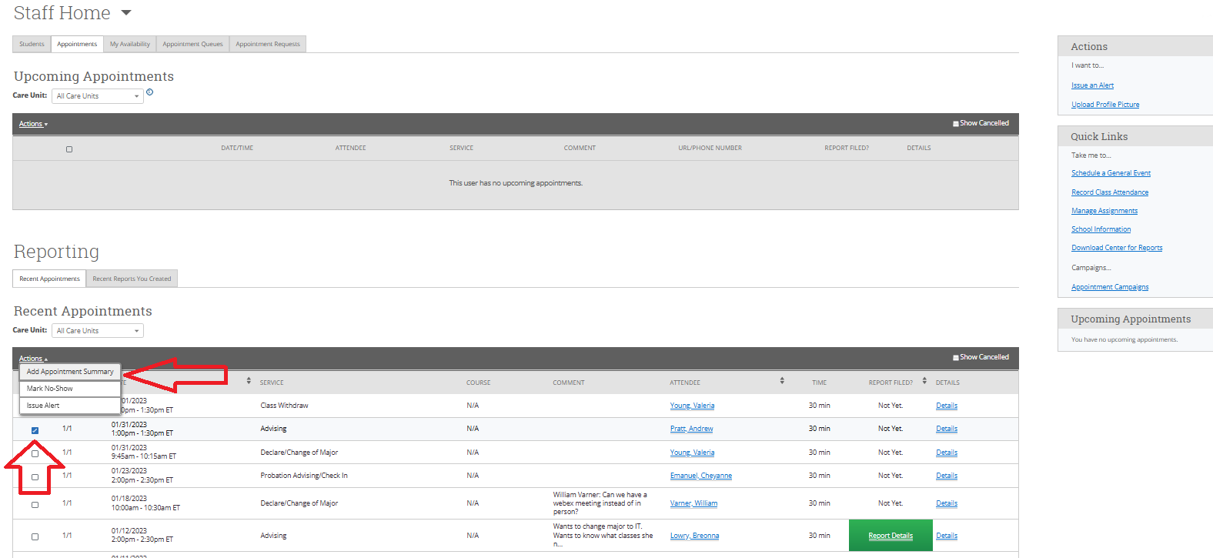
…from the ‘Staff Home’ page click ‘Appointments’ (top), select your student from ‘Recent Appointments’ and click ‘Actions’ then ‘Add Appointment Summary’…

Advisor Report continued…

Fill out appointment info, then ‘Save this Report’. You can also add attachments to this report to view them at a later date.

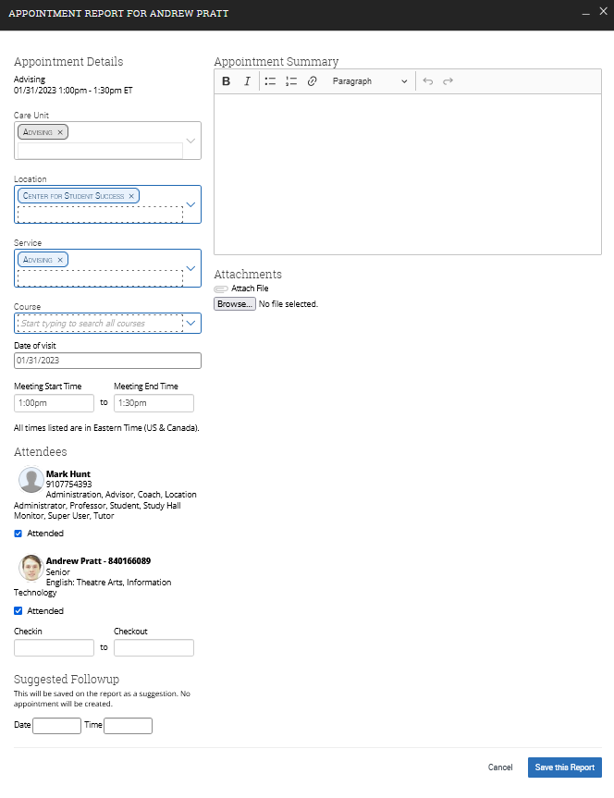
Professor Home
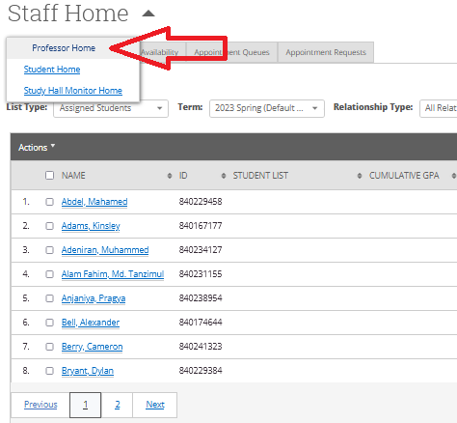

…from this screen you can see your courses, students in those courses, your advisees, issued H.A.W.K. Alerts and issue H.A.W.K. Alerts
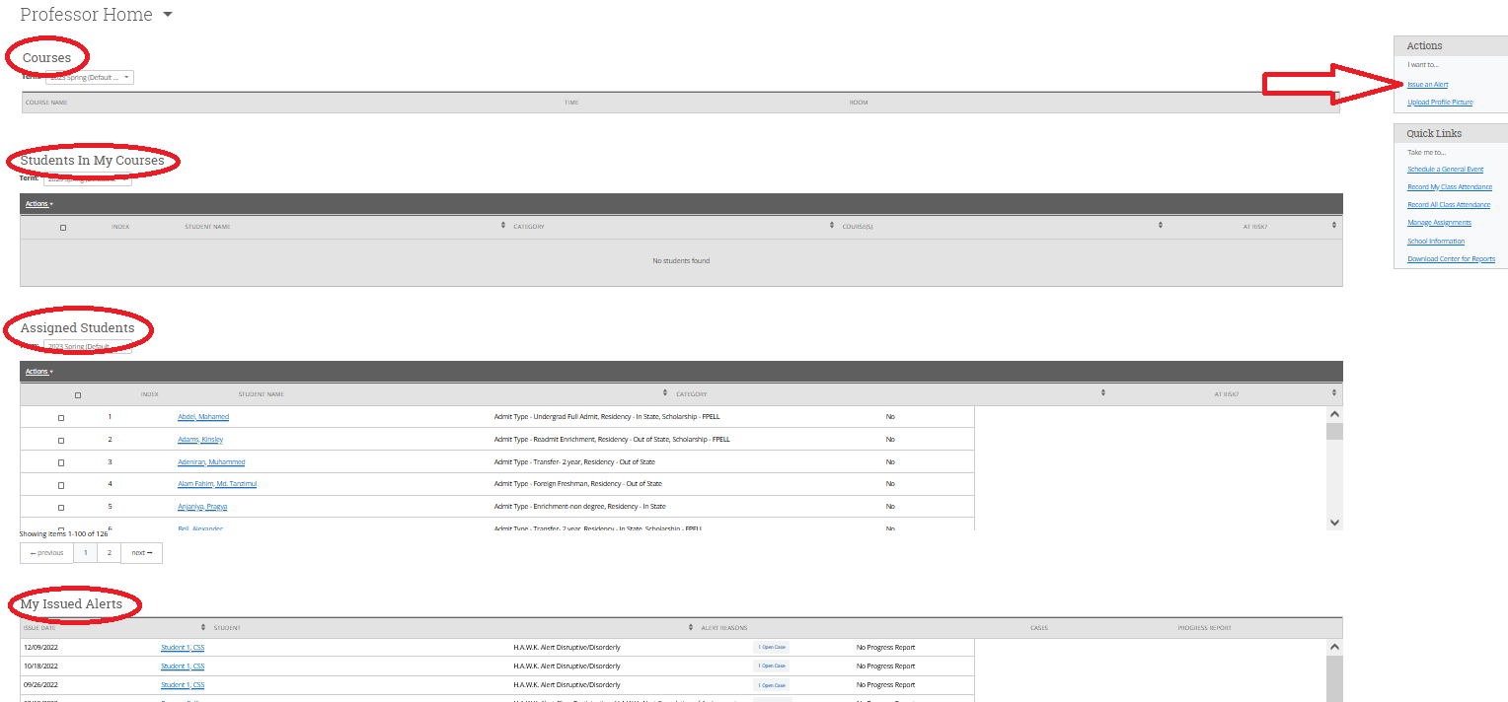

Send Message
Select students...
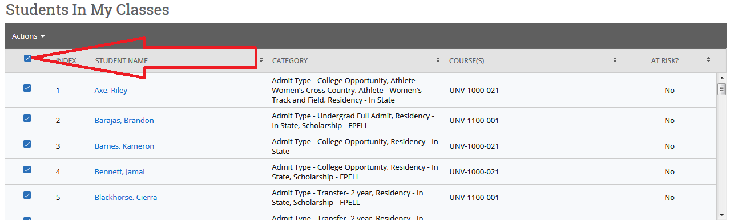
Send Message cont....
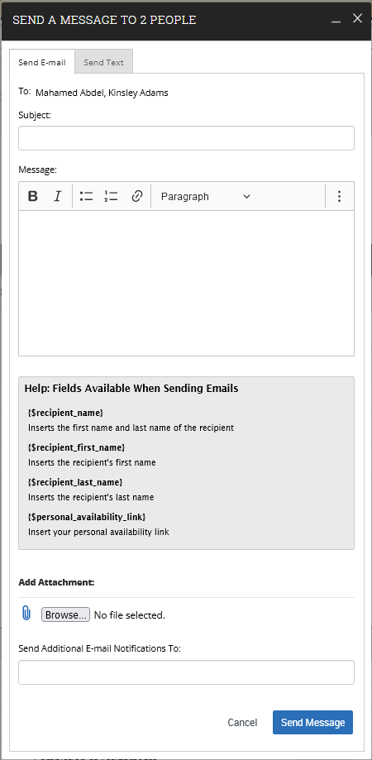
…from here you can message your students, to include attachments and cc’s

Issue Alert (two ways)
1. Class Roster –
Step A: From your Professor Home page, check box next to student’s name under “Students In My Courses” and select “Issue Alert”

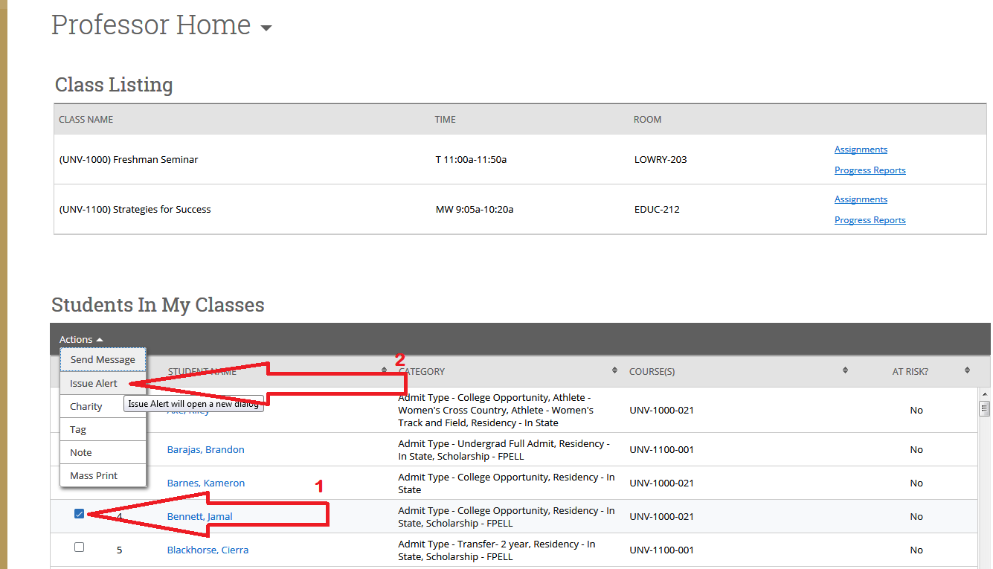

2. Professor Home Page –
Step A: At the right of your Professor home page, select “Issue an Alert” and select student by typing the name or Banner ID...

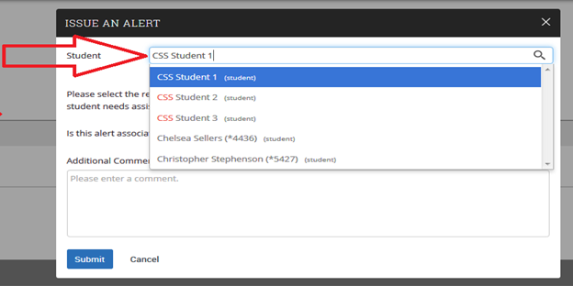

Step B: Alert Reason – Select the alert reason...both H.A.W.K. Alerts and KUDOS reasons are imbedded within this dropdown

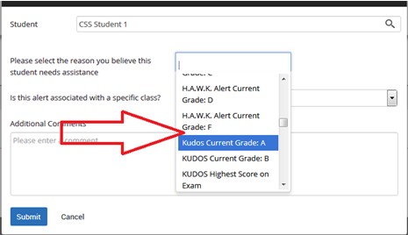

Step C: Associated with a Class? – Select course from students registered classes
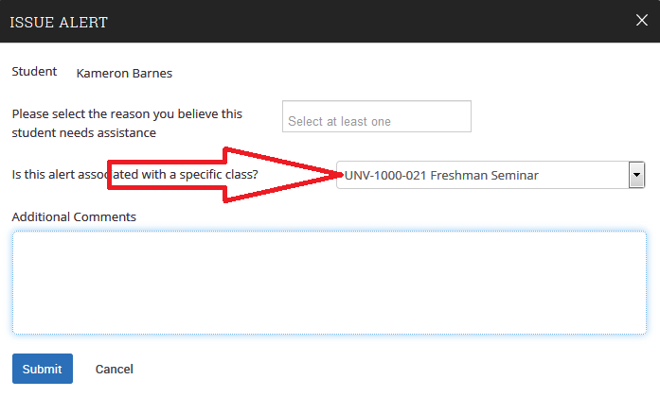

Step D: Additional Comments / Submit – Explain reason for referral and recommendations, if any and click “Submit” 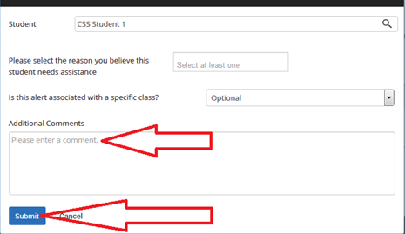

Follow-Up
To determine our progress with your referral...
1. Select the “History” tab at the top left of your student’s profile page
2. Select applicable case under “View Case”

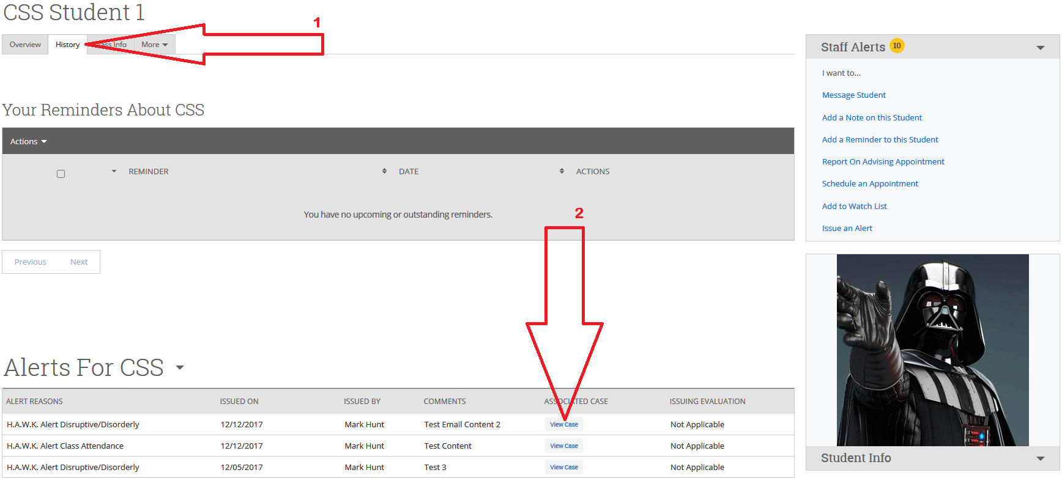

Follow-Up Continued...

From this screen you can see who the case is assigned to, when it was opened (by our H.A.W.K. Alert Specialist) and what their comments are, if any.
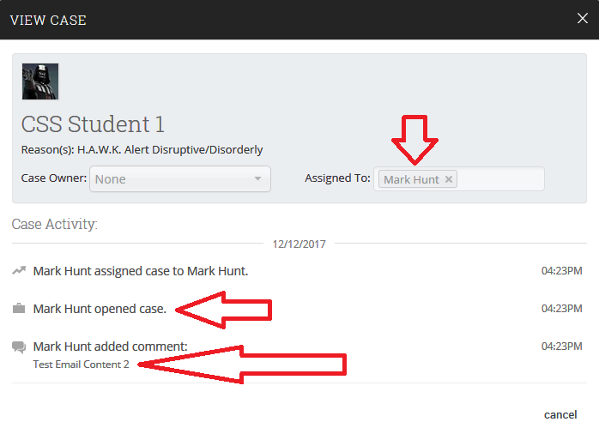

Progress Reports
Issued by various users to Professors to determine the academic progress of specific student populations.

Email notice is sent to Faculty, is accessible thorough email and includes:
- “Yes/No” field for “Is student at risk of failing your course?”
- “Yes” response requires alert reasons
- Alert reasons trigger ‘Cases’ (very similar to a H.A.W.K. Alert)
- Case management begins by:
  - Notifying assignees who initiate contact with student
  - Work with student to address ‘Case’ concerns
  - Track resoultions within EAB (under ‘Cases’ tab 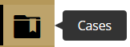 and under ‘My Issued Alerts)
Once case is closed notice is automatically sent to ‘Case’ issuer

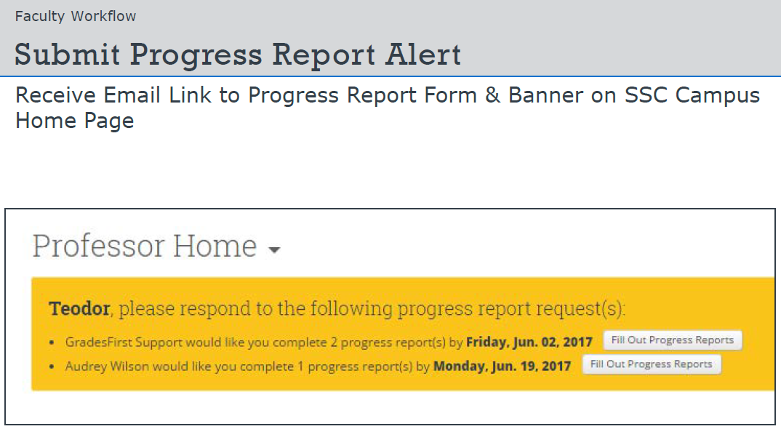

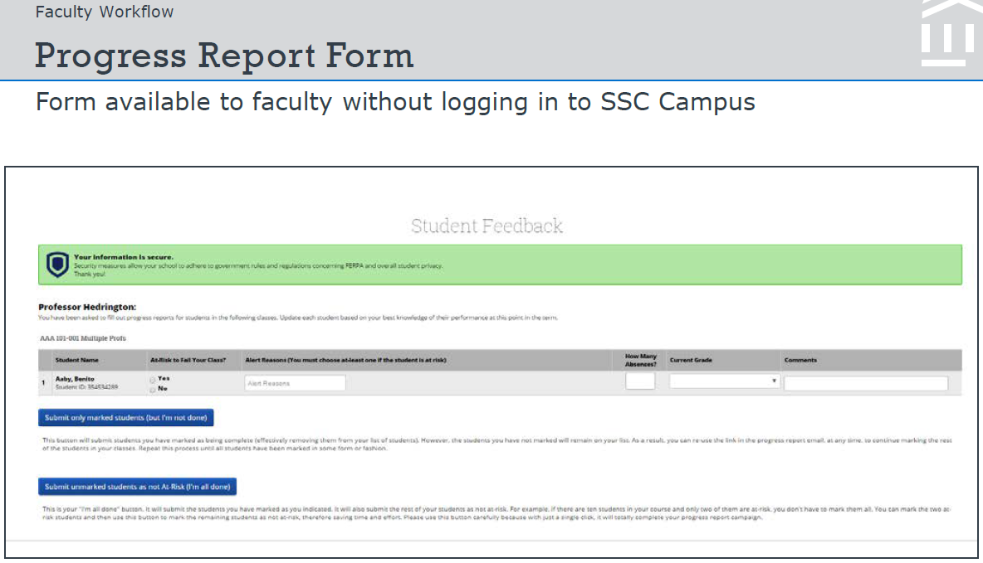

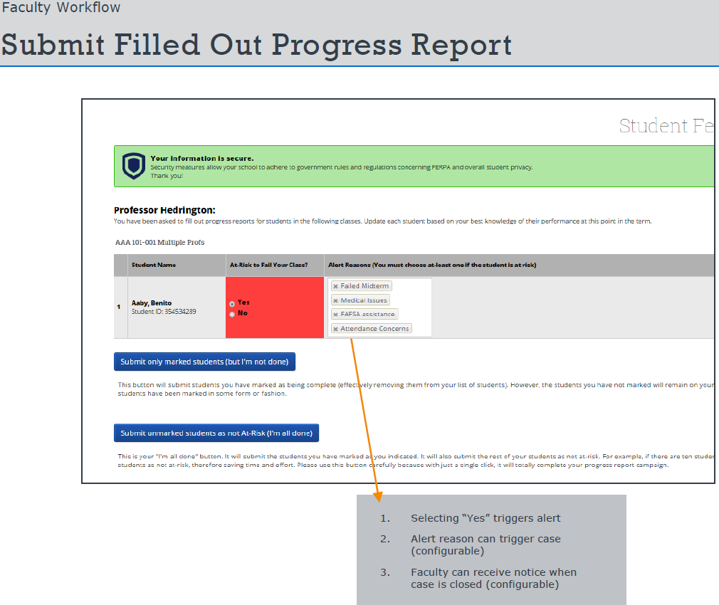
Record My Class Attendance
Select “Record My Class Attendance”

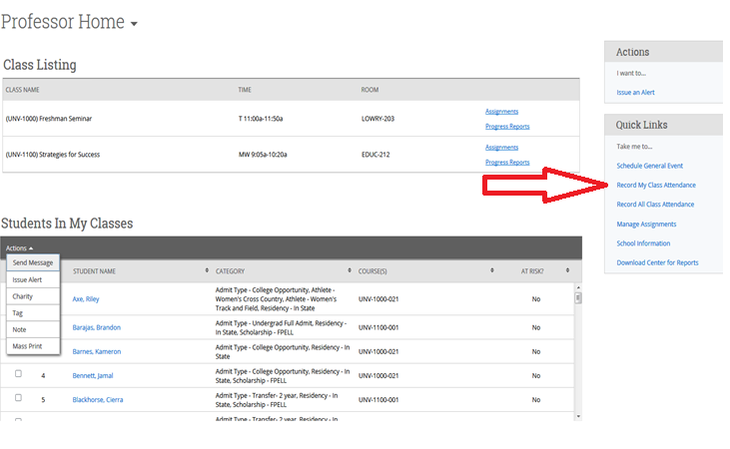

Select: Course> Date> Attendance> Save

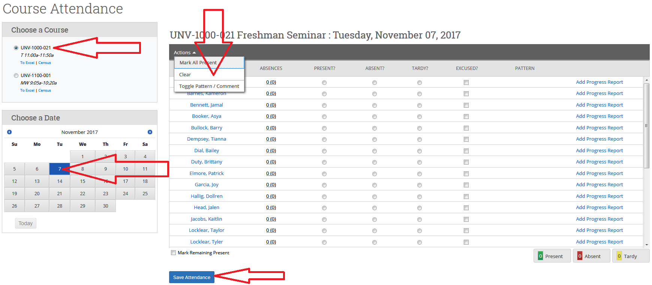
(You can record comments, toggle attendance patterns and view totals for the day. Attendance can also be taken retroactively and can be exported to an excel file.)

“Student Profile”

Tabs (Staff Home Screen):

Overview (30 sec. Gut Check)

Success Progress

History

Courses

Major Explorer

Path

Academic Plan

More: (Calendar, Study Hall, Appointments)

