Waitlist instructions

Click ‘Add’
The course will be added to the Class Summary with a pending status. This indicates that the course has not been fully added to your schedule.

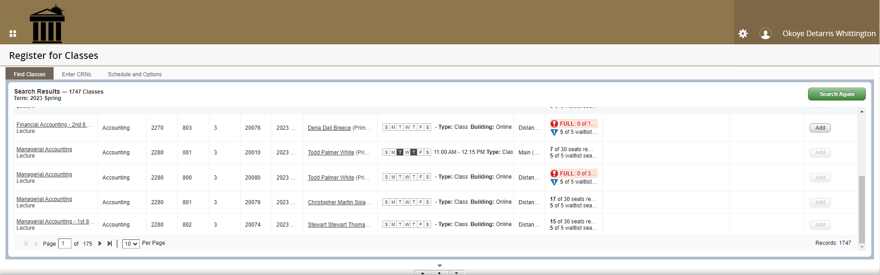

Click the **Web Registered** icon and select **Waitlisted through Braveweb**
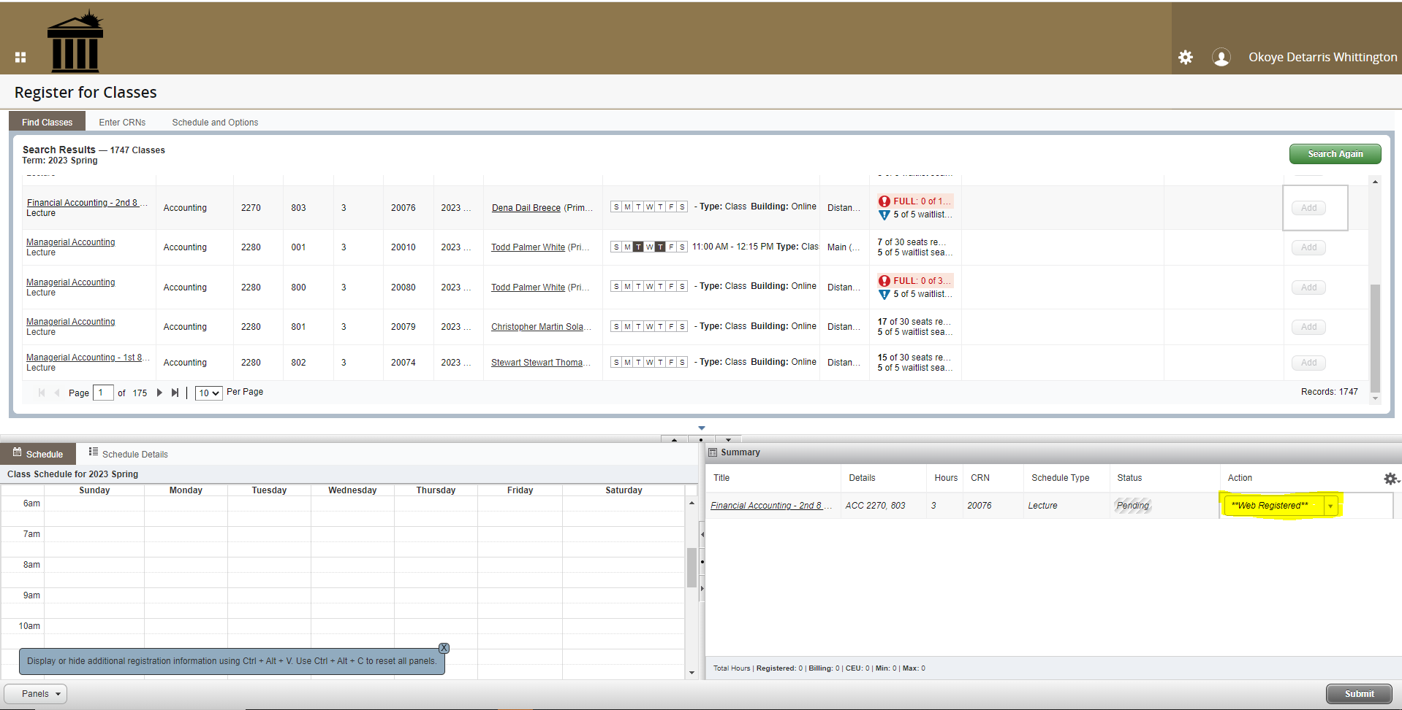
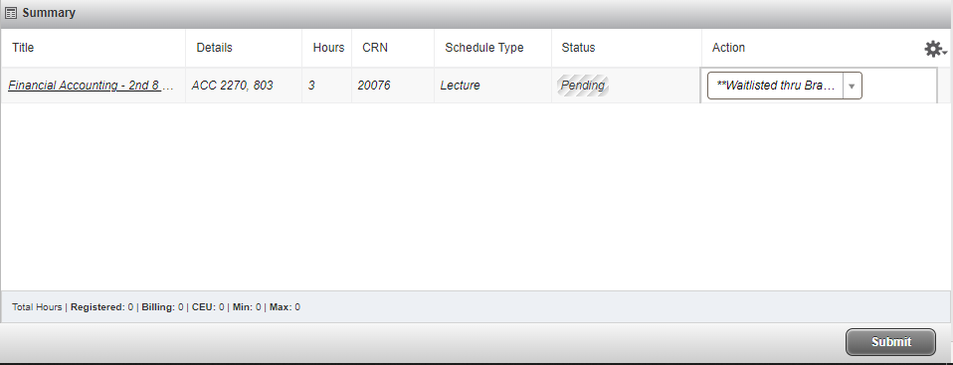
Click Submit and you will be added to the waitlist for the course.

