Braves Come Back Readmission Application Guide

1. On your computer, visit the UNCP website by going to https://www.uncp.edu/.
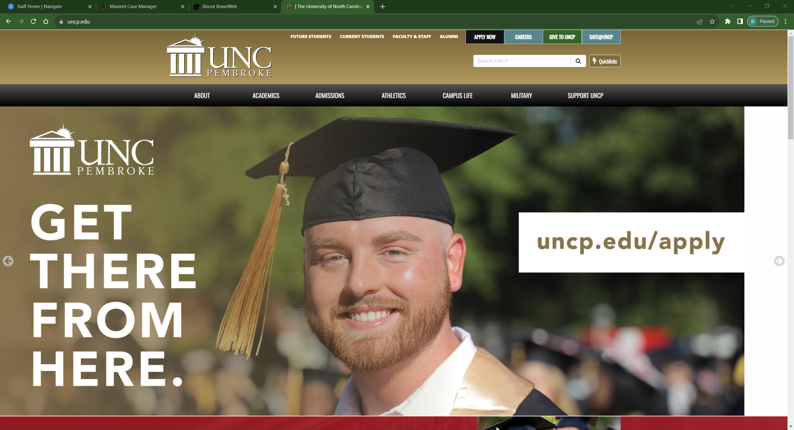

2. Once on the UNCP website, you should see “Apply Now” at the top of the page.
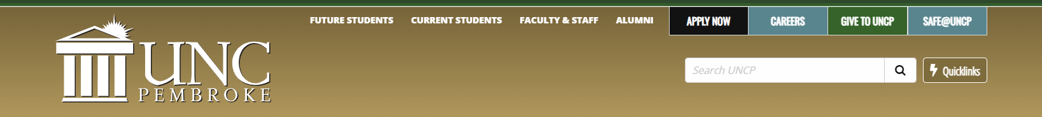

3. With your mouse, hover over the Apply Now button. You should be presented with four options: “Undergraduate Admissions”, “Graduate Admissions”, “Braves Come Back”, and “Careers”. To begin a readmission application, you should select the Braves Come Back option.
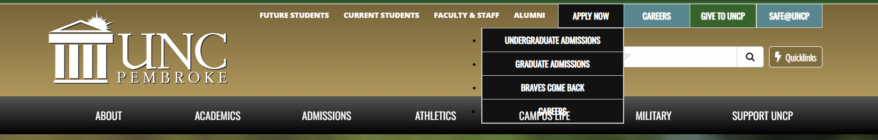

4. Once you select the Braves Come Back option, your page should automatically redirect to the UNCP Pembroke Online Application portal. This application portal exists specifically for readmission applications.
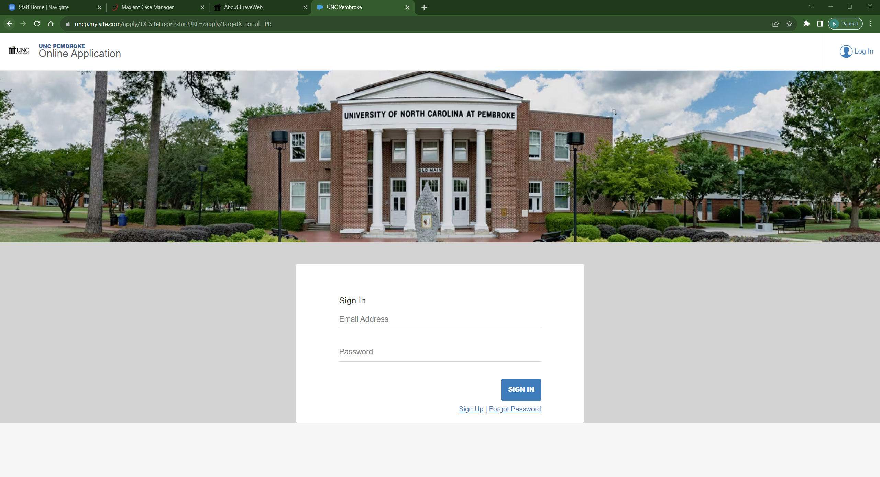

5. If you have used this application portal before, then you should be able to log on with those same credentials to begin your readmission application. However, if you have never used this application portal before, you will need to register as a new user by selecting the “Sign Up” option.
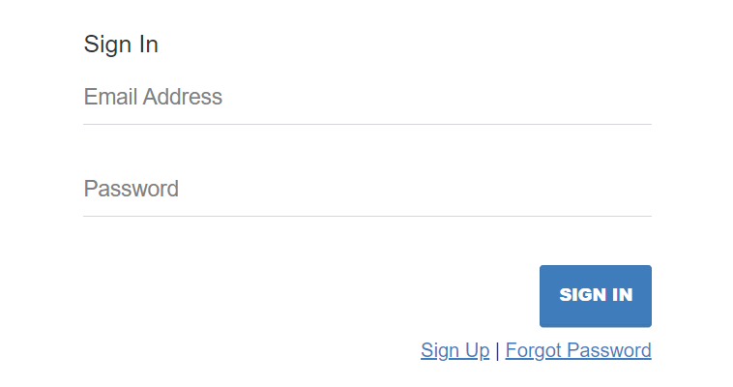
6. Once you are able to log on to the application portal, additional instructions should appear to help you complete your readmission application.

