How to Submit an Appeal

1. On your computer, visit the UNCP website at https://www.uncp.edu/

2. Once on the UNCP website, you should see the “Quicklinks” option next to the search bar.

3. Select the Quicklinks option and click on the “Department Quick Links” drop-down menu at the top of the page.
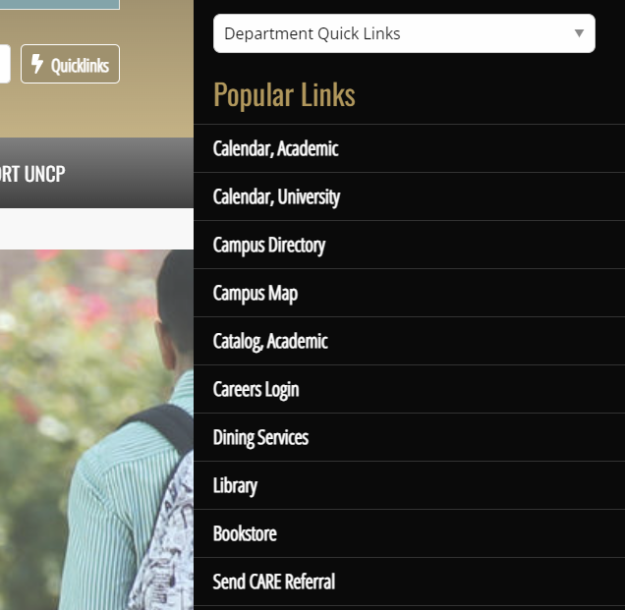

4. From the Department Quick Links menu, select the “Center for Student Success” department.
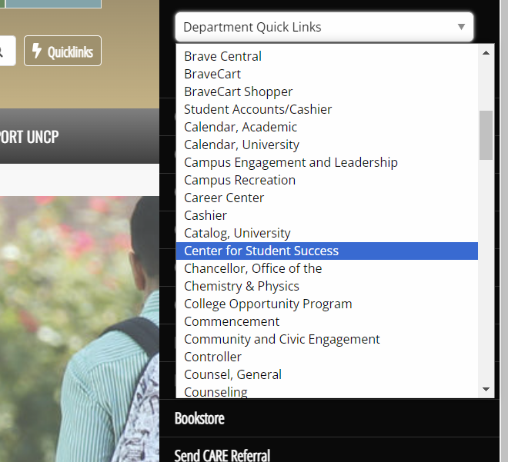

5. Once you click on the Center for Student Success, you should be redirected to the following page.
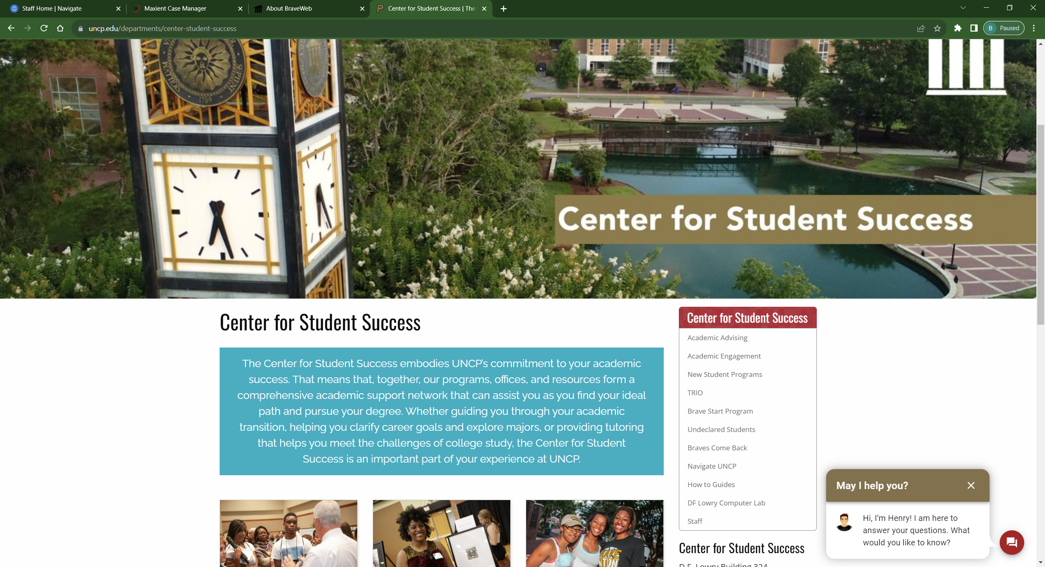

6. Select the “Academic Engagement” option from the menu to the right. Then select the “Appeal Information” option on the next page.
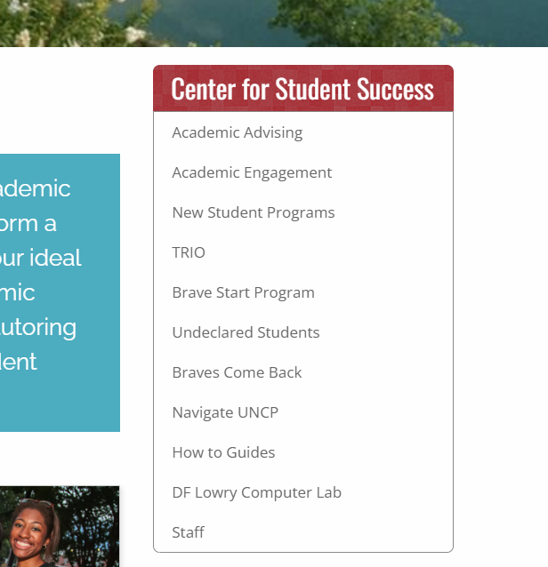

7. After selecting the Appeal Information option, you should be redirected to the page below. This page contains information on UNCP Academic Policies such as academic standing, academic probation, and academic suspension. This page also contains information on the undergraduate appeals process and their respective deadlines.
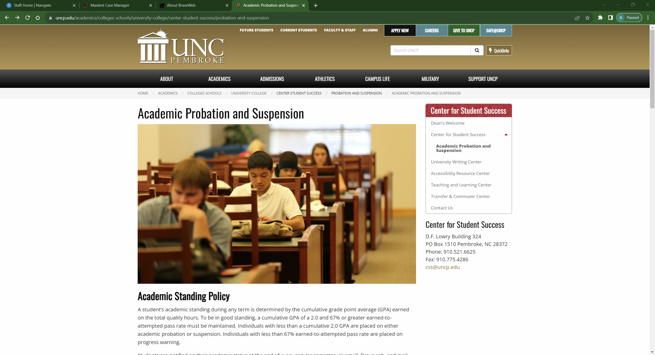

8. To access the appeal application, scroll to the bottom of the page and select the “Submit an appeal here” option. This will redirect your page to the appeal application. Follow the instructions within the application to submit your appeal.
