Effective as of 8/1/20 the Purchasing Department implemented the new Total Supplier Management (TSM) System that is being used for company vendors to complete their registration. Purchasing is no longer entering vendor forms or W9’s manually for companies/businesses/organizations unless there are issues with the system. The instructions are below. Once the registration is completed I will receive notification to review and approve the vendor profile. The department is notified with the Banner/BraveCart ID# after the registration has been approved.

**How to Invite a Company Vendor to Register**

**\***Please check Banner and BraveCart first to verify that the company is not already in the system.

If they are not please proceed with the steps below.

* Log into BraveCart
* Click the 6th icon (Vendors) on the left side pane
* Click Add Vendor

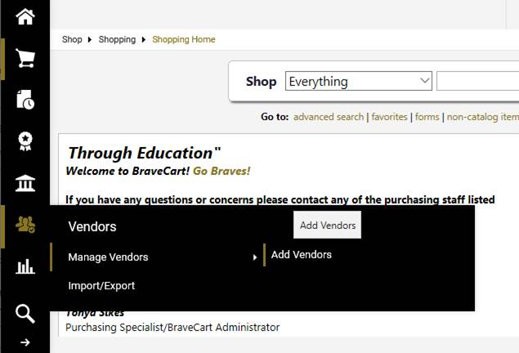

* Enter the Name of the company, first and last name of the company rep, their email address, confirm email
* Click (Invite Vendor to Register)

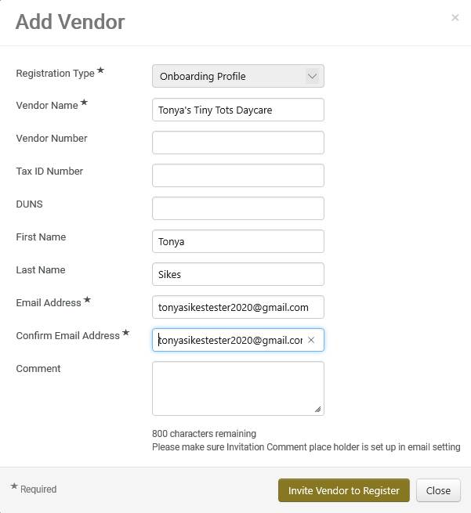

If  “Duplicate Vendor(s) Found” pop-up, please review the list and click “Invite Existing Vendor” or “Resend Invitation” next to the vendor that is most similar to the vendor you want to invite. You will be able to edit the contact information. Enter the first and last name of the company rep you want the registration to be completed by and their email address.

**Please keep in mind that whomever the invite is sent to, that is the individual that is required to complete the registration. It cannot be forwarded to anyone else in the company to complete.

If the vendor requires assistance with the registration please have them contact Jaggaer support at 1-800-233-1121 or submit a ticket via their Customer Service Portal at [https://www.jaggaer.com/supplier-support/](https://nam10.safelinks.protection.outlook.com/?url=https%3A%2F%2Fwww.jaggaer.com%2Fsupplier-support%2F&data=05%7C02%7Cbeatrice.williams%40uncp.edu%7C7e2820f77e3b4ec2e85908dc5599f784%7C1aa2e3287d0f4fd19216c479a1c14f9d%7C0%7C0%7C638479367382083366%7CUnknown%7CTWFpbGZsb3d8eyJWIjoiMC4wLjAwMDAiLCJQIjoiV2luMzIiLCJBTiI6Ik1haWwiLCJXVCI6Mn0%3D%7C0%7C%7C%7C&sdata=xF60MStatKu9U7mm6FqAa0rMpJrLZuYe%2BVB%2BC68c4ks%3D&reserved=0), click the “Submit a Supplier Support Request” link. They will be able to assist with the process.

Once the registration is completed/submitted you will receive notification. An email will also be sent to the department informing them of the approved vendor and the Banner/BraveCart ID #.

I hope this is helpful, but if you have further questions/concerns please let me know. Enjoy the remainder of this beautiful day!