Effective as of 5/1/23 the “Individual Profile” was made active within the Total Supplier Management (TSM) System so that individuals can be invited to register. Purchasing is no longer entering vendor forms or W9’s manually for individuals unless there are issues with the system. The instructions are below. Once the registration is completed, I will receive notification to review and approve the vendor profile. The department is notified with the Banner ID# after the registration has been approved.

**How to Invite an Individual to Register**

**\***Please check Banner first to verify that the individual is not already in the system.

If they are not please proceed with the steps below.

* Log into BraveCart
* Click the 6th icon (Vendors) on the left side pane
* Click Add Vendor
* Change the profile from Onboarding Profile to Individual Profile

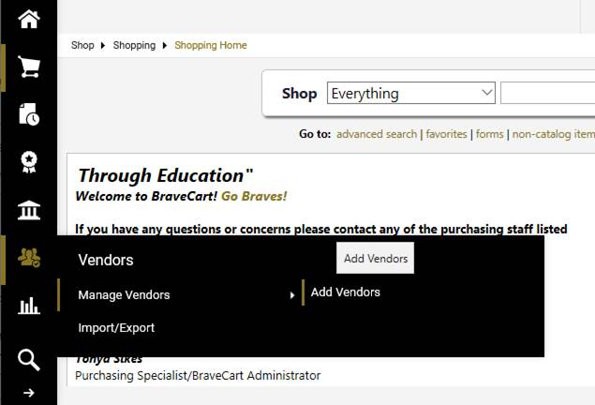

* Enter the Vendor First Name, Last Name, their email address, confirm email
* Click (Invite Vendor to Register)

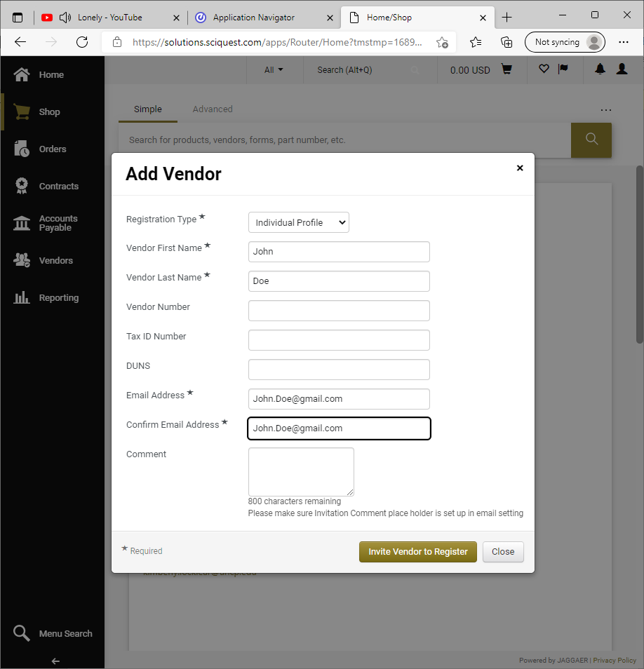

If  “Duplicate Vendor(s) Found” pop-up, please be sure to double check Banner to make sure the individual is not already in the system. If you are still not sure, please contact me at [Beatrice.Williams@uncp.edu](mailto:Beatrice.Williams@uncp.edu) or 910-775-4657.

Once the invite is sent the individual will receive an email and link to complete the registration.

If the vendor requires assistance with the registration please have them contact Jaggaer support at 1-800-233-1121 or submit a ticket via their Customer Service Portal at [https://www.jaggaer.com/supplier-support/](https://nam10.safelinks.protection.outlook.com/?url=https%3A%2F%2Fwww.jaggaer.com%2Fsupplier-support%2F&data=05%7C02%7Cbeatrice.williams%40uncp.edu%7C7e2820f77e3b4ec2e85908dc5599f784%7C1aa2e3287d0f4fd19216c479a1c14f9d%7C0%7C0%7C638479367382083366%7CUnknown%7CTWFpbGZsb3d8eyJWIjoiMC4wLjAwMDAiLCJQIjoiV2luMzIiLCJBTiI6Ik1haWwiLCJXVCI6Mn0%3D%7C0%7C%7C%7C&sdata=xF60MStatKu9U7mm6FqAa0rMpJrLZuYe%2BVB%2BC68c4ks%3D&reserved=0), click the “Submit a Supplier Support Request” link. They will be able to assist with the process.

Once the registration is completed/submitted you will receive notification. An email will also be sent to the department informing them of the approved vendor and the Banner/BraveCart ID #.

I hope this is helpful, but if you have further questions/concerns please let me know. Enjoy the remainder of this beautiful day!