

Annual Report

Academic Year: 2022-2023

The mission of the University Writing Center is to foster effective writing strategies that will not only help writers with their current assignments, but also build foundations for success in future academic and professional writing situations.

# ABOUT THE UNIVERSITY WRITING CENTER

The University Writing Center, located in the D.F. Lowry Building, is an academic support program that provides individual peer tutoring in writing to all UNCP students. The Center is supported jointly by Academic Affairs and the Department of English, Theatre, and Foreign Languages and is housed in Student Academic Support and Retention. The Director of the Center, Dr. Elise Dixon, is an assistant professor in the Department of English, Theatre, and World Languages. The University Writing Center employs student tutors from all disciplines, paying them an hourly wage for their tutoring services. A Graduate Student Assistant is also assigned to the University Writing Center. The University Writing Center provides one-to-one tutoring in writing to UNCP students who are working on writing related to UNCP coursework, scholarships, or other applications.

This annual report provides usage information gleaned from our database of student records. It also provides updated information regarding improvements, new programs, and other developments that have taken place in the University Writing Center over the past academic year.

If you have questions about this report or would like more information, please contact:

**Dr. Elise Dixon**

**Director of the University Writing Center**

**Office: D. F. Lowry 313**

**Phone: (910) 775-4627**

**Email: elise.dixon@uncp.edu**

# WRITING CENTER USAGE

## YEAR AT A GLANCE

* 1652 writing consultations total
* 669 total unique users
* 1128 online consultations

This year saw a decrease in tutorial sessions by 176 sessions, a 9.6% decrease from the previous year.

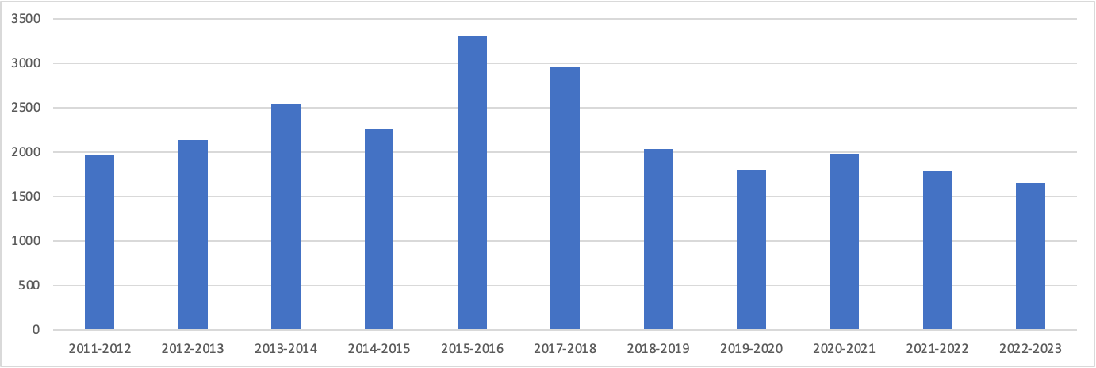

This decrease could be attributed to a decrease in tutors in the fall (totalling only 5 tutors who were working around 10 hours a week). In addition, Dr. Elise Dixon was on maternity leave in the Fall semester, with Dr. Laura Hakala taking over as interim, leading to a potential disruption in overall routine. Sessions increased dramatically in the Spring semester, when 5 additional tutors were hired, to total 10 tutors overall.

The total number of unique users decreased by 55 students to 669 students. 54% of students visiting the center returned multiple times. The Writing Center tutored 8.0% of the total UNCP population this year.

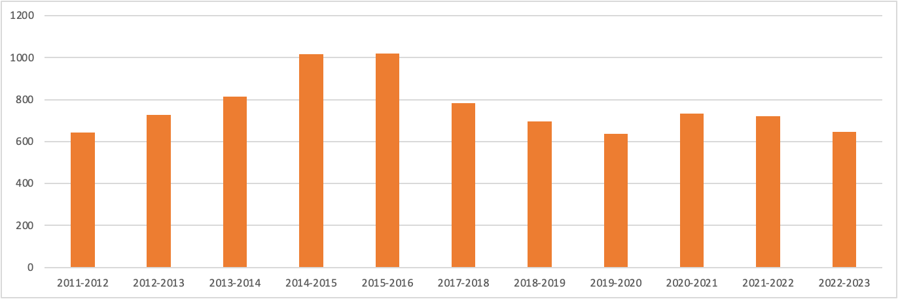

Online appointments decreased by 896 to 1128 students total. Again, this is likely due to a disruption and routine and an overall lack of tutors during the Fall semester.

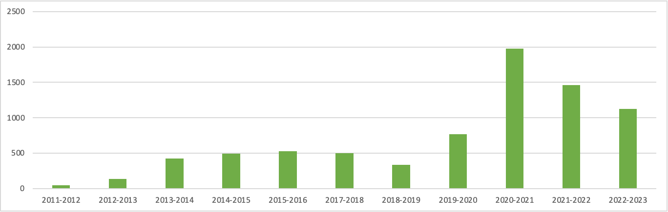

Student visits were made predominantly by freshmen, but with a strong mix of upper classmen and graduate students as well.

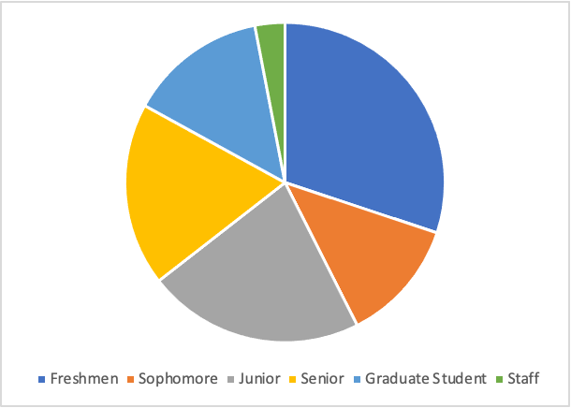

Students requested assistance on various aspects of writing, with many requests focusing on sentence structure and organization:

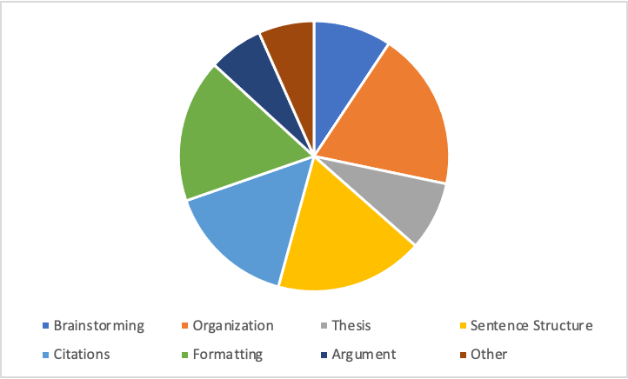

## 

## WRITING CENTER USAGE & FUNDING

The Writing Center’s student usage has grown and slowed significantly over the past five years. According to past interim director Mike Berntsen, in the academic year 2017-2018, the writing center received an initial reduction in budget, which led to limited hours. Since then, the writing center has seen some difficult years, with the pandemic impacting what could and could not be done in the center in terms of appointments and outreach. In Fall 2022, the writing center was fully open in-person for the first academic year since 2019, but due to a limited staff and the director being on leave, the center saw a significant decrease in usage for the Fall.

In terms of funding, the writing center met it’s $30,000 budget, likely due to a smaller staff. However, staff were also given raises to start at $12 per hour. In Spring 2023, Dr. Dixon requested an increased budget to meet this payroll need for the 2023-2024 academic year, which was approved by Dr. Derek Oxendine.

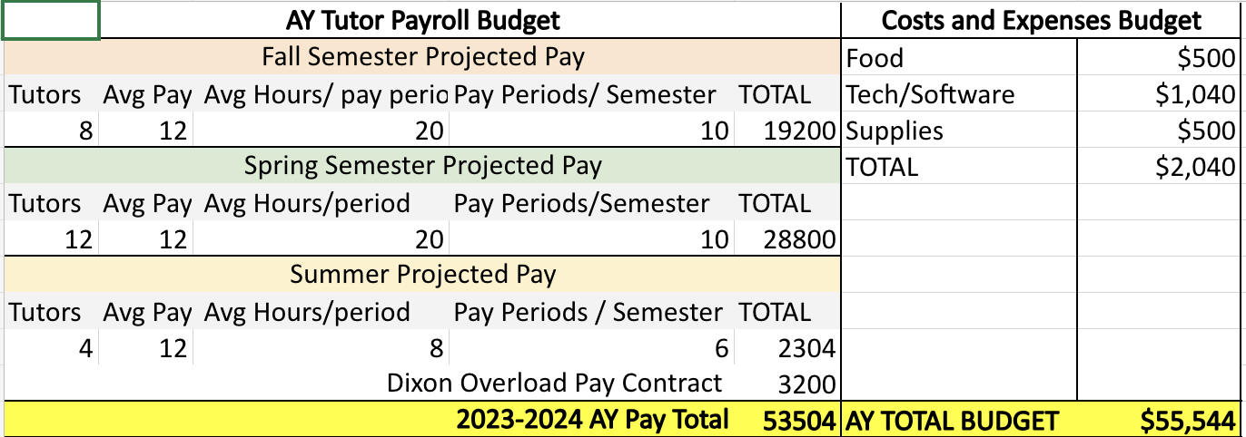

# TECHNOLOGY

## WCONLINE

For the past ten years, the University Writing Center has subscribed to WCOnline, a web-based system that included the following features:

* A web-based appointment system.
* A data base that tracks students and student visits by various attributes
* A survey tool
* Usage reporting capabilities
* Online tutoring capabilities.

## ONLINE TUTORING SESSIONS

The online tutoring capabilities feature a web-based platform where students paste or upload documents to a shared space. Tutors and clients can both highlight and modify the document. Communication is carried out through a chat feature. This is a popular feature for online and distance students

## WEBSITE

The University Writing Center’s website includes an ‘about us’ page which includes a mission statement and an explanation of our approach. The website also features a page for faculty, a page with pictures and biographies of the tutoring staff, a page of helpful links, a page that explains how to apply for a tutoring position, and a page explaining our online tutoring platform. Students can make appointments via our website.

## HARDWARE

The University Writing Center has six computers that are available for student use, one of which has DSS software installed. One printer is also available. The computers are four years old and in acceptable condition. The Writing Center now has a Webex TV for presentations and for group writing projects.

# TUTOR TRAINING & PROFESSIONAL DEVELOPMENT

## TUTOR TRAINING COURSE

University Writing Center tutors are trained in a full-credit course, ENG 2990: Writing Center Theory and Practice. In the course, students read theoretical and practical texts in the writing center field. Students in this class are required to complete four projects: a reflective narrative, a researched argument, a multimodal assignment, and a tutoring philosophy. In class, we discuss recent and foundational writing center texts and practice consulting each other. Students are also required to complete multiple observations of current tutors. The class creates a knowledgeable and skilled cohort of tutors in the University Writing Center. This experience and training greatly enhances the students’ qualifications for teaching and related careers.

## BI-WEEKLY TRAINING SESSIONS

All University Writing Center tutors participate in bi-weekly staff-training sessions. Many sessions this year focused on trouble-shooting online sessions, providing guidance for “dropoff” papers, and tutor mental health and well-being.

# STAFF & RECRUITMENT

## WRITING CENTER STAFF

Fall 2022-Spring 2023 Staff

Dr. Elise Dixon, Director (Off Fall 2022)

Dr. Laura Hakala, Interim Director (Fall 2022)

**Graduate Assistant:**

* Sherry Grant (English Ed) (Fall 2022 only)

Undergraduate Tutors:

* Lily Monaghan (Sociology/Political Science)
* Kai Anderson (Biology)
* Emma Cooke (Psychology)
* Diana Evans (Criminal Justice)
* Alyse Coggin (Elementary Ed/ Sociology)
* Clavaria Jeffreys (English Ed)
* Christina Gendron (Professional Writing)
* Linn Brown (Political Science/Spanish)
* Alaira Hainer (Social Work/Psychology)
* Noah Britt (English Literature)
* Zaveyan Pearson (English)

## RECRUITMENT

To replace graduating staff, recruitment was undertaken in the Spring. This consists of emails to faculty seeking out nominations for excellent writers, or helpful collaborators that they have seen in their courses. Once I receive the nominations, I send an email to all nominated students to register for ENG 2990. After students take the course, students apply to work in the center by submitting their resume, cover letter, and tutoring philosophy.

# UNIVERSITY OUTREACH

## WORKSHOPS

The Writing Center conducted multiple outreach activities this academic year, including participation in workshops for the UNCP wrestling team, Career Services, Social Work Class, Coffee & Facts w/ Transfer and Commuter Center, and two ENG 1060 Mini-workshops.

## FRESHMAN SEMINAR

Many Freshman Seminar instructors include the University Writing Center in their course. Some include the Center in their scavenger hunt, some bring their class by the Center, and some invite a representative of the Center to visit their class. We encourage all of the above and hope to strengthen our connection to Freshman Seminar in the coming year.

**SPECIFIC COURSES**

Many instructors teaching writing intensive courses have included the Writing Center in their syllabus. The instructors recommend, or in some cases require, all of their students to visit the Writing Center. Instructors forward copies of assignments and give us feedback on our work with their students. The Writing Center has relationships with instructors teaching courses in the following areas:

* English Composition
* Intro to Theatre
* Nursing
* Mass Communication
* Business Communication
* Math

## SOCIAL MEDIA

The UNCP Writing Center’s social media presence continued to increase, with the development of more instagram posts and the creation of a TikTok account.

# SURVEYS

**STUDENT SURVEYS**

The student surveys were conducted throughout the 2022-2023 academic year. All students who visited the University Writing Center were sent an email with a link to the survey. 226 students responded.

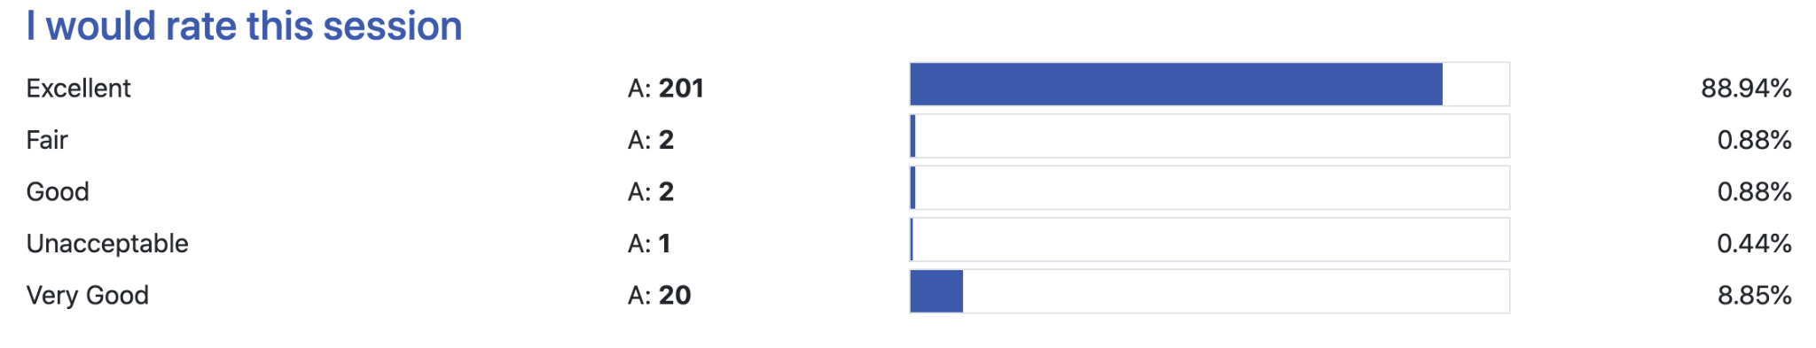

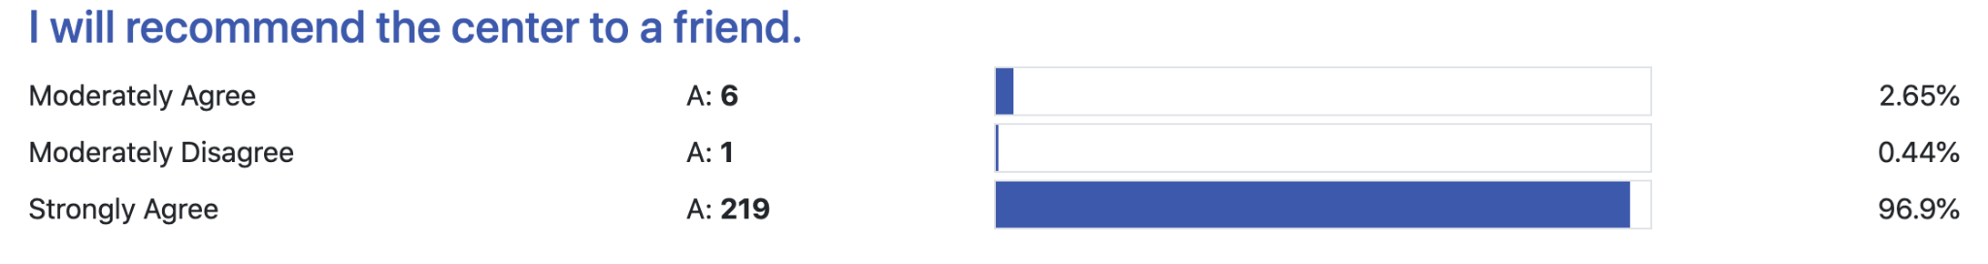

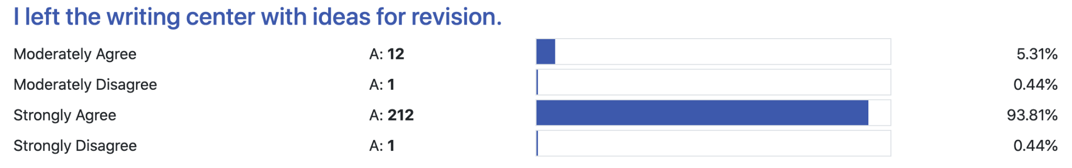

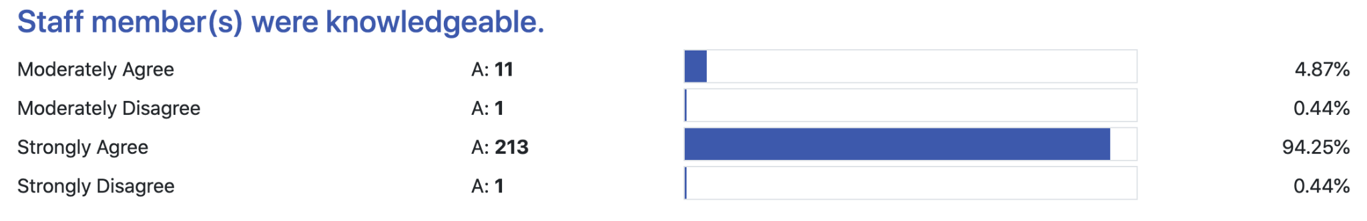

## STUDENT SURVEY: WRITTEN RESPONSES

* Absolutely loved Lily!!! Amazing person and she was able to help me get out of the rut I was in with my project. If I didn’t have a quiz I had to take care of tonight, I think I would have been able to write out my essay! ^.^ she gave me a bit of confidence as well with the idea that I will do well in these last weeks of school, and I can’t thank her enough for that
* After Zaveyan looked over my paper, he said that I had done a very good job and that everything looked great. It made me feel very confident about turning in my paper.
* Alara provided amazing feedback that really brought my resume to the next level. They provided a lot of insight regarding ways to structure my information and ways to elevate the way the information is delivered. Her feedback was so incredibly helpful, and the way she organized it also made it easy to implement!
* Alara was a fantastic help today. I appreciate her looking over my paper and ensuring everything was organized and well-formatted. It helps when someone else is reading your writing to you so you can find mistakes. Thanks again!
* Alara was great and really helped me.
* Alara's feedback was very helpful! I was also pleasantly surprised that I received written feedback within 30 minutes of submission. This will definitely help me complete the rest of my paper with greater ease.
* Always a great experience working with Alyse
* Alysa was great to work with while proofreading my paper.
* Alyse did an amazing job! I completed the meeting well refreshed and excited about finishing my assignment Criminology. She was such an amazing help and I will definitely come back for future writing assignments.
* Alyse has been consistent in professionalism and going the extra mile to provide resources to ensure that my documents are of the highest quality. I am also learning a great deal from her. Thank you Alyse for all you are doing.
* Alyse is a Stellar
* Alyse is always extremely helpful, patient, & knowledgeable. She gives her feedback in a way that’s constructive & considerate which I really appreciate :)
* Alyse is an exceptional instructor.
* Alyse was an amazing help, I feel 100 percent more confident in my paper because of her!!!
* Alyse was extremely kind, knowledgeable, and professional. She helped me develop the ideas I already had into stronger arguments. Her feedback was helpful and organized. I'm a first-time visitor of the writing center but I will definitely be back after this experience. Amazing tutor!
* Alyse was very helpful in assisting with my paper. She answered any questions I had and gave good feedback. She was very polite and knowledgeable. I would recommend her to anyone.
* Alyse was very professional and highly knowledgeable. She was easy to talk to and gave great advice for ways to improve my essay.
* Alyse's feedback has made an abstract an award-winning one.She was very honest, professional and timeous. Thank you. I will be in touch soon.
* As usual Alyse was phenomenal
* Awesome feedback!
* Christina gave me some really helpful feedback! Her suggestions made perfect sense and she provided exactly the type of assistance I was looking for.
* Christina is a great help and was able to look at my previous papers to adapt and understand how to make the paper the way my professor wants it to be done. I would strongly suggest Christina to anyone that is in need of help with writing. Christina is also very friendly and out going and is easy to approach and talk to. 100/10 would recommend to anyone.
* Christina was great! She reviewed my paper thoroughly and sent an additional email with resources to help me out in the future!
* Christina was very helpful in showing me how Wix works.
* Clavaria was sweet and very helpful
* Clavaria was very helpful.
* Clo is the best ! She really helped get on my feet and keep moving !
* Diana was very helpful and professional.
* Emma has been very knowledgeable throughout our sessions and I have been able to learn a lot from her. she is also very good at explain and communicating the material and how I should do things. this will help me in the future and I highly recommend you give her a raise!
* Emma was amazing, and she was very helpful. It was a blessing to have her as my reviewer. Emma does more than just read and correct your paper she also builds your confidence.
* Emma was excellent and patient-she knew precisely what I needed!.. Keep her on board..she is great!
* Emma was great! She really helped me better understand my overall assignment and brainstormed with me. She also was able to work through analyzing a poem with me and I left the session feeling prepared to begin drafting!
* Emma was such a big help on the finalization of my paper and now I have a better understanding on how to cite and format future papers. Thank you so much :)
* Enjoyed my session, instructor helped me and brained stormed ideas with me.
* Fantastic session with Alyse
* Fantastic tutor
* felt I was talked over, also, spent too much time on basics in my opinion, all I wanted was either a yes or no to my questions.
* From the start of my appointment Alyse was very patient and friemdly. Alyse gave me very informative information to use in writing my signature assignment for my clinical mental health counselor course. Looking forward to meeting again.
* Great experience
* Great job Noah.Thanks
* He was very nice would recommend
* I appreciate the quick response!
* I appreciated Emma reading through my paper and offering suggestions on my citations. I appreciated her comments about the flow and organization of the paper. I will utilize the Writing Center's services and tutors in future semesters. Thanks so much!
* I appreciated Sherry's feedback and enjoyed working with the writing center to better my paper. I will definitely use this service again.
* I asked for assistance on a specific citation on the reference page and wanted to know if it was correct the way I completed it. I was not given a clear answer to that question. I had already done my research and still was not confident that it was correct. I did not feel that I got a definitive answer in regard to that question. Other than that, it was a great experience.
* I asked for assistance on a specific citation on the reference page and wanted to know if it was correct the way I completed it. I was not given a clear answer to that question. I had already done my research and still was not confident that it was correct. I did not feel that I got a definitive answer in regard to that question. Other than that, it was a great experience.
* I commend Alyse's professionalism.
* I enjoy the Pembroke writing center. The environment is welcoming and peaceful. Christina was a pleasure to work with and she was willing to learn and teach. Elise Dixon has created a phenomenal atmosphere in the writing center, I will definitely be back. This was my second experience and I truly enjoy coming to the writing center.
* I enjoyed my meeting today with Alyse. She was very helpful with everything, even helped on other issues like my major and other assignments. I will definitely be back to work with her.
* I initially booked with Emma, however, Lily was really sweet. She seemed a bit unsure about the assignment and predominately guided the session. I would have preferred for her to ask more questions and allow me more of a chance to respond and give feedback, but I know she was just trying to help. Overall, the session was decent, but this does not reflect my feelings towards the writing center as a whole.
* I really enjoyed my session with Alyse, I look forward to working with this employee again.
* I really enjoyed the writing session that I had with Alyse. She was really helpful and understanding of my assignment.
* I really like the writing center. I have used this resource a couple of times and it is very useful.
* I really love working with Alara she gives really good insights on my paper as well as giving me good ideas to help with papers. I have recommended her to my friends.
* I really love working with Alara! She is very very helpful!!
* I think that she really is one of the best there at the writing center the feedback she gives is also very helpful, and she's helped my papers improve significantly.
* I was helped by Alyse, and she was very helpful and gave good recommendations on my next steps.
* I’ve used Lily every time I’ve used the writing center. She always provides great information and helps me get the best grades on my papers. She’s a 10/10.
* I've worked with Alyse for work in previous courses and she's amazing! Well-spoken, knowledgeable, and engaging. Her expertise has helped me get great scoring papers in the past.
* It is a great pleasure to work with Alyse all the time. I am learning so much from her. Thanks Alyse
* It is always a great pleasure to get feedback from Emma. She is a sterling star. Emma, thanks for all that you.
* it was good
* Lara was so helpful and amazing. I appreciate her time and feedback very much!
* Lilly has been very helpful in me accomplishing my writing goals.
* Lily acted professionally as she has always been. Lily is a great blessing
* Lily has always been helpful and very professional.
* Lily is a superstar. Her feedback is always like putting beautiful and colourful icing on the cake. Apart from making my assignments great, she has also taught me how to improve my writing. The quality of my writing has improved tremendously.
* Lily is the best writing tutor in my opinion.
* Lily is the best. (2)
* Lily was a great help, and I plan on scheduling another appointment next week! She had many suggestions for improvement, which I appreciate. Thanks, Lily!
* Lily was a great help! She gives constructive criticism well but also highlights parts of the paper she likes. I would recommend her services to anyone who is of need.
* Lily was a great tutor she broke down my own wording of my paper to better understand to read. I would most definitely recommend other students to Lily because Lily will make sure you understand what she is trying to say and help you with it.
* Lily was excellent and very knowledgeable. She exceeded my expectations.
* Lily was professional and her comments made the assignment to be perfect. Her kind words also served as an elixir to boost my confidence in writing as well as a motivation to contact the writing center more often.
* Lily was very helpful and kind. She gave me many great tips!
* Linn was great she help me out with my paper, by given great advice on how to proceed with my essay. She gave me great feedback
* My assignment became much better after I made the suggested corrections. She attended to my assignment timeously. I will continue to make use of the services and recommend the writing center to my friends and colleagues.
* My assignment is now excellent with the professional touch from Emma.
* My helper was really nice. She helped me a lot.
* Noah was very helpful and he provided the information I was seeking.
* Nothing else, everything was good.
* She was great. She help me smoothly through the process of starting my paper. I liked her writing style since it was similar to mine so we brainstorm on sentences that I could use and give me ideas on what else i could inclue in my paper which was really helpful. Overall, really happy She could help and give me ideas on what to write so I could continue to work on it with a goal in mind.
* She was very helpful and patient, helped me understood how i could come up with a good reflective essay.
* Sherry is very nice and professional
* Sherry was extremely helpful and she had a lot of incite on how I can improve my graduate school applications.
* Sherry was knowledgeable and easy to work with. She brought grammatical errors to my attention, and helped me with sentence structure. I will definitely be using this resource again.
* So awesome
* Thank you Lily! You're the best
* Thank you so much, I really appreciate all the feedback!
* Thanks for the assistance, the feedback was a big help!
* Thanks for the help😊
* Thanks for the insight Lily, Im going to make some of the recommended changes and get this paper submitted. You're always a giant help and I appreciate you!
* The feedback I received was excellent and I did not disagree with any criticism I received. Thank you Noah!!
* The staff did a good job at making me feel welcome.
* They were very helpful and gave me good recommendations of what to work on.
* This session helped me feel more confident about what I wrote.
* This Was my first time using the Writing Center and I absolutely loved the experience. Sherry was a great help and offered excellent feedback. I could not ask for a better experience or outcome. Thanks!
* This was my first time utilizing the center and Alyse was extremely friendly, knowledgeable and helpful. Will definitely return
* Very good and informative session. Alyse not only helped provide ideas for revisions, but she also explained some of the rules for grammar, for example comma splices.
* Very helpful and insightful
* Very helpful! Will definitely do this with every paper.
* Zaveyan gave me very good tips to help me with my paper.
* Zaveyan helped me with brainstorming and fixing grammatical issues in my sentences. I felt more confident with the structure of my sentences.
* Zaveyan is the greatest! This was my second appointment, and he needs to know that he is extremely appreciated!
* Zaveyan was incredibly helpful, nice, and supportive!
* Zaveyan was very helpful, patient, nice. He helped me with writing an email to my professor, about questions I had with my paper.

This publication is available in alternative formats upon request. Please contact Accessibility Resource Center, DF Lowry Building, 521-6695.